Western Ontario Waterways
Regional Council Spring Meeting

Friday, May 22 – Sunday, May 24, 2026
Meeting Workbook
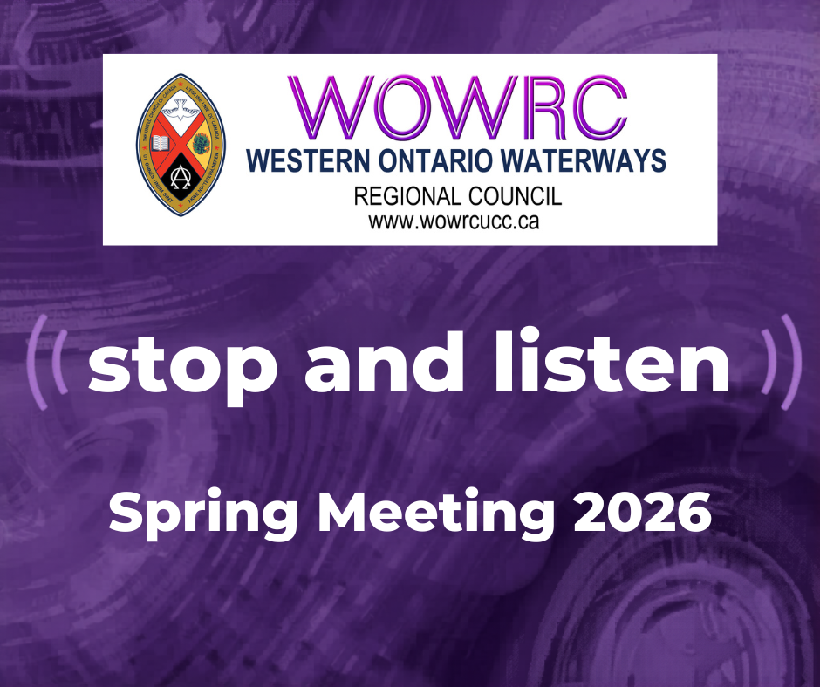

Contents
Workbook Introduction 4
WOWRC Spring Meeting Support Team 5
Commitment to Community Safety 6
Participation in a Virtual Meeting 7
Chaplains and Equity Support 9
Equity Support Team Member Position Description 10
Map of Unifor Centre 12
Section One:
Meeting Agenda 13
Acting President Jennifer Irving’s Message 14
President Rebekah Duncan’s Spring Meeting Address 15
WOW’s 100th Puzzle Project 16
Puzzle Legend 17
Workshops Descriptions for WOWRC 18
Kids and Youth 19
President-Elect Nomination – Chris Grose 23
Volunteer Recruitment Report 24
Celebrants 26
LLWL Recognition 26
Retirees 27
Leaving Us 27
Retiree Message: Sandra McLauchlan-Abuja 28
Retiree Message: Bill Bruce 29
Retiree Message: Thomas Dunbar 30
Retiree Message: Jane Sullivan 31
Retiree Message: Drew Maxwell 32
Retiree Message: Cheryl-Ann Stadelbauer Sampa 33
Retiree Message: Dave Jagger 34
Retiree Message: Heather Leffler 35
Order of Ministry Jubilands 36
LLWL Jubilands 38
Community of Faith Life Cycle Changes: 39
Section Two
Meeting Materials 40
Proposal #1 – Opening and Procedural Motion 40
Proposal #2 - Change to 2025 WOWRC Spring Meeting Minutes 42
Proposal #3 – Recruitment Slate 44
Proposal #4 – Closing Motions 45
Section Three
Atlantic School of Theology Report to the Region 46
Centre for Christian Studies Report to the Region 48
Emmanuel College Report to the Region 50
St. Andrew’s College Report to the Region 53
United Church Rural Ministry Network Report to the Region 54

Workbook Introduction

Theme: Stop and Listen

Purpose: Connecting, Supporting, Transforming

Priorities:

Assessment | Mission & Support
Communities of Faith Support/Pastoral Relations | Children and Youth
Communications and Resources Support | Chaplaincy
Connecting/Meeting | Social Justice

Format and Process: Decision Making
The format for General Council proposals is being used for the regional meeting. The General Council approach involves three distinct stages in the decision-making process:
- Listening/Learning;
- Discussion;
- Decision.
In our regional council meeting we do not have the space or time to mirror these stages in the same way the General Council practices them.
In our proceedings, the steps will be:
- The Presenter will outline:
  - What is the issue? And,
  - The suggested way in which the regional council might respond to the issue.
- The President will inquire if there are questions for clarification.
Please note this is for clarification only.
- The President will then ask if there are changes or additions being suggested for the proposal.
- Once there is significant agreement, the President will invite the Presenter to move the motion at which point the regional council enters the formal debate process.

WOWRC Spring Meeting Support Team

Agenda & Business – Terry Smith (Chair), Dawn Blanchard (Secretary), Gary Clark (Parliamentarian), Jennifer Irving (Acting President), Mark Laird (Executive Minister), Max Watkinson, (Executive Assistant)
Please contact Executive Minister, Mark Laird at mlaird@united-church.ca with any Agenda & Business items.
Chaplains – Laurie Stevenson, Keith Reynolds, Mary Elizabeth Piercy (participating online)
Rev. Dr. Laurie Stevenson – lstevenson@united-church.ca / call 226-564-1956
Rev. Keith Reynolds – contact information to be shared at meeting
Rev. Mary Elizabeth Piercy – maryelizabethpiercy@gmail.com / call 705-445-4740

Note: email and phone messages will be checked throughout the meeting day.
The chaplains are available throughout our meeting time to offer pastoral and spiritual support to participants. The chaplains provide a compassionate, confidential listening presence for anyone who may be feeling overwhelmed, anxious, emotionally affected by discussions, carrying personal concerns, or simply in need of conversation, prayer, or quiet support during the gathering.
The chaplains are present to care for the well-being of participants, not to address procedural or policy concerns.
Please note that during meeting sessions, the chaplains may not be able to respond immediately to private zoom chats, phone calls or emails. Your message is important, and they will respond as soon as they are able. We thank you for your patience and understanding.
Equity Support – Phyllis Fleming, Linda Roberts
Note: Contact information for Equity Support persons will be shared at the meeting.
Those wanting to be in touch with equity support prior to the meeting are asked to contact:
Equity Support Staff: Thérèse Samuel– tsamuel@united-church.ca / call 226-407-4310 or
John Egger – jegger@united-church.ca / call 226-407-4309
Hospitality/Community Building – Heather Leffler, Chris Grose
Hospitality/Local Arrangements – Judy Zarubick, Liz Dillman
Parliamentarian – Gary Clark
Tech Team – Greg Smith-Young, John Neff and Michele Petick
Worship Team – Roz Vincent-Haven, Thérèse Samuel, Gord Dunbar, Ayldia Smith, Chris Burton and friends
Zoom Room Community Host – Gord Dunbar

Commitment to Community Safety
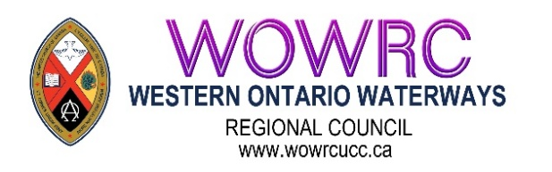

BRAVE Statement
Western Ontario Waterways Regional Council of The United Church of Canada
Box 100, Carlisle, Ontario, L0R 1H0 | Main Phone: 1-833-236-0280 / 905-659-3343
Western Ontario Waterways Regional Council of The United Church of Canada
Box 100, Carlisle, Ontario, L0R 1H0 | 1-833-236-0280 / 905-659-3343 | wowrc@united-church.ca
We strive, in this time of co-learning, to be brave by
B – being accountable for the impact of both our words and our silence
R – reflecting on and naming our own biases
A – actively listening
V – vocalizing questions that arise from our learning
E – encountering new ideas with curiosity and wonder

Western Ontario Waterways Regional Council Affirming Ministry Vision Statement

SAFETY. SANCTUARY. UNCONDITIONAL LOVE
Striving to be faithful followers of Jesus in our time and place, Western Ontario Waterways Regional Council will continue to remove barriers to participation in the life and work of the regional council and society, committing ourselves to be open to the Spirit. Resisting all forms of oppression, we welcome and celebrate people of any sexual orientation and gender identity, and all others who are marginalized. The Regional Council, Staff, Executive, Commissions, networks, and members commit to working toward fulfilling the vision statement by:
- Continuing to remove barriers to participation in the life and work of Western Ontario Waterways
- Regional Council.
- Continuing to remove barriers to participation in society.
- Committing to be open to the Spirit.
- Resisting oppression.
- Welcoming and celebrating people of any sexual orientation and gender identity.

Participation in a Virtual Meeting

Zoom Link for Plenary: https://united-church.zoom.us/j/84885117949

If joining by Zoom, please review the following. How Zoom presents depends upon the device being used. Every participant is expected to know:
- How to mute and unmute themselves;
- How to turn their video on and off;
- How to rename themselves;
- How to raise their hand.
If you are not familiar with these options, there are zoom information tips at: Zoom Resources

Please ensure you have updated to the latest version of Zoom. Otherwise, some meeting options might not work for you.
Waiting Room
When you first log into the meeting, you will be placed in a waiting room. As soon as the meeting is ready to start, you will be admitted automatically.

Participants
When you are admitted to the meeting, please go immediately to the Participants List. You will see your name listed BUT sometimes you are identified by the type of device you are using. The President will be recognizing people on the basis of the name that is shown. So, please change your name to read First Name/Surname by hovering over the mic and camera icons, click on More, then Rename.
For example, Executive Minister, Mark’s iPhone might read: Mark’s iPhone. Mark would need to go to the Participant List and change his name to: Mark Laird (he/him). All participants are encouraged to add their pronouns after their name.
Those who are at the meeting as a guest (not a voting participant) please add an x in front of your name. THIS IS IMPORTANT IF YOU ARE A NON-VOTING GUEST.
For example, if Mark was a guest, he would write his name as:
x-Mark Laird. This helps us with vote counting.

Mute
All participants will be automatically muted when they enter the meeting. Please ensure your microphone remains off. This reduces background noise and feedback and improves the quality of sound for everyone.
You will need to click on the Mute button to turn on your microphone if you are recognized by the President to speak in debate and when you move into breakout rooms.

Video
Please have your video on as you join the meeting! It is lovely to see everyone as we gather. Once the meeting begins, please turn off your video. That way, you have some privacy if you move around and are not in danger of sharing unintentionally. This also helps with the stability of the Zoom call especially in places with unstable internet.

Thumbs Up/Thumbs Down
There may be times when the President wishes to informally poll the regional council concerning a proposed change. The President may ask for a thumbs up or thumbs down. These two icons are found under reactions.

Being recognized to speak
To be recognized to speak in the discussion time, first please raise your hand by clicking on the button labeled Raise Hand. Your digital hand will then be raised. The Zoom host will draw the President’s attention to your hand. The hand will be lowered by the meeting hosts after you have spoken.

Remember when the President calls you by name to:
- Unmute your microphone
- Turn on video
- State your name; and
- Your community of faith – be sure to add the location as we have a few Trinity United
Churches, Emmanuel United Churches, St. John’s United Churches …

Voting
This will be explained in the meeting. If you are a guest, please remember you do not vote.

Chat Box
We are asking participants not to use the chat function during this meeting unless specifically instructed to do so as the chat box is disruptive for those using screen readers and can be distracting to the flow of the meeting.
Please use the private message feature in the chat to speak directly to the Zoom Community Host for the following:
- Questions of clarification;
- Procedural concerns and questions;
- Matters of privilege (for example someone uses a term that is insulting to another who then wishes to bring that to the President’s attention re the conduct of the council).
If you see a friend among the participants with whom you wish to chat, please feel free to send a private message to them. Go to Participants, enter their name or scroll to their name and click on it and then you can send them a private note! Alternatively, select “New chat” in the chat feature and select their name.

Breakout Rooms
Participants will be invited to move into a breakout room at various times during the meeting.
To join the breakout room, participants must accept the join invitation. Once you enter the breakout room, unmute your microphone and turn on your video.

Chaplains and Equity Support

If You Have Concerns During the Meeting:
the Chaplains and the Equity Support Team are here to assist.
Contact information will be posted during the meeting.
CHAPLAINS
The chaplains are available throughout our meeting time to offer pastoral and spiritual support to participants. The chaplain provides a compassionate, confidential listening presence for anyone who may be feeling overwhelmed, anxious, emotionally affected by discussions, carrying personal concerns, or simply in need of conversation, prayer, or quiet support during the gathering.

The chaplains are present to care for the well-being of participants, not to address procedural or policy concerns.

Please note that during meeting sessions, the chaplain may not be able to respond immediately to phone calls or emails. Your message is important, and they will respond as soon as they are able. We thank you for your patience and understanding.
EQUITY SUPPORT TEAM
The Equity Support Team focuses on the health of the communal space and group dynamics, especially around justice and inclusion, throughout the planning, registration and meeting.

Equity Support Team members are here to
- Notice barriers and social and ecological injustices, as well as steps taken toward justice and equity
- Receive concerns and kudos from participants
- Report/convey/communicate concerns and kudos
- After the meeting: with a written report to the Executive
- During the meeting: with immediate communication to the business table, only when the team deems it necessary
Equity Support Team members can be reached by email or phone during or after the meeting.
To Contact a Chaplain or Equity Team Member
Email and Phone contact information will be readily available during the meeting.
Chaplains Laurie Stevenson
Keith Reynolds
Mary Elizabeth Piercy
Equity Support Team Phyllis Fleming
Linda Roberts
If you have any questions or concerns, before the meeting you may contact regional council staff:
Pastoral Support: Laurie Stevenson – Minister, Pastoral Support
lstevenson@united-church.ca / call 226-564-1956
Equity Support: John Egger – Minister, Social Justice jegger@united-church.ca / call 226-407-4309
Thérèse Samuel – Minister, Right Relations and Social Justice
tsamuel@united-church.ca / call 226-407-4310

Equity Support Team Member Position Description

The members of the Equity Support Team are two or more individuals who might volunteer to be active participants at a United Church meeting or event. The Equity Support Team members are part of the leadership of a meeting or an event, and have responsibilities before, during, and after a gathering.

Equity realizes that in order to ensure fair treatment, access, opportunity, and advancement for all peoples, we need to identify and eliminate barriers that have prevented the full participation of some people and groups. Equity moves closer to justice, and it is part of the work of the church.

While working toward equity is a collective responsibility of everyone, the members of the Equity Support Team have a particular role in helping to name equity issues at gatherings.

Responsibilities
Before the meeting
- Attend planning team meetings, when possible, to help offer advice about equity- related issues and to help shape the planning process for the event or meeting.
- Receive background education and training on equity and receive an orientation to the Equity Support Team role.
- Offer advice about Web content, meetings, workshops, or events so that they follow established protocols for equity, accessibility, and communication-related issues; and that PowerPoint slides comply with an established font size protocol (as suggested by the 43rd General Council) and communicate a set of best practices for online and in-person meetings.
- Along with the planning team, clarify that the role of the Equity Support Team is different from the role of theological reflectors, chaplains, Elders, and other leadership roles that are present at a meeting or event.
- Share a contact phone number or equity email with participants so they can be in touch with the Equity Support Members during the gathering.
- Be introduced to participants of the meeting in advance (by short video and/or by email with a bio) so participants at the meeting might get to know the team members before the gathering takes place.

During the meeting
- At the beginning of the meeting, offer a covenant, equity agreements, intercultural lens questions, or other related protocols that can help work toward equity at the gathering.
- Be available (by phone or email) to participants at the meeting who would like to share about any equity-related issues over the course of the meeting (including affirmation of processes, or hearing particular challenges that people are experiencing).
- Help work toward the full participation of peoples of all identities.
- Be attentive to microaggressions, unhelpful power dynamics, harm, intercultural conflicts, oppressive practices, and/or other inequities.
- If hurt or harm has been done in the course of a meeting, in most cases do not offer a direct intervention or interjection in the moment, but rather be in touch with the moderator or chair of the meeting and ask them to address the issue at another point during the gathering.
- Partway through the gathering and/or at the end of the gathering, offer advice and feedback on how the meeting has been functioning in terms of equity. It is helpful to offer some affirmation about what has been going well, and suggestions for a subsequent gathering.
- When reporting back to the meeting, point out any issues in a general way, and not specifically target individual people.

After the meeting
- Meet with staff and/or the planning team to offer feedback about equity for a subsequent meeting. These could name what has worked well and what should continue, as well as suggestions for improvement at a subsequent meeting.
- If possible, offer a written report of their insights and recommendations for a future meeting.

Background
The United Church of Canada, through its General Council, has made several commitments around equity in recent years. These commitments include the following:
- adopting the United Nations Declaration on the Rights of Indigenous Peoples as the framework for reconciliation between Indigenous and non-Indigenous peoples
- adopting the Calls to the Church as the basis for a new relationship
- welcoming people of all sexual orientations and gender identities into full membership and ministry in the church
- committing to becoming an intercultural church
- committing to becoming an open, accessible, and barrier-free church, where there is full participation of people with disabilities
- working toward functional bilingualism and ensuring that francophone ministries are an integral part of the church’s identity, mission, and vision
- opposing discrimination of any kind on the basis of identity, and
- developing an anti-racism policy and committing to becoming an anti-racist denomination.

All of these commitments are part of ongoing and sustained efforts for the United Church to continue to work toward equity, creating better places of belonging for people of all identities, to challenging power and privilege, and to live into God’s call to be the church.

Map of Unifor Centre

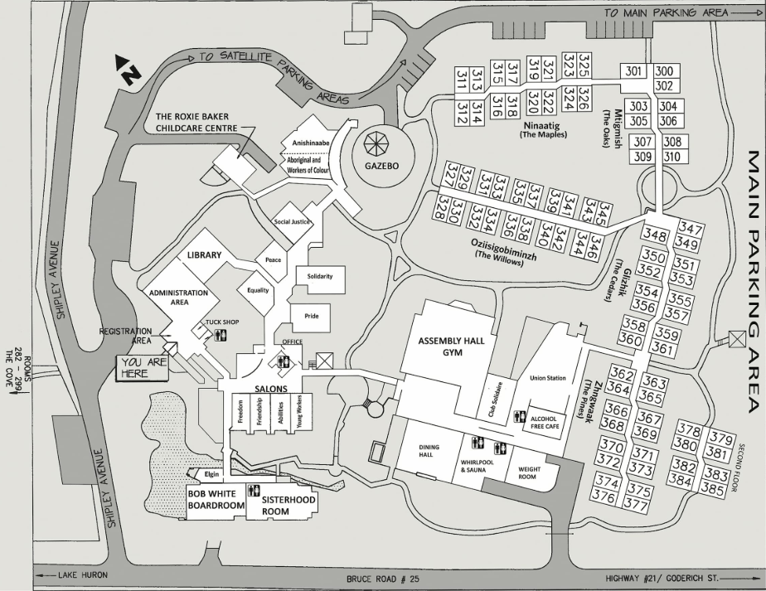
Link to Map: https://www.uniforcentre.ca/centre_map

Section One:

Meeting Agenda

Friday, May 22nd | 1:30 p.m. – 8:30 p.m.
Welcome & Land Acknowledgement
Opening Motions
Introduction of New Staff and Meeting Leadership
Opening Worship & Community Building
including Covenanting Services with New Staff and LLWL
Hearing from the Candidates
Prayer
Theme Speaker-Betty Pries
GCO Time
Dinner
Workshops
Saturday, May 23rd | 9:00 a.m. – 8:30 p.m.
Worship
2SLGBTQIA+ Apology
Break
2SLGBTQIA+ Apology cont’d
Prayer
Presentation of Pride Flags for New Affirming Ministries
Theme Speaker-Betty Pries
Prayer
Lunch
Celebration of Ministry Service – 2:00 p.m.
Dinner
Hearing from President Elect Nominee(s)
TUCC Presentation
Time with Youth
Listening with the Indigenous Church
Prayer
Sunday May 24th | 9:00 a.m. – 12:15 p.m.
Worship
Elections
Towards 2035 Update
Break
Covenanting with Newly Elected Positions
Prayer
Retirees / Jubilands
In Memoriam
Thank Yous
Closing Motions
Lunch to go
Acting President Jennifer Irving’s Message

Welcome to the 2026 Spring Meeting of the Western Ontario Waterways Regional Council: Stop and Listen!
It is such an honour for me to be able to chair this Spring Meeting on behalf of our current President, Reverend Rebekah Duncan, so that she can have the time she needs to stop and listen to her body as she continues to recover, even while her mind and spirit long to be with us.

I pray that this meeting will live up to the vision she had for it and offer each one of us an opportunity to rest from the noise and movement of a busy world so that we might truly listen—to one another and to the Spirit of God in our midst.
As you prepare for this meeting, I would encourage you to put just as much emphasis on the “stop” as you do to the “listen”. So often, we find ourselves caught up in the whirlwind of our daily lives that it becomes almost impossible to tune in and “hear” each other, let alone what the Spirit might be saying to the church. Understandable really since there are church fundraisers to host and worship services to plan and meetings to attend. It’s a lot of go, go, go to keep our communities of faith alive and well. Yet, I’m sure you have all found immense value in taking the time to slow down, just sit, wait a minute for the dust to settle and the spirit to enwrap you.
Recognizing just how hard this first step of ‘stopping’ is, we have set up a quiet space at the UNIFOR Centre separate from the meeting space that we hope you will take advantage of. The beautiful grounds with fish and fountains, trees and pathways also provide a space for decompressing and recentering ourselves. And throughout the meeting—in worship, theme conversation, presentation engagement, workshops, and table group time there is an invitation to cool the heat and slow the pace.
Centered in this way, we can be intentional in deepening our relationships with one another and opening ourselves to really listen deeply to each other, in all our diversity. A kind of listening that goes beyond that which we can hear with our ears. In these quiet centres, miraculously, there is also room for the Spirit of God to guide us.
As we “Stop and Listen” at this WOWRC Spring Meeting, let us pray that our connections within the regional council will be strengthened in ways that support our common ministries and also enable us to go home with a renewed energy and enthusiasm for our individual ministries.
Yours in Service,

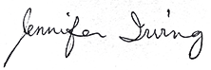
Rev. Jennifer Irving
Acting President, Western Ontario Waterways Regional

President Rebekah Duncan’s Spring Meeting Address
Happy Spring 2026 All you beautiful WOWer’s

Thank you !!!
So right off the bat, THANK YOU to Past President Rev. Jennifer Irving and the rest of the Western Ontario Waterways Regional Council Executive for pulling all the weight for this meeting. For the care and support everyone has offered me through my extended stay in hospital and through my recovery. As I work hard to practice the lessons that inform the theme of this meeting, listening to my body as I continue to heal, I am very sorry to not be with you all this weekend as you do this very important work of listening to one another (and yourselves)

I pray this weekend is a time of joy and rejuvenation, a time of reflection and an opportunity to open up dialogue that continues to strengthen relationships and promote healing. I am very excited by the theme and the work the WOW exec has put into creating what I am certain will be a meaningful weekend.

Sing, Pray, Laugh, Cry, and feel free to express what sits in your heart.

Blessings! Love! Light! Patience!
Rev. Rebekah RMT, M.A., M.Div, OM President of Western Ontario Waterways.

Keep alert, stand firm in your faith, be courageous, be strong.
Let all you do be done in love.
1 Corinthians 16: 13-14

WOW’s 100th Puzzle Project

Hello Western Ontario Regional Council Members and Communities of Faith,

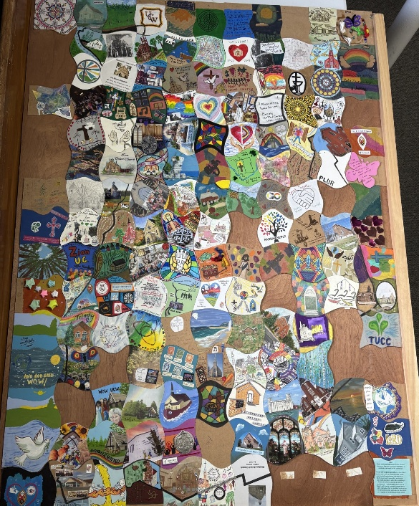
What started out as a part of a brainstorming session in the spring of 2024, prior to the ramp up of our 100th anniversary in June 2025, has finally found completion two years later. I am so very proud of this art installation and the time and effort that has been put in by everyone involved. I could not have imagined how much time and effort it would take on my part to pull it all together. Though somehow fittingly I estimate 100 hours of my time has gone into sending out, collecting, assembling and reassembling and reassembling and finishing blank pieces and trying my very very best to make sure you are all represented here.

Despite our best efforts, one piece is missing, I think this may be fitting as we as a church are a work in progress and are still identifying areas we are missing. If you find yourself or know of a congregation that is not named in the legend know that you can find yourself there, you are our missing piece.

For whatever reason not every community of faith received or sent back a piece. Those are attributed to the “On behalf of:” pieces. Decorated with care, love and faith by children and adults alike eager to help fill in the undecorated pieces.

There is a chance that there will be small changes to the legend between submitting it to the workbook and the final printed copy on display at the meeting. I apologize for that. I have done my best to have it be as accurate and up to date as possible.

Thank you to everyone involved in the distribution, return, decoration, assembly and transportation of this amazing piece of WOW art. I hope it lasts a long time.

Blessings! Love! Light!
Rev. Rebekah Duncan RMT, M.A., M.Div, OM President of Western Ontario Waterways.

Puzzle Legend

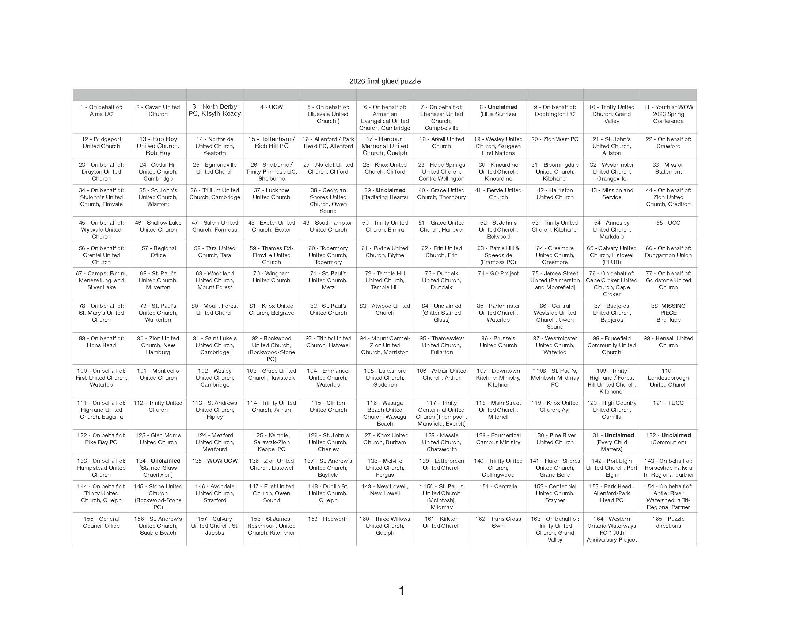

Workshops Descriptions for WOWRC Spring
Time: 7 p.m. on Friday May 22nd, 2026
STOP AND LISTEN: We're More Than a Holding Operation! (It'll make sense in the presentation!) - In Person Only Join Kyle Pugh, the Ontario Regional Councils Archivist, as he talks about The United Church of Canada Archives, its holdings, the services they offer, and how they can help you and your congregation!
STOP AND LISTEN WITHIN: Simple Practices for Spiritual Connection presented by Minister Pastoral Support Laurie Stevenson - In Person Only In the midst of busy lives, learning to "stop and listen" is both a challenge and a gift. This workshop offers an introduction to a range of spiritual practices that invite deeper awareness of self, others and God. Through guided experiences and gentle reflection, participants will be encouraged to notice how the Spirit speaks through body, mind and soul. Come with curiosity and leave with practices you can carry into daily life.
STOP AND LISTEN: To Global Voices – In person or Online In 2025, Revs. Wonder Chimvinga and Aidan Legault travelled to meet with Global Partners of the United Church of Canada. They were sent to listen to the voices of partners, to experience their work, to celebrate with them the key successes of their relationship with the United Church, and to bring their wisdom back to the United Church as our denomination discerns the future of our Global Partnership Program. Join Revs. Wonder and Aidan as they share what they witnessed: Rev. Aidan will recount the story of his participation on a Pilgrimage of Learning to partners in the Philippines, and Rev. Wonder will describe his congregation’s experience meeting partners in Zimbabwe. Zoom link: https://united-church.zoom.us/j/84885117949
STOP AND LISTEN: For Diversity, Equity and Inclusion – Online only How do we set aside our assumptions and instead stop and listen to the voices that have been excluded from the table? How can your community more intentionally engage in Diversity, Equity, and Inclusion (DEI) ministries? Through the support of M&S, a new resource has been developed to share learnings for how to do this work in a good way. Join us for an interactive online conversation and presentation to explore DEI as an expression of our faith.
Zoom link: https://united-church.zoom.us/j/83390473286
STOP AND LISTEN: Faithful Conversations for Amalgamation Discernment – In Person Only This workshop offers a guided introduction to Exploring Amalgamation Faithfully, a resource designed to help congregations slow down, listen deeply, and approach amalgamation as a spiritual and relational journey. Participants will explore practical tools and facilitated exercises that emphasize story-sharing, trust, pastoral care, and discernment before outcomes. Ideal for those supporting congregations navigating uncertainty, change, and shared decision-making.
STOP AND LISTEN: To Creation – In Person Only Are you passionate about the climate? Or someone who supports young people in their climate anxiety and work? Come learn about the Climate Motivator program! The United Church of Canada has identified four pillars to climate response: connecting with creation, raising our spirited voices, responding to climate impact, and getting our house in order. Join past young adult United Church Climate Motivators, Sifa Kanyamuneza and Matthew Tyhurst, as they share about the program and their work in climate action and leave inspired to work toward climate action in your own community.
CHOOSE ONE!
Register for workshops here: WOWRC Spring Workshops 2026 – Fill out form

Kids and Youth

Yay! You are coming to the WOW Spring Meeting
Now what?
Soon we will be gathering at our WOW Regional Gathering in Port Elgin on May 22-24, 2026. Here is an information package for our children and youth program to help you prepare and know what to expect.
Arrival (12:30-1:30PM) **Optional early drop-in**
Our team will happily greet you at our welcome table in the lobby. We will guide you to the “Young Workers” room where you can leave your luggage until checking in later. We can show you the Friendship/Freedom room next door, as well as the main meeting space. This drop-in time is optional to ease your familiarity with our space, team and other participants.
Please eat before you arrive or bring along a lunch to eat in our space.
It is helpful to let us know when you plan on arriving, so we can make sure someone is available to assist you.
Sign In/Out
It is expected that caregivers will sign in each child/youth when they are starting the program each day and sign them out when they will not be returning for the evening.
Reminder that they will be sharing accommodation with their caregiver or as otherwise assigned. They will not be supervised outside of program hours.
No need to come and get them for meals. Meals will be with the adults. We will bring children to you and have you initial our sign in/out sheet. They are welcome to eat with you or us until our next activity begins. We will provide nut and dairy-free snacks during the day for those not bringing their own.
Packing List
What should you bring? We hope to be outside some of the time. So, here’s what we think:
- Pajamas (will be a PJ party both nights for children who stay after dinner)
- Comfort Item (books, stuffy, blanket, fidgets, etc.)
- Shirts, pants, sweatshirts, underwear, socks, etc.
- Face cloth & toiletries (toothbrush, toothpaste, deodorant etc.)
- Weather appropriate coat and comfortable indoor & outdoor footwear
- Sunscreen and hat
- Refillable water bottle
- Personal snacks for breaks/room
- Medicine (as needed)

Meet Our Leaders
A superstar team that has been preparing for months for this moment! It takes a village �
  - Rev. Jen Auger (Master of Counselling, Diaconal Minister)– Minister for Families & Youth at Hope Springs United Church, Elora
  - Sara Dales (Registered Early Childhood Educator) – Leader of Christian Development and Outreach at Georgian Shores United Church, Owen Sound
  - Robyn Runstedler – Children's Ministry Leader for Drayton United Church (oversees the Quack Pack because they are DUC’s), and home childcare provider
  - Sifa Kanyamuneza – Leadership Animator & Past Climate Motivator, GO Project
  - Matthew Tyhurst – Youth Leadership Coordinator & Past Climate Motivator, GO Project
  - Neelah Irving – General Council 45 delegate and first-aid trained lifeguard from Centennial United Church, Stayner
  - Olyndra Irving – Youth leader from Centennial United Church, Stayner
  - Laura Black (Master of Education) – WOW Regional Council Staff, First Third Ministry Faith Formation
*Shout out to Jennifer Irving (WOW RC President), Golda Wilson, and Christine Grose for their significant planning contributions, as well as Max Watkinson and Michele Petick for their super admin support.
Group Covenant for Health, Safety, and Respect
In Western Ontario Waterways Region, we seek to serve by connecting, supporting, and transforming. To prioritize a safer and meaningful experience for everyone involved, we ask all participants to align with the following covenant, informed by Faithful Community: A Duty of Care Approach for Programs.
- Because I want to serve others, I will bring an open and curious attitude. I will come ready to build relationships, help the community, and learn from the people I meet.
- Because I understand my actions affect others, I will follow all local laws, UNIFOR and United Church of Canada policies. This means:
  - I will not bring or use illegal substances, alcohol, cannabis, or tobacco products while participating in the program.
  - I will maintain personal boundaries and follow laws of consent. There are no secrets around touch. I will listen when someone says stop with their words or body.
  - I commit to using electronic devices respectfully (moderate usage – putting them away during program time) to focus on building relationships and limit distractions. I will not take or post content (videos, photos, etc.) about others unless I have their consent.
- Because I value community, I will treat everyone – leaders, staff, other participants, and community members – with kindness, respect, and understanding. I will consider how I am showing up, who hasn’t had an opportunity to contribute, and not repeat personal stories without permission. I honour that people learn, process, and communicate differently.
- Because my well-being and the well-being of others is important, I will follow safety guidelines, stay within designated boundaries in groups of three or more when required, be wise about my choices, and communicate regularly with my leaders.
- Because I know how I treat others and their belongings matters, I will respect the property of others, and the spaces where we gather, work, and stay. I will remember that I represent the wider church community. I will act in a way that reflects care and humility.
Health & Safety Note: First Aid Kit and Lifeguard Trained leaders will be present at the event.
Program
An overview of our evolving weekend schedule – without revealing all the magic.
FRIDAY
12:30 PM – Welcome & Drop In (Main lobby)
1:30 PM – Worship & Community Building (Main Meeting Room with Adults) 3:15 PM – Icebreaker & Group Activities (Young Workers Room)
5:30 PM – Supper (with adults; sign out as needed)
7:00 PM – PJ Movie Night (Young Workers Room); youth could also do games or register for an in-person workshop. See Workshop List below for descriptions.
8:30 PM – Complete sign-out of our care
SATURDAY
9:00 AM – Group Activities including parachute & balloons (Young Workers Room) 10:30 AM – Prep for Sunday Worship & Youth Presentation (Young Workers Room) 12:00 PM – Lunch (with adults; sign out as needed)
2:00 PM – Group Activities including sound wave experiment (Young Workers Room) 5:30 PM – Supper (with adults; sign out as needed for the night)
7:00 PM – PJ Video & Board Games Party (Young Workers Room); or – Youth prep and lead time (Main Meeting Room with Adults)
8:30 PM – Bonfire with Songs & Smores (outside, weather permitting; sign out for night)
SUNDAY
9:00 AM – Worship (Main Meeting Room with Adults)
9:50 AM – Listening to Nature: Walk to the Beach (outside)
*Timing may shift based on weather; we will not be in the water* 11:00 AM – Listening to our Bodies: Kids Yoga (Young Workers Room) 11:30 AM – Closing Circle (Young Workers Room)
12:30 PM – Lunch to go (adults come to room for final sign out)
Friday Workshop List – Optional for Youth & Young Adults
***Select one and register this week***
STOP AND LISTEN: "We're More Than a Holding Operation!" Join Kyle Pugh, the Ontario Regional Councils Archivist, as he talks about The United Church of Canada Archives, its holdings, the services they offer, and how they can help you and your congregation!
STOP AND LISTEN WITHIN: Simple Practices for Spiritual Connection presented by
Minister Pastoral Support Laurie Stevenson. Amid busy lives, learning to "stop and listen" is both a challenge and a gift. This workshop offers an introduction to a range of spiritual practices that invite deeper awareness of self, others and God. Through guided experiences and gentle reflection, participants will be encouraged to notice how the Spirit speaks through body, mind and soul. Come with curiosity and leave with practices you can carry into daily life.
STOP AND LISTEN: TO GLOBAL VOICES – In 2025, Revs. Wonder Chimvinga and Aidan Legault travelled to meet with Global Partners of the United Church of Canada. They were sent to listen to the voices of partners, to experience their work, to celebrate with them the key successes of their relationship with the United Church, and to bring their wisdom back to the United Church as our denomination discerns the future of our Global Partnership Program.
Join Revs. Wonder and Aidan as they share what they witnessed: Rev. Aidan will recount the story of his participation on a Pilgrimage of Learning to partners in the Philippines, and Rev. Wonder will describe his congregation’s experience meeting partners in Zimbabwe
STOP AND LISTEN: Faithful Conversations for Amalgamation Discernment – This workshop offers a guided introduction to Exploring Amalgamation Faithfully, a resource designed to help congregations slow down, listen deeply, and approach amalgamation as a spiritual and relational journey. Participants will explore practical tools and facilitated exercises that emphasize story-sharing, trust, pastoral care, and discernment before outcomes. Ideal for those supporting congregations navigating uncertainty, change, and shared decision-making.
STOP AND LISTEN: TO CREATION – Are you passionate about the climate? Or someone who supports young people in their climate anxiety and work? Come learn about the Climate Motivator program! The United Church of Canada has identified four pillars to climate response: connecting with creation, raising our spirited voices, responding to climate impact, and getting our house in order. Join past young adult United Church Climate Motivators, Sifa Kanyamuneza and Matthew Tyhurst, as they share about the program and their work in climate action and leave inspired to work toward climate action in your own community.
Questions or Concerns
Before Event Contact – Laura Black, Lblack@united-church.ca or 1-226-407-4308
During Event Contact – Jen Auger, Call 519-943-6577 (for immediate response) or email rev.jen@hopespringsunited.ca (to check in at some point)

President-Elect Nomination – Chris Grose
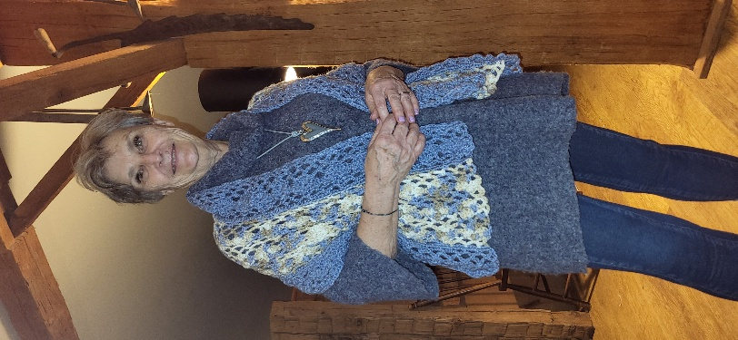
Greetings WOWer's! It is an honour for me to have this opportunity to share a little bit about me, and the gifts that I have been blessed with.
I was born and raised in Elmira, Ontario along with one brother and one sister. I am the oldest, however these days I would like to pretend I am the much younger one! Attending Wesley United and then the amalgamated Trinity United, was a regular activity for our family – not just on Sundays. I was actively involved in Messengers, CGIT, Sunday School, Youth Group, Junior & Senior Choirs. Attending Silver Lake United Church Camp for many years as a camper and then on staff, was a big step in my spiritual development journey. Not to mention the added advantage of meeting and marrying the love of my life! Gord and I have been married now for almost 49 years and have lived all those years just outside of Alma Ontario on a lovely third generation family farm. We are blessed with 4 beautiful boys, their equally beautiful wives and 10 precious grandchildren. Four of those grandkids are now going to Silver Lake Camp – and one as a leader-in-training this summer. Her parents also just happened to meet at Silver Lake United Church Camp!
After we were married, Gord and I attended Alma United Church and remained actively with that community of faith until our amalgamation to Hope Springs United Church in 2022. While at Alma United I shared gifts as a Youth Group Leader, choir member, board member and chair, as well as a Waterloo Presbytery Lay Rep. where I also chaired and co-chaired the Pastoral Relations Committee. I have continued the role of Lay Regional Rep since the amalgamation.
My background in Aquatics and Recreation Leadership were steppingstones to many faith building and sharing opportunities. Some of these are:
- creating my own business offering workshops to primarily not for profit organizations
- facilitator for the Canadian Red Cross Society offering Volunteer Resource Management Workshops across Canada
- short term contract with Hamilton Conference offering Essence Workshops primarily within the Bruce and Wellington Counties
- co-ordinator for "Seasonal Spiritual Stirrings" – day long workshops offered 4 times a year through Alma UC focused on spiritual deepening
- chair of a provincial aquatic association during a time of transition
- chair of Five Oaks Retreat Centre Board during their time of transition
- Artistic Director for Journey to Bethlehem – a shared faith community event which is still being presented every other year in Alma
- Labyrinth Facilitator – was chair of a committee that oversaw the creation of a 12-circuit labyrinth at Wallace Cumming Park in Alma
- Spiritual Director – through Jubilee
- UCC Licensed Lay Worship Leader
- chair of the Amalgamation Committee for Hope Springs United Church
I am so thankful for all the leadership opportunities that I have been called and invited into. There was a time when I would jump into every invite that came my way. I have however learned to "Stop and Listen" – take time for prayerful discernment. I also pray for guidance on where God is calling me to share my gifts. It was after one such prayer that an email came my way wondering if I would give President Elect of WOW prayerful consideration. And so my prayers continue...I love how the Spirit works!
Chistine Grose

Volunteer Recruitment Report

Origin: Volunteer Recruitment Team
Western Ontario Waterways Regional Council Volunteer Recruitment Report
The Volunteer Recruitment Team prepares a slate of volunteers for the Spring Meeting of WOWRC and continues to put forward names of volunteers to serve throughout the year.
The Executive appointed the following volunteers:
- Liz Dillman to the Executive
- Nancy Flagel to the Congregational Support Commission
- Barbara Schoch to assist the Congregational Support Commission with reading Annual Reports
- Jan Howitt to the Discipleship and Justice Commission
- Extended the term of Andrew Hyde on the Discipleship and Justice Commission until September 1, 2025, when Kate Ballagh-Steeper became chair
- Nancy Flagel and Amber Culley to the Student and Candidate Support Network
Thank you to the volunteers who agreed to continue for a second term.
- Beth Kerr on the Executive
- Roz Vincent-Haven on the Congregational Support Commission
- Linda Peacock on the Discipleship and Justice Commission
- Harry Disher and Carol Stephenson on the Pastoral Relations Commission
We give thanks for the work of those who competed their term or stepped down from their position
- Jennifer Irving – Past President and Brent Caslick – Treasurer,
Heather Leffler and Terry Smith from the Executive
- Peter Kudelka from the Congregation Support Commission
- Kate Ballagh-Steeper and Ayla Mackie from the Discipleship and Justice
- Cathy Larmond, Cait Stewart and Jane Sullivan from the Pastoral Relations Commission

Thank you to all the volunteers who help us connect, support and transform communities of faith in WOWRC.
Regional Council members are invited to discern where they might serve. Expressions of interest will be accepted for vacancies until Friday, May 22 at 7 pm. The Committee will discern with volunteers and present a slate to WOWRC on Saturday, May 23.

Western Ontario Waterways Regional Council
Connecting, Supporting, Transforming
Executive, Commissions, Committees and Networks 2025-26
Executive
President – Rebekah Duncan OM ⁽²⁸⁾  Vice/Past – Jennifer Irving OM ⁽²⁶⁾  Secretary – Dawn Blanchard L ⁽²⁷⁾  Treasurer – Brent Caslick ^{(26) 2nd}  Executive Minister – Mark Laird | Indigenous – Brian George L ⁽²⁸⁾  Diversity – Beth Kerr DM ⁽²⁶⁾  Racialized ____________________  Youth/YA ____________________  Members at Large (4)  Heather Leffler OM ^{(26) 2nd}  Terry Smith L ^{(26) 2nd} | Robert Lawson OM ⁽²⁸⁾  Liz Dillman L ⁽²⁸⁾  Commission Representatives (3)  CSC – Roz Vincent-Haven  DJC – Andrew Hyde/  Kate Ballagh-Steeper/Kristal McGee  PRC – Cathy Larmond
Note: Commissions require a minimum of seven members and can have a maximum of 12 members, at least one-third of which are ministry personnel and one-third are lay.
Congregational Support Commission
Chair– Roz Vincent-Haven DM ⁽²⁶⁾  Peter Kudelka ⁽²⁶⁾  Bruce Gregersen OM ^{(27) 2nd}  Margaret Krauter ^{(27) 2nd} | Peter Kupfer L ⁽²⁷⁾  Sharon Norton L ⁽²⁷⁾  Colin Snyder OM ⁽²⁷⁾  Gord Dunbar OM ⁽²⁸⁾ | Margaret Ruggles DM ⁽²⁸⁾  Nancy Flagel L ⁽²⁹⁾  ____________________  ____________________
Discipleship and Justice Commission
Chair - *Kate Ballagh-Steeper OM⁽²⁷⁾/ Kristal McGee OM ⁽²⁷⁾  Linda Peacock L ⁽²⁶⁾  John Adeyemi OM ⁽²⁷⁾ | Diane Dick L ⁽²⁷⁾  *Ayla Mackie L ⁽²⁷⁾  Meghan Gilholm L ⁽²⁸⁾  Judy Jones L ⁽²⁸⁾ | Dan Leaver DM ⁽²⁸⁾  Jan Howlett L ⁽²⁸⁾  ____________________  ____________________
Pastoral Relations Commission
Chair – David Shearman OM ^{(28) 2nd}  Harry Disher OM ⁽²⁶⁾  Cathy Larmond OM ^{(26) 2nd}  Carol Stephenson L ⁽²⁶⁾ | *Jane Sullivan OM ^{(26) 2nd}  Lena Medeiros OM ⁽²⁷⁾  James Montgomery L ⁽²⁷⁾  Lori Campbell OM ⁽²⁸⁾ | John Greg Smith OM ⁽²⁸⁾  *Cait Stewart L ⁽²⁸⁾  ____________________ ⁽²⁹⁾  ____________________ ⁽²⁹⁾
Student and Candidate Support Network
S/C DM – Lisa Leffler ⁽²⁸⁾  S/C OM ____________________ ⁽²⁹⁾  OM –Robert Lawson ⁽²⁸⁾  DM – ____________________ ⁽²⁹⁾ | Lay Person – Nancy Flagel L ⁽²⁹⁾  Members at Large (5)  Gord Dunbar OM ⁽²⁸⁾  Rebekah Duncan OM ⁽²⁸⁾ | Amber Culley (L) ⁽²⁹⁾  ____________________  ____________________
Volunteer Recruitment Committee
President – Rebekah Duncan OM | Past President – Jennifer Irving OM | Heather Leffler OM
Presbyteries of Toronto Conference Corporation (PTCC)
Director – Peter Kupfer L ⁽²⁷⁾  Director – Brent Caslick L ⁽²⁸⁾ | Member – James Montgomery L ⁽²⁸⁾  Member – Betty Morrison L ⁽²⁸⁾
Toronto United Church Council (TUCC)
Director – David Shearman OM ⁽²⁶⁾ | Member – John Fraser L ⁽²⁶⁾ | Member – Michael Torrie L ⁽²⁶⁾
*stepped down

Celebrants:

Rohan Pushparajan
Admitted to Ordained Ministry from the Church of South India

Sonja van de Hoef
Ordained Ministry of The United Church of Canada

Brenda Torrie
Admitted to Ordained Ministry from the United Methodist Church

Celebration of Ministry Service attendance will be in-person at Unifor Centre and livestreamed on YouTube at this link on Saturday May 23rd at 2pm:
https://youtube.com/live/W0OjOZOpD3c?feature=share

LLWL Recognition:
Nancy Flagel
Dundalk United Church


Retirees
Sandra McLauchlan-Abuja, OM
Westminster UC, Orangeville
September 30, 2024

Bill Bruce, OM
Annan-Woodfield P.C.
August 1, 2025

Thomas Dunbar, OM
Mitchell: Main Street P.C.
September 1, 2025

Jane Sullivan, OM
Creemore-New Lowell P.C.
December 31, 2025

Andrew "Drew" Maxwell, OM
St. Jacob’s: Calvary Evangelical P.C.
February 1, 2026

Cheryl-Ann Stadelbauer-Sampa
Senior Governance Support Lead, The United Church of Canada
May 31, 2026

Dave Jagger, OM
Community of Faith Stewardship Lead
General Council Philanthropy Unit, The United Church of Canada
June 30, 2026

Heather Leffler, OM
Rockwood-Stone P.C.
June 30, 2026

Leaving Us
Tanya Cameron
Office of Vocation, The United Church of Canada
June 30, 2026

Retiree Message: Sandra McLauchlan-Abuja

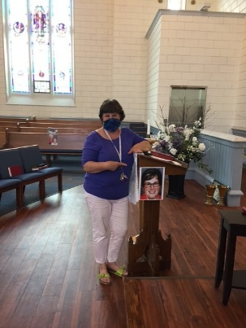
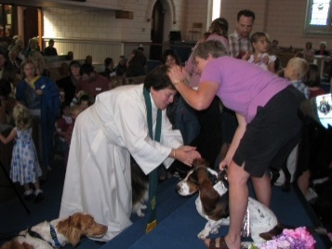
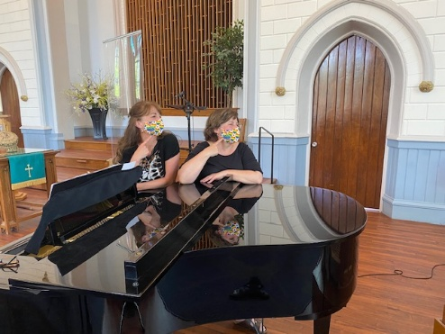
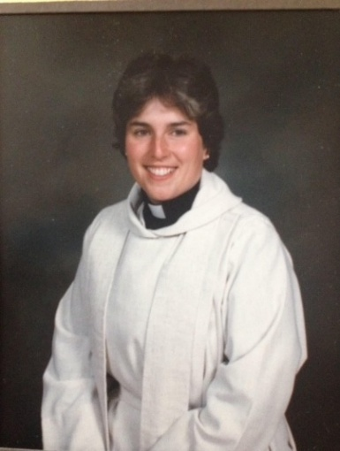
Sandra McLauchlan-Abuja began to ponder ministry when she attended the First General Council Youth Forum in Calgary in 1977. She attended Carleton University and McGill University then was ordained by the Montreal-Ottawa Conference on May 31,1983. Due to the number of ordinands that year, the service was held at the Roman Catholic Cathedrale St. Michel with the resident priest receiving the sacrament from a woman clergy. It was an ecumenical stop, listen and respond moment as the bells peeled. Sandra served student fields at Dominion Chalmers, Ottawa, Ontario; Grand Forks-Christina Lake, British Columbia and final year placement at St. Columba House, Montreal, Quebec. Sandra’s settlement charge was the Little Current-Sheguiandah-Green Bay Pastoral Charge on Manitoulin Island. She then attended the University of Toronto to study Marriage and Family therapy to enhance her pastoral care skills. Then on to Mayfield United Church in Caledon, Ontario and Westminster United in Orangeville, Ontario where theological students were placed for honing their skills to complete their training.

Having been born and raised in the beautiful Eastern Townships of Quebec she was raised in a family that valued the gift of Creator’s work by taking time to stop and listen to the whispers and groans of Mother Earth and our relationship to her. She gives thanks to her family, teachers, mentors, neighbours of other faiths on the road for 41 years of ministry. Sandra retired October 1, 2024.
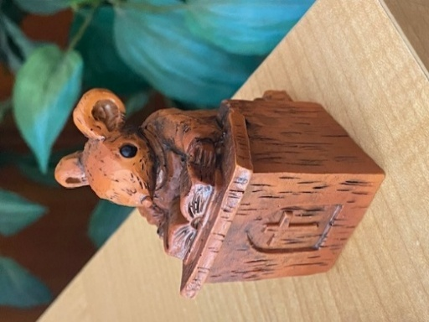
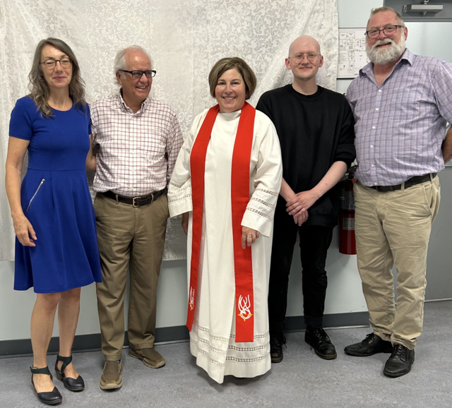
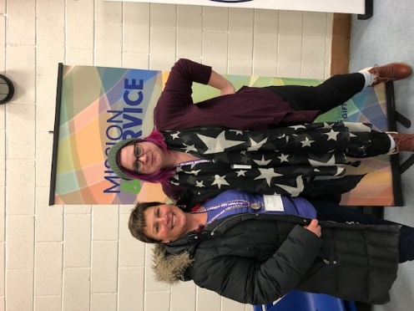

Retiree Message: Bill Bruce

Called in my baptism for over 70 years, confirmed for over 55, session elder till 50 years ago, candidate from 1979, on rolls of 5 Conferences, then 3 Regions, I served 17 pastorates by settlement, call, or appointment, shared ministry and exchanges with 5 other denominations, a national staff bit, and retained through interrupted or bi-vocational lawyer stretches. My part in the church’s ministry did not begin upon ordination in 1983, nor does it end now.

Grateful to those who invited and welcomed me into a wide variety of ministries, aware that my opportunities were more privileged than their own, I wonder at the opportunity costs: who or what did I displace? Our generation’s experiments, in this glib liberal denomination, on the margins of the one holy, catholic and apostolic church, correlate with tragic losses and unholy alliances. It wasn’t all my fault, but I am accountable for my errors.

Duties are owed by all of us, of sabbath, tithing, gleaning, confession of sin and of faith, witness to ‘celebrate God’s presence, live with respect in creation, seek justice and resist evil, proclaim Jesus, crucified and risen, our judge and our hope’. To worship, learn, serve in retirement, I may resist the transactional market of fee-for-service lemming-herding occupied by most peers. This jubilee year of transition has already provoked me to stop and listen.

For more detailed annotations of those ministries, that gratitude, those remaining duties, see: www.billbrucewords.com , or www.hereticslikeus.com .
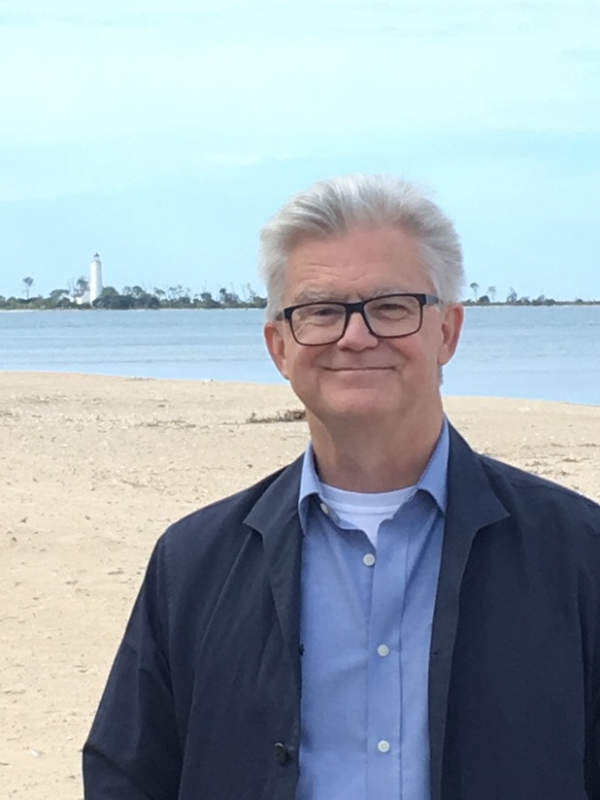

Retiree Message: Thomas Dunbar

Rev.Thomas Dunbar BSc M.Div CBT

On hearing the voice of God.

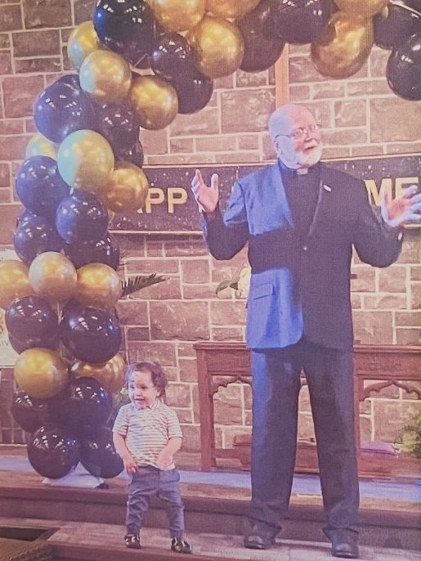
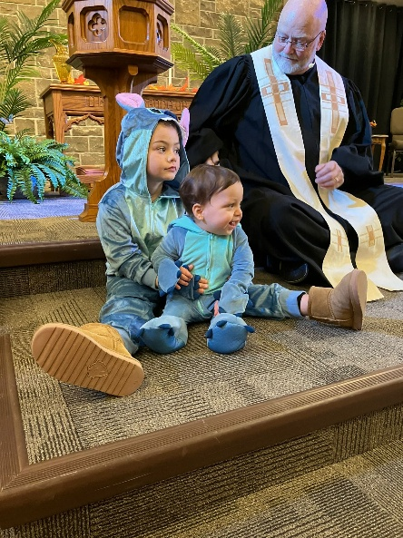
Nope. Never happened. Always wondered about. Even in the days of my previous career as wildlife biologist doing oil spill response around the world I wondered. I put it down to being too busy so was always a bit envious of those who could make that claim. Only after decades of working in the field of disaster management did the realization come that God wasn't so much heard as seen in the dedicated people including hundreds of volunteers who gave up their daily lives to help in any way they could. God is not found the cause but in the response. This was truly humbling to witness. That realization brought me into formal ministry and continued in the various congregations I served. The disaster management experience turned out to be a rather transferable skill as my student charge was destroyed in the tornado in Goderich. The second point in that charge was then voluntarily demolished. As if that wasn't enough, during my first year in the charge I would spend the next 13 years in, we received the structural engineers report stating, "Complete catastrophic failure of the building is imminent ". Three church buildings destroyed in one ministry could make one a tad paranoid if not for the final case where a new church building was constructed. Final record 3:1 Throughout all of that never a peep from God but I have no doubt God was actively at work through every person connected to those churches. Once again, it was humbling. Still no voice but it has become easier to see God at work in this world. For that joy, throughout all the trials of ministry, I will be forever grateful.

Tom
Retiree Message: Jane Sullivan

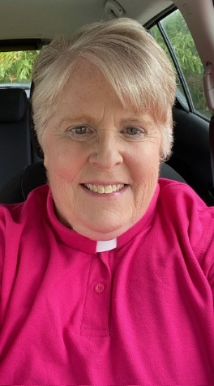
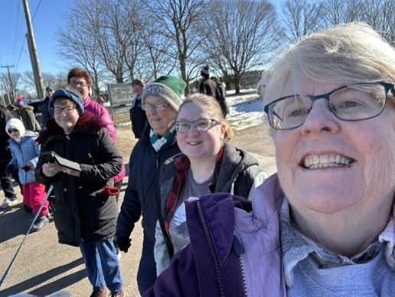
In Toronto Conference, ever so many years ago, retirees were asked to pick the hymn that spoke most completely to their ministry, and I always thought I would have to say “all of them!” Hymnody emerges to reflect and direct the faithful in their lives of faith. Every hymn that we sing, including those which have become dated, has some echo or reflection of all of us, some aspect or era of our ministries. Over nearly 40 years of ministry, I have passed through many waves in church life. In each context, both generational and geographical, God comes to the faithful in recognizable ways. Hymns both reflect the faith of their authors, and direct the faithful to God’s presence in our lives. Fine-tuning happens, both of our hymn use and in its impact on us. So, for nearly 40 years, I learned to listen for the new notes, and fine-tune as necessary.
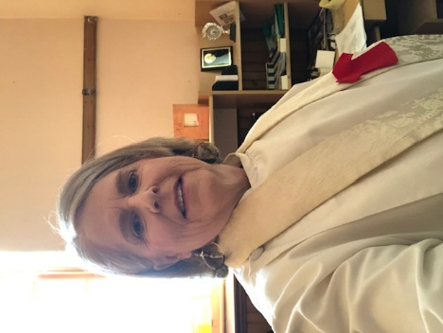
It is a privileged life, this life of the religious leader. Not only are we gifted with the intimate lives of our people, caring for them when they really need us. We are given a community of inspiration and hope in the church at large. We are thrown into unlikely connections that can be truly strengthening. I have been the press attaché of the Archbishop of Canterbury’s trip to Quebec City, have stood shoulder to shoulder with Indigenous people to perform a special baptism at the Dr. Jessie Saulteaux Centre in Beausejour, Manitoba. I have stood in the presence of the United Church’s first apology, in Sudbury in 1986, marched with thousands across the bridge in Ottawa at the conclusion of the Truth and Reconciliation Commission. I have sat in the holy moment of death with congregants and stood in misery at the realizations produced by the Blanket Exercise.

There is no shorthand for the life of an ordained minister. But maybe if you sing all the hymns…
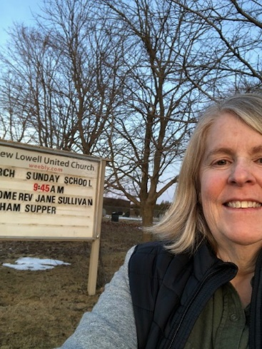
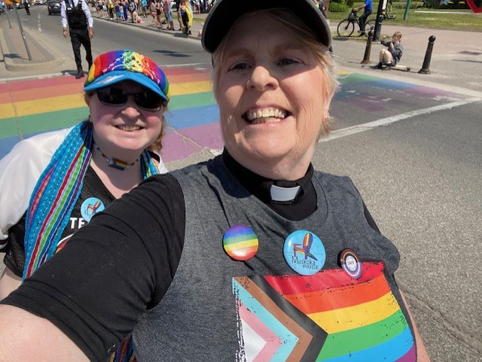
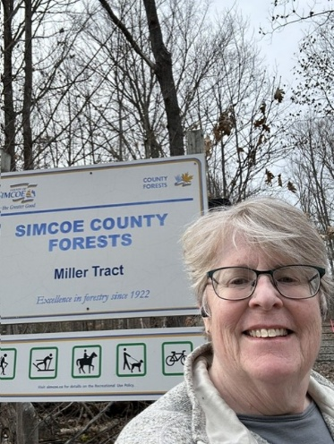

Retiree Message: Drew Maxwell
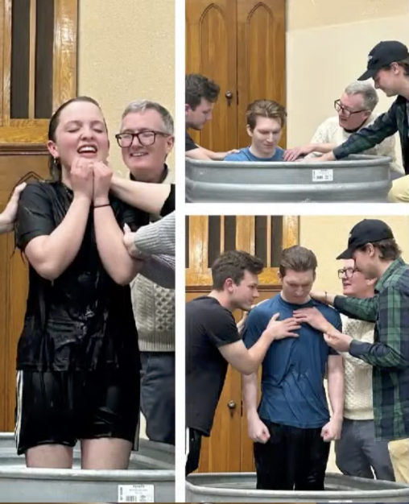
“And maybe someone here is feeling called to the ministry” my minister said one morning. As if Jesus himself was speaking, I felt stopped, hunted and trapped – by God. I love Jesus. But, as a kid, church and encountering God didn’t necessarily go together for me. There were moments: Mrs. Wilkie’s love for Jesus shone through her flannelgraph bible stories. Moments in worship and once during a reading of Isaiah 6, I sensed he was real. But, it was outside of church that I met him: camp, youth group, and people who taught me to pray and listen to Jesus. So why would Jesus want me to go into the congregational ministry?

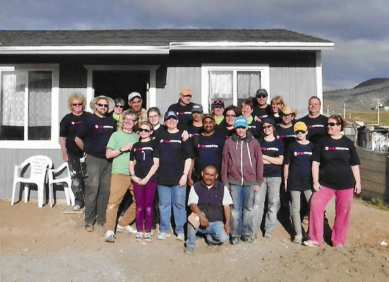
30 (and more) years of ministry later, I can still say “it’s not about services or programs, but whatever helps people meet and know Jesus. Amazing though they often were, contemporary services, events, camp or small groups, even mission trips were never the goal. But, through them, one person at a time met Jesus and discovered he loves them and wants to walk with them through their lives. What a privilege I’ve had to work with teams of people, helping broken hearted receive prayer and discover Jesus is near, comforting healing and restoring. We saw adults declaring their trust in Jesus and being baptized in lakes and pools and cattle troughs. (Pic 1) We gathered for nights of worship seeing the Holy Spirit move. And gathered for over a decade in early mornings week after week to pray and listen for God’s heart. (Pic 2). We’ve seen people take courageous risks to step out, use their gifts, see God meet others through what they had to offer. Mission trips, sharing about Jesus on downtown streets and Sunday mornings. I most treasure how much I’ve got to witness people’s depth, gifts and confidence grow. (Pic 3). To think – just like the disciples, we have had the privilege of seeing Jesus meet others through us!

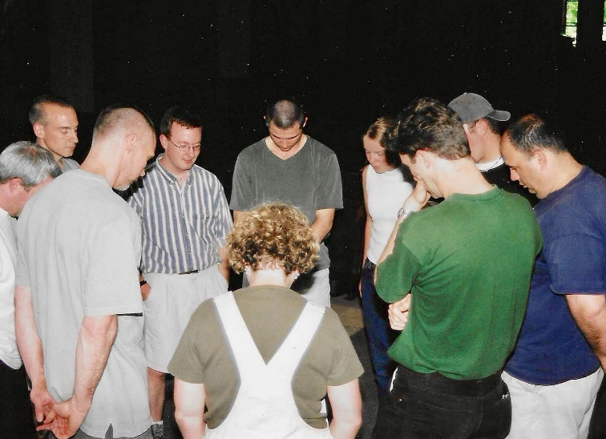
So, I’m grateful for the people who helped me learn to pray and worship, read scripture to find words to talk with Jesus and understand him more. For the Hamilton conference camps, youth events alumni, the Calvary and wellington square and Dublin congregations and leaders and the innumerable individuals: thank you for learning hear Jesus’ voice and walk with him. You’ve changed so many lives, including mine. I’m so grateful for my wife and family and the incredible patience, love and grace they’ve offered as we’ve ministered together. And I’m grateful Jesus stopped me in my tracks and called me all those years ago.

Retiree Message: Cheryl-Ann Stadelbauer Sampa

"Listen” was the word that caught my attention when Acting President Jennifer invited me to write a few lines about my experience in ministry reflecting on the meeting theme. The past few weeks have been filled with recollections that, with Jennifer's note, sorted themselves around the word "listen".

I am so grateful that I listened as a young adult when I heard a call to ministry at a Festival of Faith. I am also grateful that I listened when the church offered its first overseas internships. That experience shaped my understanding of church and introduced me to my husband, James. I appreciate how carefully the church listened when it settled me with Egmondville United Church, a community that welcomed our family and taught me how to be a minister. I wish I had trusted the whisper I heard as the guest preacher at the former Central United Church in Stratford that hinted "some day". I'm relieved that fourteen years later I listened to James who encouraged me to submit my application there when I was wondering why I should bother since the pastoral relations process was not working for me. It was also James who encouraged me to listen to the church when I was asked to let my name stand for President of London Conference. If I had not served as President, I doubt I would have listened to the call I heard to the ministry of administration which allowed me to help celebrate the church’s first century and be part of the plan for its next.

Recently, at an event with staff from across the denomination, I listened from the back of the room. I listened to colleagues who love the church, who have energy and insight and who are focused on helping the church move Toward 2035. What I heard makes it easy to leave as I started—with a sense of purpose and a heart filled with hope.
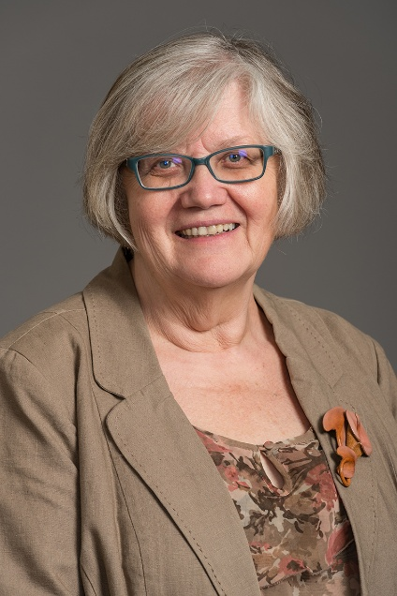

Retiree Message: Dave Jagger

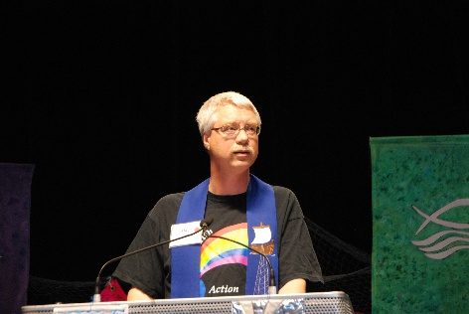
1990, the year of my Ordination by Hamilton Conference, feels like 200 years and a world ago. However, the importance of taking time to stop and listen for God’s recurring call and the willingness to act upon it has been constant throughout my ministry. You must do both parts.
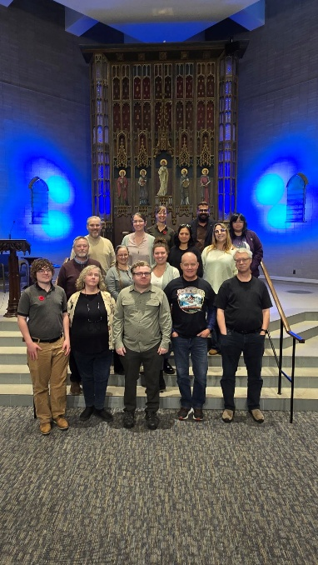
In the days of settlement, when we showed our commitment to serving the Church by physically picking up and moving across the country, God’s call led my young family to Northwestern Alberta for 3 years.

A lesson for ministry learned on the Edson Trail Pastoral Charge? Being in leadership is like riding a donkey. When you are riding a donkey, you need to take a big stick with you. Every now and then you jam the stick in the ground beside you. As long as the stick is going backwards, you’re doing OK. Stop and listen, or in this case, stop and watch the stick.

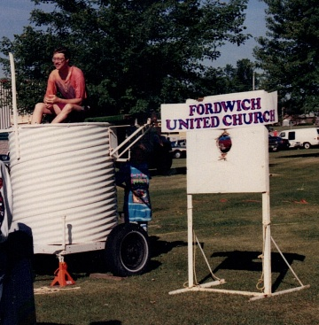
During a bout with cancer while in Alberta God gave me these words of grace. “The rules of the game have not changed, only the playing field”. So, as long as you know what the rules of the game are then the question is simply, “How do you do them in this situation?”.

For me those rules are twofold: Love God with everything you are and everything you have. Love your neighbor as you love yourself.

That statement has guided the rest of my ministry years:
Fordwich Pastoral Charge (9 years)
Trinity, Elmira Pastoral Charge (14 years)
General Council Stewardship work. (10 years)

I think right now those are the questions before each community of faith, each regional council, and our denomination as a whole. That is what we stop and listen to discern. What are the rules of the game? Why do we exist? How are we going to live those in the places God has planted us? And then we watch the stick to make sure we are moving forward.
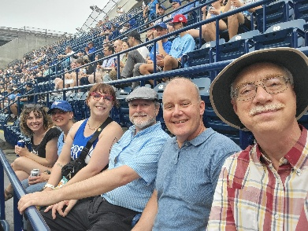
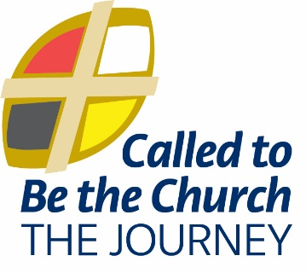
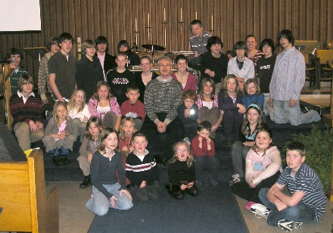

Retiree Message: Heather Leffler
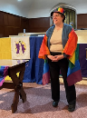
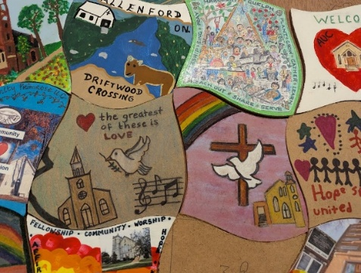
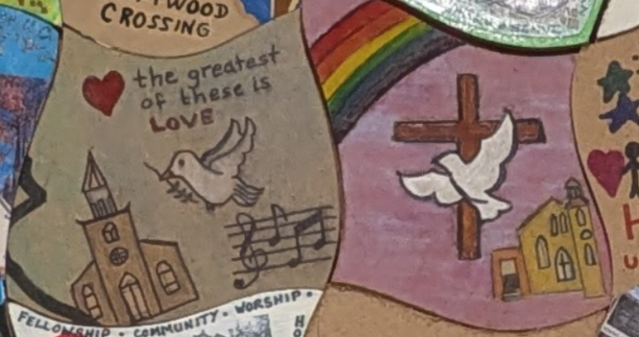
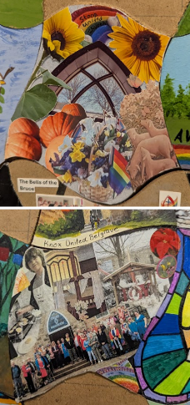
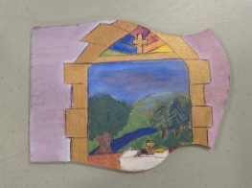
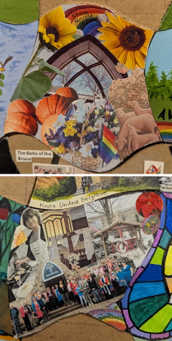
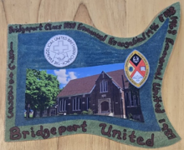
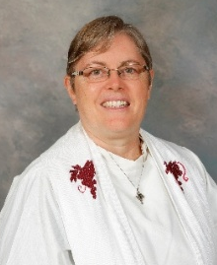
Throughout my life, the One who is Holy Mystery and Wholly Love, has sent people to invite me to stop and listen.
Life with my husband John and three daughters – Sarah, Helen and Lisa, – was full: volunteering at Bridgeport United, participating in Guided Prayer, supply teaching, teaching at Conestoga College and being active in Scouting in Bridgeport and North Waterloo. Then at a Hamilton Conference meeting, Rev. Wayne nominated me to be a commissioner at General Council in Fergus in 1994. Where could I possibly find the time?
Elected as an alternate commissioner, I attended GC94. Through conversations with ministers and lay people, friends and people I had just met I began to hear a call to ministry. John and my minister encouraged me to begin my discernment. Attending Emmanuel College felt like coming home.
Gord, a family friend, and I reconnected there and journeyed together through school and ministry. Our support group changed over the years – Jeff and Meg, Maggie, Dave and Peter. Along with my spiritual director Barbara, they helped me stop and listen to where the Spirit was calling me.
Rev. Hugh and the folk at Ryerson, now Faith United, in Hamilton nurtured me in ministry. Rev. Bruce, Flora and members of the Guided Prayer Network through the years, the Spirituality Committee at Hamilton Conference, Mary-Edith, Pastor Jim and all those who joined in Sacred Circle dancing and Healing Prayer services at Trinity United Kitchener and Bridgeport nurtured my spirit. Sister Colleen during my CPE experience and Sister Anne from St. Michael’s College, who gave me the opportunity to study in Israel, stretched my boundaries. Again and again, the Spirit invited me to stop what I was doing, listen and open myself to new experiences that would enrich my ministry.
Ordained in 1999 I served with Knox Clifford and Alsfeldt United Churches until 2012, reconnecting with my Evangelical United Brethren Roots. Since then, serving with the folk at Rockwood and Stone United Churches, ministry has been filled with opportunities to stop, discern and listen for ways to serve God faithfully – through Kids Worship and Faith, Food, Friendship and Fun, Circle Worship and Discernment Circles, reconciliation work with Cape Crocker and Anishnabeg Outreach, and becoming the first affirming Pastoral Charge.
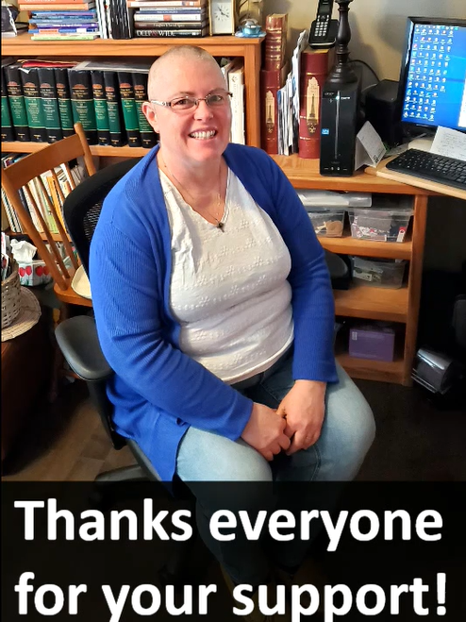
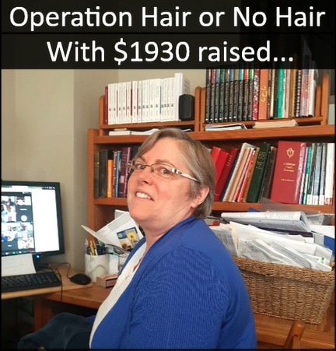
Covid, especially, became was a time to stop, listen and change direction. Out of that season came online and hybrid worship and meetings, conversation in worship each Sunday, weekly Contemplation and Conversation emails, seasonal congregation care packages and even an online haircut fundraiser in support of our churches.
Through the Lowville Prayer Centre, Bruce and Waterloo Presbyteries, Hamilton Conference, the Transition Team, Western Ontario Waterways Regional Council and Executive, Arnprior, General Council, and General Councils in Wolfville, Thunder Bay, Kelowna, Corner Brook and Oshawa, there have been countless opportunities to stop, listen, learn and grow with the amazing people who make up our United Church.
I am deeply grateful to have been nurtured and called to leadership in a church committed to deep spirituality, bold discipleship and daring justice. I look forward to having more time to stop and listen in retirement and continue to serve alongside you in new ways.
With thanks and blessings,
Rev. Heather Leffler

Order of Ministry Jubilands
5 Years
Young Seo, OM – admitted from the Presbyterian Church in the Republic of Korea
Gavin Williams, OM
10 Years
Deborah Boukydis-Grant, OM
Miriam Flynn, OM
Kathryn Underwood, OM
15 Years
Kevin Hart, DLM
Helena Medeiros, OM
Sandra Morris
20 Years
Stephen Hildebrand
Bonnie Holiday, OM
Allison Playfair, OM
25 Years
Peter Hartmans, OM – admitted from the Reformed Church in the US
Jennifer Irving, OM
30 Years
Kyle Benger, OM
J. Scott Boughner, OM
Paul Gliroy, OM
Willem Kreeft, OM
Greg Smith-Young, OM
Peter (Jock) Tolmay, OM – ordained June 1984 by Indiana Michigan Conference, Mennonite Church
Philip Ziegler, OM
35 Years
Craig Donnelly, OM
Jack Fearnall, OM
Ralph Schmidt, OM – admitted 1981 from Evangelical Lutheran Church of Canada
Jeffery Werner, OM
Brenda Woodall, OM
40 Years
Katharine Edmonstone, DM
Edward Laksmanis, OM
John Lawson, OM
Sally Longfellow – admitted 1986 from United Church of Christ, ordained in 1981, OM

40 Years
Hugh McDonald, OM
Janet McDonald, OM
Roy Nicol-Macdonald, OM
Judith Springett, OM
45 Years
James Ball, OM
B. Paul Ellingham, OM
F. Curtis Marwood, OM
William McAuslan, OM
George Russell, OM
50 Years
Bruce Gregersen, OM
Robert McMullen, OM
Robert Nightingale, OM
55 Years
Bryan Lapier, OM
Gordon Williams, OM
60 Years
Douglas Kaufman, OM
Sylvia Bell, DM
Jubilands – 60+ Years
David Burns, OM – 62 Years
John Getridge, OM – 62 Years
Kenneth Meyers, OM – 62 Years
John Griffin, OM – 63 Years
Donald Johns, OM – 63 Years
Charles Beaton, OM – 64 Years
Joan Gugeler, DM – 67 Years
Morley Hammond, OM – 67 Years
Paul Webb, OM – 67 Years
70+ Years
Bruce Seebach, OM – admitted in 1968 from Evangelical United Brethren Church – 70 Years
Calvin Evans, OM – 71 Years
75 Years
Hugh Rose, OM
R. Cerwyn Davies, OM – ordained in 1951 by Church of England, in UCC since 1964

LLWL Jubilands
5 years
Norm Eygenraam, Mount Forest UC
Phyllis Fleming, Grace UC Thornbury
10 years
Angie Lannin, Atwood UC
Trish MacGregor, Egmondville UC
Kate Monk, Thamesview UC Fullerton
25 years
Penny Squirrell, Badjeros UC
In Memoriam
Rev. Jeff Learmonth
Carol Solomon
Ross Mckinnell
The Very Rev. Dr. N. Bruce McLeod
Rev. Alun Thomas
Rev. Lorne O’Neill
Rev. Hendrik (Henk) Dykman

Community of Faith Life Cycle Changes:

Disbandments
12/11/2025 – Kitchener: Bridgeport Pastoral Charge

Amalgamations
12/11/2025 – Exeter Pastoral Charge + Hensall Pastoral Charge

Collaborations
10/9/2025 – Listowel: Trinity Pastoral Charge + Atwood Pastoral Charge
2/12/2026 – Southampton-Mount Hope Pastoral Charge + Hepworth-Sauble Beach Pastoral Charge

Special Acknowledgement
Christian Resource Centre, Mitchell
Ceased operations Jan 8, 2026
50 years of service

New Affirming Ministries
Trinity United Church, Guelph
Trinity United Church, Annan
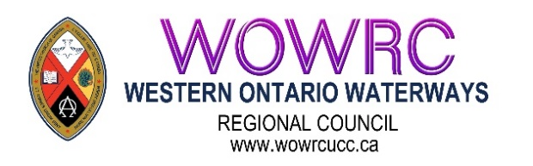
Section Two
Meeting Materials

Proposal #1 – Opening and Procedural Motion
Title: Opening and Procedural Motion
Origin: Executive Minister

What is the issue?
The regional council must establish the procedures by which it will conduct business.

Why is this issue important?
This clarifies and confirms the way in which decision-making will happen.

How might the regional council respond to the issue?
The regional council might adopt the following as a consent docket:
- Adopt the agenda as circulated and authorize the Agenda and Business Committee to make any changes as necessary;
- Approve the minutes of the meeting of 2025-11-07/08;
- Receive the minutes of the following meetings of the
  - Executive
25-10-15
25-11-19
20-01-21
26-03-18
- Congregational Support Commission
25-10-09
25-11-13
25-12-11
26-01-08
26-02-12
- Pastoral Relations Commission
25-09-16
25-10-21
25-11-25
26-02-17
26-03-17
- Discipleship and Justice Commission
25-09-23
25-10-21
25-11-25
26-01-27
Note: Minutes are posted on the website www.wowrcucc.ca “About” page
- Appoint Gary Clark as Parliamentarian;
- Appoint Terry Smith as Chair, Agenda and Business Committee;
- Name Phyllis Fleming and Linda Roberts to serve as Equity Support Team Members;
- Name Mary Elizabeth Piercy, Keith Reynolds and Laurie Stevenson as Chaplains;
- Name Acting President Jennifer Irving (Past-President), Chair Agenda and Business Committee Terry Smith, Executive Minister Mark Laird, Executive Assistant Max Watkinson and Recording Secretary Dawn Blanchard, Parliamentarian Gary Clark as the Agenda and Business Committee;
- Set the bounds of the meeting as the Unifor Family Education Centre, 115 Shipley Avenue, Port Elgin, ON, N0H 2C5, and the Zoom call
- Make the designated representative from any United Church ministry, other than a congregation, which has been invited to become a community of faith by entering into a covenant with the regional council, a member of the regional council for this meeting (Section C.1.2 c);
- Make all guests corresponding members;
- Set the deadline for new business to be submitted to the Agenda and Business Committee as 9:00 a.m., Saturday, May 23rd, 2026
- Adopt the following method for dealing with proposals for action by the regional council:
Step One:
The Presenter will outline:
- What is the issue? and
- The suggested way in which the regional council might respond to the issue.
Step Two:
The President will inquire if there are questions for clarification.
Please note this is for clarification only.
Step Three:
The President will then ask if there are changes or additions being suggested for the proposal. Using warm and cool signals, the regional council will seek to come closer to agreement on how to respond to the issue.
Step Four:
Once there is significant agreement, the President will invite the Presenter to move the motion at which point the regional council enters the formal debate process.

Proposal #2 - Change to 2025 WOWRC Spring Meeting Minutes
Title: Change to 2025 WOWRC Spring Meeting Minutes
Originating Body: Executive Minister & Recruitment Team

What is the issue?
The minutes of the Regional Council meetings are our record of decisions made and discussions had. At the Spring 2025 meeting during the proposal to elect new representatives to the Commissions and Executive more time was requested for those at the meeting to add their names to the slate. The minutes of that meeting were approved at the Fall 2025 WOWRC meeting without that slate of people included.

Why is this issue important?
We want to have an accurate representation of what was done at the meeting, and who has been elected to different positions.

What might Western Ontario Waterways Regional Council do?
The Regional Council might agree to the following:
The Western Ontario Waterways Regional Council update the Spring 2025 Regional Council minutes to include the following information and slate of people who were elected at the 2025 Spring meeting:
Information
WOWRC Recruitment Team of Rebekah Duncan, Jennifer Irving and Heather Leffler would like to thank all our faithful volunteers and staff of WOWRC and especially those who put their names forward to serve on our Executive, Commissions, as Pastoral Charge Supervisors and Liaisons and members of our new Student and Candidate Support Network. When it came time to discern the slate of volunteers for this meeting, we invited Gord Dunbar, OM and Ann Harbridge, OM to help in discernment of this proposed slate for 2025-2026.
On behalf of the Recruitment Team, thank you to those completing terms or resigning:
From the Executive: Andrea Allan, OM
From the Congregational Support Commission:
Rebekah Duncan, OM (stepping into role as President),
Norm Eygenraam, L (25) 2nd Term
Lesley Fox, OM (retired)
Ann Harbridge, OM (25) 2nd Term
Judy Chalmers, L (25) 2nd Term
From the Discipleship & Justice Commission:
Edith Coyle, L (26) 2nd Term
Cathy Hird, OM (moved)
Andrew Hyde (25), OM 1st Term
From the Pastoral Relations Commission: Douglas Hayward, L

Executive/Commissions/Networks Slate
Executive: Robert Lawson, OM (28) Member at Large/Diversity
Congregational Support Commission: Gord Dunbar, OM (28), Margaret Ruggles, DM (28)
Discipleship & Justice Commission: Meghan Gilholm, L (28), Judy Jones, L (28), Dan Leaver, DM (28)
Pastoral Relations Commission: Lori Campbell, OM (28), John Greg Smith, OM (28)
Student Candidate Support Network: Lisa Leffler, L (Student/Candidate for Diaconal Ministry), Robert Lawson, OM (Ordained Minister), Rebekah Duncan, OM, Gord Dunbar, OM, (Still to be filled on the Network: Student/candidate for ordination, Diaconal Minister, Lay Person, other members at large)

Proposal #3 – Recruitment Slate

Proposal
What is the issue?
The regional council can best fulfill its decision-making responsibilities if it has a full slate of diverse members in decision-making roles.
What might the regional council do?
The regional council might agree to: Accept the slate discerned by the Recruitment Team as presented on the floor of the court of Western Ontario Waterways Regional Council Spring Meeting May 3rd, 2025:
That Western Ontario Waterways Regional Council approve the slate prepared by the Volunteer Recruitment Committee as presented (additional names to be added at the spring meeting):

Volunteer Recruitment Committee
Proposed Slate for Western Ontario Waterways Regional Council
Spring Meeting May 22 to 24, 2026
as of May 11, 2026
Executive
Treasurer – Paul Warder L ⁽²⁹⁾ | Diversity – Beth Kerr DM ^{(29) 2nd}  Racialized – Rohan Pushparajan OM ⁽²⁹⁾  Youth/YA ____________________ ⁽²⁹⁾ | Members at Large (2)  __________________ ⁽²⁹⁾  __________________ ⁽²⁹⁾
Congregational Support Commission
Chair– Roz Vincent-Haven DM ^{(29) 2nd} | Roger Hyatt ⁽²⁹⁾  Terry Smith ⁽²⁹⁾ | __________________ ⁽²⁹⁾
Discipleship and Justice Commission
Linda Peacock L ^{(29) 2nd} | Diane Greenhalgh-Vosding ⁽²⁹⁾  Dyanne Marlok DM ⁽²⁹⁾ | __________________ ⁽²⁹⁾  __________________ ⁽²⁹⁾
Pastoral Relations Commission
Harry Disher OM ^{(29) 2nd}  Carol Stephenson L ^{(29) 2nd} | Alex Jebson OM ⁽²⁹⁾  ____________________ ⁽²⁹⁾  ____________________ ⁽²⁹⁾ | __________________ ⁽²⁹⁾  __________________ ⁽²⁹⁾
Student and Candidate Support Network
S/C OM _____________ ⁽²⁹⁾  DM – __________________ ⁽²⁹⁾ | Members at Large (2)  ____________________ ⁽²⁹⁾ | __________________ ⁽²⁹⁾
Volunteer Recruitment Committee
Executive Members (2)  ____________________ ⁽²⁹⁾ | Members at Large (3)  Jennifer Irving ⁽²⁹⁾ | Heather Leffler ⁽²⁹⁾  __________________ ⁽²⁹⁾

Proposal #4 – Closing Motions

PROPOSAL #4

Title: Closing Motion
Origin: Executive Minister
What is the issue?
The work of the regional council continues between regional council meetings.

Why is this issue important?
The regional council must be clear how the work will continue.

What might the regional council do?
The regional council might
1. Entrust any unfinished business from its May 22-24, 2026 meeting to the Executive;
2. Authorize the Executive to fill any vacancies on the understanding that appointments will be confirmed at the next spring regional council meeting;
3. Direct the Executive to plan to convene a meeting of the regional council in the fall of 2026;
4. Entrust the Executive and Commissions with the responsibilities and authority of Western Ontario Waterways Regional Council in accordance with The Manual of The United Church of Canada and the Governance Handbook of the Western Ontario Waterways Regional Council.
5. Close the May 22-24, 2026 meeting of the Western Ontario Waterways Regional Council.

Section Three

Atlantic School of Theology Report to the Region

Atlantic School of Theology serves Christ’s mission by shaping effective and faithful ordained and lay leaders and understanding among communities of faith. We did this in a variety of ways in 2025. With students and alumni in almost every United Church of Canada Region, we bring together a community with an extensive understanding of the varied needs of the church. The Summer Distance MDiv continues to be the degree with the highest enrollment. This form of the MDiv is normally 5 years and integrates the 2-year SME required for ordination into the program of study. This program brings students together for 6 weeks of intensive learning on campus in the summer and online, synchronous, and asynchronous classes are taken in the fall and winter. This integrated MDiv, suitable for those who have been approved as candidates and deemed eligible for a pastoral appointment outside of SME, enables candidates to being working in a ministry site at the start of their degree, or at any point within it, integrating the study of theology with the practice of ministry, allowing them to earn an income, serve the church and experience 6 weeks each year of in person community, formation and learning. Many of our graduates will be ordained at spring meetings of their regions and we rejoice in their success and the ministry they will continue to share with the church.
In addition to the MDiv degree, we have United Church of Canada Students enrolled in the MA as well as 3 diplomas and a wide range of continuing education options. The Diploma in Theological Studies and the Diploma in Intergenerational Faith Formation are lovely steppingstones for those interested in theological education but not sure if they want to commit to a degree. AST is also beginning to offer micro credentials for those looking to develop recognized skills in practical aspects of pastoral ministry. We believe these short term, specifically focused areas of learning, will provide people with credentials that will be valuable for the wider church.
The Bachelor of Theology degree, which includes a “Ministry Specialization” stream, is proving popular with UCC students. We anticipate our first UCC graduates in this stream in May 2027. This degree reduces the barrier for those without an undergraduate degree who feel called to serve the church and want academic excellence at a bachelor's level combined with opportunities for practical experience serving the church. Students who complete the degree and all the requirements for Testamur can be approved for SME as the final requirement for ordination. We are excited about the ways this may meet the identified needs of our founding parties. We value our relationship with the Office of Vocation and Candidacy Boards across the country as we seek to respond to the educational needs of the church for shaping effective and faithful leaders. We are grateful to Pine Hill Divinity Hall who offer all United Church of Canada Candidates for ministry with a full tuition bursary, allowing them to follow their calling without incurring huge debt.
Our President, the Rev. Dr. Heather McCance works closely with the other heads of UCC colleges and schools as we seek to find ways of sharing ideas and resources. As part of that consortium, AST is pleased to be part of the large-scale Lilly Grant, Reimagining Theological Education Across the United Church of Canada Affiliated Schools. In addition to this grant, AST is the lead school in a second large-scale Lilly grant given to work with schools from other denominations and the Canadian Council of Churches on Ecumenical Shared Ministries.
We are excited to move this initiative forward and help congregations, students and judicatories develop and work successfully in these ecumenical partnerships.

AST is involved in various accreditation processes to ensure that we maintain the highest standards of theological education.
Like all educational institutions, we face challenges and the road ahead is not always clear, however, there is a spirit of optimism and a sense of renewal within our school community as we chart a path for the future.
It is a joy to work with United Church of Canada students as well as those who support them within the administrative structure of the church and individual communities of faith. We welcome your input as we seek to serve the ever-changing needs of the church. It has been a pleasure to serve as Dean at AST for these past 3 years.

With the Deepest Respect and Gratitude,

Susan MacAlpine-Gillis

Rev. Dr. Susan MacAlpine-Gillis
Academic Dean
Atlantic School of Theology

Centre for Christian Studies Report to the Region


The Centre for Christian Studies is a national theological school grounded in the tradition of diakonia. We prepare people for ministries in the United Church of Canada and the Anglican Church of Canada, and offer lifelong learning for anyone who wants to deepen their faith-in-action
2025 Students and Programming
Central to the preparation of diaconal ministers and lay leaders are the learning circles, the vessels through which learning, growth and development occurred. In addition to the regular circles, a 2-week Learning on Purpose circle was held in Winnipeg in June 2025. The Theme circles offered in 2025 included
- Ministry as Community Building, Worship,
- Grief and Loss, Ministry as Listening,
- Power and Privilege, and
- Health, Pain and Trauma, as well as the three Integration Year Circles.
Learning on Purpose and all Theme circles are open to lay people, candidates for all ministry streams, and ministry personnel for Continuing Education. More information is available online about upcoming learning circles, for both online and in-person 6-day intensives and 6-week circles.
In Winter, 2025, we also offered a course on Intercultural Leadership for Educational Ministry, in collaboration with Emmanuel College and St. Andrews College.
Two students and one programme staff person were able to be part of the meeting of the Diakonia World Federation (DWF) in Tanzania, in July 2025, and that formed their Global Perspective Experience.
In other programming news, we continued our free, monthly, ‘lunchtime’ Zoom CCS Fridays on topics such as:
Punching Up or Punching Down: Comedy, Politics, and Social Justice, Unbounded Stories from Palestine, Our Daily Bread: Resisting the Lie of ‘Diet Culture’, Decolonizing Diakonia, God and Money, and Microaggressions.
2025 Milestones and Celebrations
The 2025 graduates were Hyerim Park, Letitia Berger, Lisa Byer-de Wever, Lisa Leffler, and Lynda Dickson. Lisa Leffler was a graduate from your Regional Council.
Ann Naylor was recognized as a beloved and honoured Companion of the Centre. Ann’s commitment to diaconal ministry and to the Centre for Christian Studies is unquestioned, as was evidenced by the number of former students who spoke of the profound influence Ann had on their personal formation and ministry identity. Her service to the General Council Office of the United Church of Canada as staff and then as Acting General Secretary in the Division of Ministry Personnel and Education was acknowledged.
It was with a deep sense of gratitude that CCS accepted and acknowledged the retirement of Cheryl Thiessen. Cheryl served faithfully as the Office Administrator for 10 years and was also celebrated at the graduation event.
Later in the calendar year the contract period of Gwen McAllister came to an end. Gwen held the role of Interim Development Coordinator for 2 years.

The Centre welcomed two new members of staff: Robyn Cruz and Marlene Britton.
Robyn assumed the role of Finance and Administration Coordinator, having previously worked as a manager with the Manitoba Aboriginal Sports and Recreation Council. She has brought to CCS her love for administration and her deep understanding of her own roots as an Indigenous person.
Marlene assumed the role of Principal for Leadership and Development, having previously served at the General Council Office of the United Church of Canada, as the Director of the Office of Vocation.
2025 Strategic Planning and Deeper Partnerships
The recommendations in the areas of governance simplification and staffing restructuring have been put into place. New staff was hired as detailed above, and significant, deep conversations were held with potential partners in theological education. While those conversations were taking place, town hall meetings were also held with the various constituencies of CCS in order to share the progress of the conversations, as well as to garner helpful contributions and to have concerns aired.
2025 Sustainability and Partnerships
Amidst the shifting sands of theological education, funding challenges, and volatile investment markets, we continue to be sustained by generous donors, creative collaboration, dedicated and visionary volunteers, Council members, and staff, a diaconal imagination of what church can be in the world, and God’s grace.
We are thankful for the mutual partnerships with which we engage in this sacred ministry of education, spiritual care, and justice. Particularly with; Sandy-Saulteaux Spiritual Centre, St Stephen's College, St Andrew's College / Saskatoon Theological Union, associate schools in the United and Anglican Churches of Canada, and the national staff who support them, Diakonia of the United Church of Canada, Anglican Deacons Canada, Diakonia of the Americas and Caribbean (DOTAC), and all who support CCS and its students (particularly, diaconal Mentors, Field Placement organizations & communities of faith, Learning Facilitators, Local Committee members).

In addition…
The 2026 Learning on Purpose course will be held in June at Five Oaks, in Paris, Ontario. Come deepen your self-awareness as a leader in these changing times, discern your next steps in ministry or formation, learn practical tools like the Spiral model of theological reflection, and engage liberative perspectives of the Bible, theologies, and social analysis. And it’s fun! From puppets to Paulo Freire to prayer, music to Miriam to social movements, come learn together.
To know more…
• Subscribe to our monthly e-newsletter Common Threads: http://ccsonline.ca/blog/common-threads/
• Follow us on Facebook or Instagram to hear about happenings and upcoming events.
• For information about the program and studying with us: http://ccsonline.ca/about-ccs/
• For more details and numbers, 2025 Yearbook, 2025 Annual Report, and financial statements: http://ccsonline.ca/event/ccs-annual-general-meeting-2025/

Respectfully submitted by Marlene Britton, Interim Principal, April 2026.


Emmanuel College Report to the Region
Emmanuel College – Principal’s Report to United Church of Canada Regional Councils, Spring 2026
Dear friends in the United Church of Canada,
Greetings from Emmanuel College at Victoria University in the University of Toronto. We give thanks for your ongoing partnership in theological education, leadership formation, and the shared work of nurturing ministry across the Church. It is a privilege to share a brief update on the life and work of the College.
Lilly Endowment Grants: Pathways for Tomorrow
Emmanuel College is deeply engaged in the Pathways for Tomorrow initiative, supported by the Lilly Endowment. This includes:
• $1M USD awarded directly to Emmanuel College
• $10M USD awarded to the United Church of Canada (Collaborative Grant)
• $6.5M USD awarded to the Toronto School of Theology (Collaborative Grant)
These grants are enabling us to strengthen leadership pathways, expand continuing education, and deepen collaboration with the United Church of Canada.
As part of this work:
• We will be hiring a Manager for the Emmanuel Professional Advancement and Continuing Training Centre (EMPACT Centre) this spring. This role will help coordinate Emmanuel’s work within the Lilly initiative and support collaboration with United Church partners.
• We are also launching a pilot Artist-in-Residence program, supporting creativity, worship life, and experiential learning within theological education.
New Centre for Buddhist Spiritual Care and Counselling
We are pleased to share that Emmanuel College has secured $750,000 in funding over 10 years to establish the:
Tung Lin Kok Yuen (TLKY), Canada Society Research and Education Centre for Buddhist Spiritual Care and Counselling.
This groundbreaking Centre will:
• Launch a new academic journal in Buddhist Spiritual Care and Practical Theology
• Host academic conferences and scholarly gatherings
• Offer psychospiritual continuing education for healthcare professionals
• Serve and support Buddhist communities in Canada and beyond
This initiative reflects Emmanuel’s growing leadership in multifaith theological education and its commitment to equipping leaders for diverse spiritual care contexts.

Faculty Updates
We celebrate important milestones among our faculty:
• Dr. Glenn McCullough – Interim review: Successfully completed his interim (pre-tenure) review.
• Dr. Henry Shiu – Tenure and promotion: Approved for tenure and promotion to Associate Professor, effective July 1, 2026, along with a year of research leave.
• The Very Reverend Dr. Carmen Lansdowne – New appointment: We were pleased to welcome Dr. Lansdowne to Emmanuel College on December 1, 2025, following the completion of her term as Moderator of the United Church of Canada. She serves as Assistant Professor of United Church Studies—the first appointment of its kind at Emmanuel—and will serve as the Director of the Master of Divinity program, as of July 1, 2026. We are deeply grateful for the leadership and insight she brings from across the national Church, enriching the formation of our students and strengthening our shared work of preparing future ministry leaders.
Student Admissions
• Continued growth in applications: Emmanuel is experiencing another year of strong application growth, with sustained and increasing interest in our multi-faith Master of Psychospiritual Studies program.
• Steady MDiv enrolment with renewed focus: Applications to the Master of Divinity program remain steady. Through our participation in the Lilly Endowment Pathways for Tomorrow initiative, we are intentionally deepening engagement with United Church communities—supporting vocational discernment and encouraging potential leaders for ministry.
• Strong doctoral interest: Emmanuel has received a growing pool of applicants, including 26 PhD applications in the first round, among the highest in recent years.
• TST-wide doctoral trends: Across the Toronto School of Theology, there were 54 PhD applications (32 international, 22 domestic).
We continue to discern ways to strengthen financial support for students, ensuring accessibility and competitiveness within the broader University of Toronto context.
Psychospiritual Continuing Education Initiative
Supported by a generous gift from Ms. and Mr. Price, Emmanuel has launched a three-year pilot in Psychospiritual Continuing Education:
• A dedicated program coordinator has been hired
• A soft launch will take place online on April 24, 2026
• Initial instructors include Prof. Jenny Bright and Dr. Agnes Wong (SickKids Hospital)
• A formal public launch is anticipated in 2026–2027
This initiative aligns closely with Emmanuel’s commitment to equipping leaders for spiritual care, counselling, and ministry in complex contexts.
Alumni Update: Centennial 2028
As Emmanuel College prepares for its Centennial in 2028, we are updating our alumni records and reconnecting with graduates across generations. If you are an Emmanuel College alum, please reach out to emmanuel.admissions@utoronto.ca to ensure we have your current contact information and can keep you connected to the celebrations ahead.
We are also delighted to invite alumni to our annual Alumni Day on May 11, 2026, a special opportunity to return to Emmanuel, reconnect with the community, and celebrate the life of the College as we begin this journey toward our Centennial. Two of our faculty members, Prof. Natalie Wigg-Stevenson and Prof. Nazila Isgandarova will be workshop leaders for the Day.
Closing
We remain deeply grateful for the United Church of Canada’s ongoing partnership in theological education and leadership formation. Your communities continue to shape and send students to Emmanuel, and we are committed to forming leaders who embody deep spirituality, bold discipleship, and daring justice.
With gratitude and every blessing,
HyeRan Kim-Cragg
Principal and Professor of Preaching
Emmanuel College

St. Andrew’s College
Dear Kin in Christ of the Western Ontario Waterways Regional Council,
I am grateful for the continued support and encouragement of the Regional Councils, and I am pleased to share an update on the life and work of St. Andrew’s College. There is much to be thankful for, and a strong sense that we are building on solid foundations while responding faithfully to the needs of the church today.
The Oliver & Gruchy Learning Centre continues to emerge as a central platform for accessible theological learning. It is serving both congregations and the wider church with programmes that are flexible, grounded and responsive. The Centre has become a trusted space for ongoing formation, supporting lay leaders, ministry personnel and those exploring new questions of faith and practice. Its reach and impact continue to grow, and it reflects our shared commitment to learning that is open, hospitable and connected to the realities of ministry.
Our collaboration through the Saskatoon Theological Union remains a significant strength. Working alongside our partner colleges, we are expanding learning opportunities through shared faculty, joint programmes and a spirit of genuine collegiality. This collaboration allows us to steward resources wisely while also enriching our students’ academic and formational experience. The current alignment with the STU is strong and life-giving, and it continues to shape our teaching and community in constructive ways.
The College continues to welcome a strong cohort of students preparing for leadership in the church. Our students bring diverse experiences, cultural backgrounds and vocational stories, alongside a deep commitment to ministry and service. Their presence enriches classroom learning and community life, and their engagement gives us confidence in the future leadership of the United Church. We remain attentive to the changing patterns of ministry and are committed to preparing leaders who are adaptable, reflective and grounded in faith.
Alongside this, important work is underway to strengthen pathways of leadership development and vocational discernment within the United Church. We are paying close attention to how people are invited, accompanied and supported as they explore calls to ministry and other forms of leadership. This work is relational and collaborative, and it reflects a shared desire to nurture gifts with care, clarity and integrity.
We also continue to value and deepen our local and international partnerships. These relationships broaden our perspective and root our work in the global church. We are especially pleased to name our new relationship with Murray Theological College in Zimbabwe. This partnership is already opening opportunities for mutual learning, shared reflection and deeper solidarity, and we look forward to where it may lead.
Overall, there is a strong sense of momentum and hope. We remain committed to serving the church with humility, imagination and faithfulness, and we are thankful for the ongoing relationship with the Regional Councils as partners in this shared ministry.
In Christ,
Dea. Dr. Richard Manley-Tannis

United Church Rural Ministry Network Report to the Region
The United Church Rural Ministry Network (UCRMN) is a national network, connecting 515 subscribers from all of the Regions in Canada, an electronic network sharing stories and news of rural communities across Canada (and around the world), and bringing together leaders of rural communities of faith – lay and clergy. In 2020, we received a one-time start up grant of $5,000 from United Church Foundation and got going. UCRMN is a charitable organization that receipts donations from Regional Councils, Congregations or interested people. At UCRMN.ca, there is a link for online donations, and information for emailing e-Transfers or mailing cheques. UCRMN has requested that all Regional Councils (or tri-Region groupings) put UCRMN in their annual budgets; 70% of United Church congregations across the country are in rural or small towns, therefore this support is a relevant cost to each Regional Council.
Our primary ways of connecting with people are e-Newsletters (10 times a year), quarterly Zoom workshops and the ongoing presence of our website, https://ucrmn.ca, online. Peter Chynoweth of Cochrane, AB, has been our Web Minder since October 2022.
The e-Newsletters are always available for sharing worship ideas and hopeful stories from rural congregations. Regularly, there is excellent tech advice and challenges from Martin Dawson in PEI and from Peter Chynoweth in Cochrane, AB, who write the regular ‘Tech Corner’. In addition, the e-Newsletters publicize events happening throughout the Church which are of interest to rural folks, advertising from Regions and committees like Affirming Connections, Learning on the Way, etc. Rural Routes Through the Holy conference held in the Maritimes for a number of years receives good coverage through the UCRMN newsletter and website as Catherine Smith is a partner of the UCRMN Board. Chinook Winds has also held rural ministry conferences publicized by UCRMN. If other Regional Councils would like to connect with the wider rural constituency, let us know through editor@ucrmn.ca. We invite all rural congregations to connect and receive e-newsletters through registering on the website (www.ucrmn.ca ).
Our Zoom workshops this year:
- Jan. 20 “LLWL Check in” (continuation of conversation with Licensed Lay Worship Leaders across the country. So interesting and helpful finding out the different practices within Regions and supporting each other. Continued in June.)
- May 15, “How to Save your Computer” (as Windows 10 reached the end of its life and Windows made demands for new systems, Martin and Peter, our tech gurus, talked about open-source software as a secure, ethical and economic option for churches).
- Nov. 20, “The gifts of Rural Culture” (Shawn Sanford-Beck led some thinking about the gifts rural communities offer the wider church shaped by Joyce Sasse’s observations on rural culture).
- Jan. 22, 2026, Christine Jerrett who is leading the ChurchX Lenten Study on book, Bless, Break and Share, led a discussion to hear a rural perspective on the theme.
- Feb, 19, 2026, Lay-Led Congregational Leadership.
These workshops are advertised in the e-Newsletters and offered free of charge. Registration is done through Eventbrite. Reports on a number of the workshops that were held are found on the UCRMN website.
IRCA (International Rural Churches Association) Day of Prayer will be hosted by UCRMN folks again this year, on April 16, with some stories of local ministries and opportunity to pray for them. You can check last year’s program out on the IRCA website (https://irca.online/24-hour-prayer-zoom - the Americas).
UCRMN members take part regularly in the “Rural Townhalls” by United in Learning to hear peoples’ thoughts about what is going on in rural churches, and how rural ministries can be supported.
Finally, UCRMN always is looking for members to serve on our national Board, as e-Newsletter Editor, Workshop Coordinator, or on the Finance Committee.
Respectfully Submitted
Catherine Christie - President, UCRMN (Abbey, SK)

Notes:

