Minutes
January 21, 2026 9:30 a.m.
Zoom
Roster: Jennifer Irving (Past President) Dawn Blanchard (Recording Secretary), Kate Ballagh-Steeper, Liz Dillman, Beth Kerr, Cathy Larmond, Robert Lawson, Heather Leffler, Terry Smith, Roz Vincent-Haven
Regrets: Rebekah Duncan (President), Brent Caslick (Treasurer), Brian George
Staff Support: Mark Laird (Executive Minister) Max Watkinson (Executive Assistant)
Welcome and Constitution of Meeting: I constitute this meeting in the name of Jesus Christ, the one true head of the Church and by the authority invested in me by Western Ontario Waterways Regional Council for whatever business may properly come before it.
Acknowledging the Land
For thousands of years, First Nations people have walked on this land; their relationship with the land is at the centre of their lives and spirituality. We acknowledge that collectively we are situated on the diverse traditional lands of the Petun, Anishinabewaki, Huron-Wendat peoples. Mississauga's of the New Credit, Attawondron, Aninishinabwe, Haudenesaune, the Anishinabek Nation, the people of the three fires known as the Odawa, Ojibway and Potawatomi First Nations, the Chippewas of Saugeen, the Saugeen Ojibway Nation, and Anishinabeg.
We acknowledge the enduring presence of First Nation, Métis and Inuit people on this land and are committed to moving forward in the spirit of reconciliation and respect.
Opening Worship - Past President Jennifer shared the link to Star Words - https://perchance.org/xxp0wwpf7m. We each shared the word or words we each received and how we felt their meaning. Past President then started the meeting with prayer.
Opening Agreements
Consent Docket
Any of the following matters that require discussion can be lifted from the consent docket and voted upon separately:
A. Enabling Actions
- That the proposed Agenda be approved as presented.
2. That the minutes of the 25-11-19 meeting be approved as distributed.
- That motions be written and given to the Recording Secretary.
B. Correspondence
1. Email votes
- MOTION:
that Western Ontario Waterways Regional Council support the work of the Canadian Bible Society translating the bible into Anihshininiimowin with a grant of $5,000 in Dec of 2025 and a grant of $5,000 in Jan of 2026. Each grant to come out of Unrestricted Reserves and go to the Emerging Ministries budget lines for 2025 and 2026.
TABELED UNTIL JANUARY MEETING
(motion was discussed via email and officially tabled December 10, 2025)

- MOTION: Roz Vincent-Haven / Terry Smith
That the Executive of Western Ontario Waterways Regional Council approves the position description for Minister First Third Ministry Faith formation and directs the Executive Minister along with the chair of the Staff Support Committee to form an interview team and hire for the position of Minister, First Third Ministry Faith Formation
CARRIED.
(vote conducted electronically December 17th, 2025)
Approved by Consensus
Business Arising
- Commission Reports
  - Pastoral Relations Commission:
WOWRC Pastoral Relations Commission November 2025 Summary Report to Executive:
- Welcomed Laurie Stevenson, Pastoral Support Minister to the region
- Great feedback from WOWRC Fall Meeting PRC presentation
- Reviewed Commission Expenses for 2025
- Discussed Clergy Credentialling and the new CHURCHx Creating Safe and Respectful Environments for Ministry
- Discussed Pension challenging inquiries to be sent to Micol Cottrell and Tanya Cameron
- Approved regular business, position descriptions, appointments, voluntary associate ministry and change of pastoral relationships
- Reviewed Long Term Disability (LTD) process after two years of absence.

- Discipleship and Justice - Last meeting was in November. Meeting planned for next week.
- Congregational Support - looking at the future towards 2035 and assisting Communities of Faith.

New Business:
- Canadian Bible Society Proposal-discussion from email vote
Summary from November 2025 meeting – Canadian Bible Society requesting a gift of $10,000.
WOWRC Exec decided to ask for more financial information. This was received.
Email Motion: Liz / Cathy look up email motion for wording
Defeated
Executive Minister Mark Laird to advise the Canadian Bible Society that at the current time WOW is going to be respectfully declining the request for funds. The work the Canadian Bible Society is doing on this initiative is very important, but the WOW Executive feels that as this is an initiative outside the bounds of WOW that they cannot support it at this time. The WOW Executive would be willing to entertain a future request if the CBS was working with the National Indigenous Church for The United Church of Canada, and the request came from them to the Regional Council to partner. Thank you so much for the work that you do.

--*BREAK (5 min)*--
- Update Parkminster United Church PTCC grant
  - Update – work near completion.
- Update Trinity Primrose Clergy Salary Fund
  - Clery salary fund help a CoF to increase their ministry hours. $25,000 over a 3-year span, 50%, 30% & 20% each year.
- Grant Request United Church Rural Ministry Network-Rural Ministry Fund
Motion: Roz Vincent-Haven/ Terry Smith
Approved by consensus
That the Executive of Western Ontario Regional Council grant the request from the United Church Rural Ministry Network in the amount of $500 to be paid from the Rural Ministry Fund.
- Radio Campaign
  - Request from President Beki to discuss expansion of our advertising campaigns to another radio station.
  - We currently have 5 different messages throughout the year that are advertised.
  - Suggestion from Heather – Mark to discuss with Michele
  - Our regions have been advertising five times a year on ... National Indigenous Day, Truth and Reconciliation Day ... . WOWRC has been using a station in Kitchener. The executive asked that the messaged and station be put in our eNewsletter which might inspire congregations to share the message on their local station. The executive decided to add a station out of Goderich for the coming year and would consider using a different rural station on a rotating basis.
Agreement to expand our audience reach by adding a station. We will add this to the regional newsletter.

- Proposal Richard Bott Mediation Retainer
Discussion of Richard’s Proposal to be retained as a Mediator. Tabled for further discussion at our next meeting in March.

- Volunteer Recruitment
In preparation for the annual meeting the Volunteer Recruitment team will contact volunteers completing their first term to ask if they wish to serve a second term after consulting with commission chairs. People completing their second term as of the annual meeting will be thanked now and invited to submit an expression of interest if they would like to serve in another way.
We would like to change our mandate to include two members of the executive and three members at large who would serve three year terms so that we can seek new members in this recruitment cycle.
- 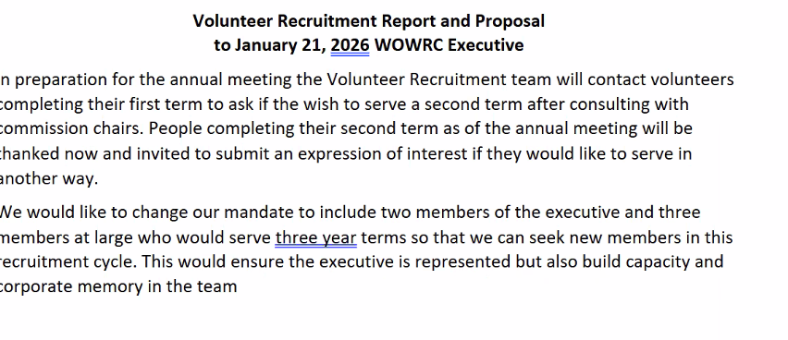Approved by Consensus for both proposals
Proposal
That the membership of the Volunteer Recruitment Team be two members of the executive and three members at large, recruited through the recruitment process, with a commitment of 3 years, renewable once for the members at large.
Proposal
That Nancy Flagel be appointed to Congregational Support Commission for term ending 2029.
That Nancy Flagel and Amber Culley be appointed to the Student and Candidate Support Network.
Approved by consensus.

Next Meeting: March 18

Future Meetings: May 20, July 15, Sept 16 (in-person), Nov 18. Having other meetings as needed called by the President.

Special Meetings: WOWRC Spring Meeting – May 22/23 (possibly 24) -UNIFOR Centre, Port Elgin
All meetings are scheduled Wednesdays from 9:30 a.m. to 12:30 a.m. unless otherwise noted.
Adjourned.

