Congregational Support Commission
Western Ontario Waterways Regional Council
of The United Church of Canada

WOWRC Purpose: Connecting, Supporting, Transforming
WOWRC Values: Love Unconditionally, Seek Reconciliation, Risk Courageously
WOWRC Commitment to be: Affirming, Anti-Racist

January 8, 2026 – 12:30 PM
Join Zoom Meeting Meeting ID: 948 1084 3630; Password: 317828

Roster: (9) (Quorum = 5) Roz Vincent-Haven (Chair, Rep to Exec), Bruce Gregersen, Marg Krauter, Peter Kudelka, Peter Kupfer, Sharon Norton, Colin Snyder, Gord Dunbar, Margaret Ruggles
Resource Pool: Barbara Schoch – Annual Reports
Staff Support: John Neff, Minister, Congregational Support
Max Watkinson, Executive Assistant

Present: Roz, Peter Kupfer, Bruce, Colin, Marg Krauter, Sharon N

Regrets: Gord Dunbar

Welcome and Constitute Meeting: Roz welcomed all and constituted the meeting in the name of Jesus Christ for all business that comes before it.

Acknowledgement of the Land: John Neff

Worship: Margaret Ruggles – Not at meeting

Items for Information:

Approval of Agenda:
The Congregational Support Commission of Western Ontario Waterways Regional Council agree on the agenda.

Approval of Previous minutes:
The Congregational Support Commission of Western Ontario Waterways Regional Council approves the 251211 - CSC Mtg Minutes.docx

PCS Appointments
- Tom Dunbar, as Pastoral Charge Supervisor (PCS), to Lakeshore United Church, Goderich beginning January 6, 2026. There is an admissions minister.
- Brian Goodings, as Pastoral Charge Supervisor (PCS), to Grace United Church, Thornbury starting January 6, 2026 and until his Short Term appointment is finalized.
- Rev. Martin Garniss, as Pastoral Charge Supervisor (PCS), to St. Paul’s United Church, Walkerton for their annual meeting on March 1, 2026.
- Greg Smith-Young, as Pastoral Charge Supervisor (PCS), to St. Paul’s United Church, Milverton for their Annual meeting on February 8, 2026.

PCS Reports
Centralia-Zion West PC - PCS Report.msg
Meaford - PCS Report 260107.msg

Budget
2025 - CSC Budget.xlsx final amounts
2026 - WOW CSC Budget.xlsx

Report from Rep to the Executive – Roz
There was no executive meeting. They are now meeting bi-monthly

Congregational Support Minister (CSM) Report
- Minister’s searching in WOW chart
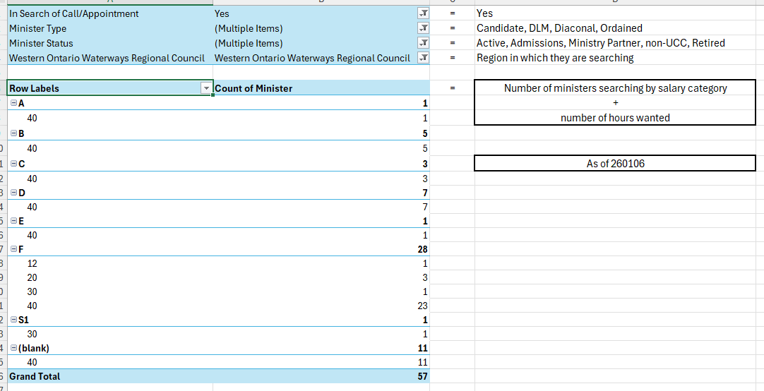
- Total number of ministers searching nationally = 203
- Total number of ministers searching only in WOW = 3

End of Items for Information
The Congregational Support Commission of Western Ontario Waterways Regional Council agrees by consensus to receiving all items for information.

Items for Discussion

Congregational Support Commission (CSC) powers/authority/priorities
Document: Congregational Support Commission - Authority & Responsibility.docx

2026 Learning Event
- Best process for establishing a collaboration agreement
- Visioning process
- How to run good meetings
- Personality assessments, Productivity assessment, emotional intelligence.
- Could do 2 events in a year.
- Considering T2035 one in September may be enough
- What are other regions doing? Who is most popular? What do others say is important to offer to the region. John to ask other CSMs. What are other denominations doing? Example: What are three things you can do to turn your church around?

Items for Decision

Creemore/New Lowell Pastoral Charge – Community of Faith Profile for search.
Documents:
Creemore-New Lowell Cover letter.docx
Demographics-Worksheet-Creemore.docx
Demographics-Worksheet-NewLowell.docx
Finances-Creemore-New Lowell.jpeg
Financial-Viability-Worksheet-Creemore-New Lowell.docx
Living-Faith-Story-Worksheet Creemore.docx
Living-Faith-Story-Worksheet New Lowell.docx
Real-Property-Creemore.docx
Real-Property-Worksheet-New Lowell.docx
Possible MOTION Marg Krauter / Colin Snyder
that the Congregational Support Commission of Western Ontario Waterways Regional Council receives the CoF Profile from Creemore/New Lowell Pastoral Charge and agrees with the recommendation that Creemore/New Lowell Pastoral Charge is viable to call/appoint a minister for up to 30 hrs at category F or equivalent.

CARRIED

Next Meeting: February 12, 2026, 12:30 PM (Regular mtgs 2nd Thursday monthly at 12:30 pm)
Worship by: Margaret Ruggles
Land Acknowledgement:

Adjournment – 2:05 PM

Policies
- PCS Payment Policy
- WOWRC Congregation Education and Training Fund

Blank Motions
Possible MOTION _____ / _____
that the Congregational Support Commission of Western Ontario Waterways Regional Council …
Possible MOTION _____ / _____
that the Congregational Support Commission of Western Ontario Waterways Regional Council receives the CoF Profile from ___ and agrees with the recommendation that ___ UC is viable to call/appoint a minister for up to __ hrs at category __ or equivalent.

