Congregational Support Commission
Western Ontario Waterways Regional Council
of The United Church of Canada

WOWRC Purpose: Connecting, Supporting, Transforming
WOWRC Values: Love Unconditionally, Seek Reconciliation, Risk Courageously
WOWRC Commitment to be: Affirming, Anti-Racist

December 11, 2025 – 12:30 PM
Join Zoom Meeting Meeting ID: 948 1084 3630; Password: 317828

Roster: (9) (Quorum = 5) Roz Vincent-Haven (Chair, Rep to Exec), Bruce Gregersen, Marg Krauter, Peter Kudelka, Peter Kupfer, Sharon Norton, Colin Snyder, Gord Dunbar, Margaret Ruggles
Resource Pool: Barbara Schoch – Annual Reports
Staff Support: John Neff, Minister, Congregational Support
Max Watkinson, Executive Assistant

Present: Roz Vincent-Haven, Bruce Gregersen, Marg Krauter, Colin Snyder, Marg Ruggles

Regrets: Gord Dunbar

Welcome and Constitute Meeting: Roz welcomed all and constituted the meeting in the name of Jesus Christ for all business that comes before it.

Acknowledgement of the Land: by Roz

Worship: Roz opened with Prayer

Items for Information:

Approval of Agenda:
The Congregational Support Commission of Western Ontario Waterways Regional Council agree on the agenda.
Stated Hour – 12:450M – Daniel Reed & Ron Ewart – Toronto United Church Council (TUCC)
Stated hour – 1:00 PM – Michael Richardson & Jennifer Maddock – Dublin St. UC, Guelph

Approval of Previous minutes:
The Congregational Support Commission of Western Ontario Waterways Regional Council approves the 251113 - WOW CSC Mtg Minutes.docx with the following amendment (change: #17 - Exeter and Hensal - the motion is duplicated. The first motion should be) “that the Congregational Support Commission of Western Ontario Waterways Regional Council approve the amalgamation agreement between Exeter United Church and Hensal United Church effective after, and conditional to congregational approvals and with the following change: Removal of “a Board of Trustees and” from the Governance section.”

Email Vote:
251202 MOTION:
Peter Kupfer/ Bruce Gregersen that the Congregational Support Commission (CSC) of Western Ontario Waterways Regional Council approve the request of Bridgeport UC, Kitchener for the following disbursements following their disbandment.
1. Waterloo Wayside (incorporated ministry through Emmanuel UC, Waterloo) (31.666667%) = $123,969.35
2. Cave Springs Camp (31.666667%) = $123,969.35
3. UC Foundation - Legacy student grant for candidates for ministry (31.666667%) = $123,969.35
4. Grand River Hospital (5%) = $19,574.11

PCS Reports Reviewed
Pastoral Charge Supervisor Report Feedback Dec 9th, 2025.pdf

PCS Appointments
- Ann Harbridge, as Pastoral Charge Supervisor (PCS), to Creemore-New Lowell Pastoral Charge starting January 1, 2026
- Marion Loree, as Pastoral Charge Supervisor (PCS), to Rockwood-Stone Pastoral Charge starting July 1, 2026
- Heather Davies, as Pastoral Charge Supervisor (PCS), to Hepworth-Sauble Beach Pastoral Charge starting January 1, 2026

PCSs Needed
None currently needed.

PCS Reports
Walkerton - PCS Report.msg
Wasaga Beach - PCS Report.msg
Highland UC, Eugenia - PCS Report.msg
Londesborough 251125 PCS Report.msg
Letterbreen 251210 - PCS Report.msg

Budget update
2025 - CSC Budget.xlsx
2026 - WOW CSC Budget.xlsx

Report from Rep to the Executive - Roz

Congregational Support Minister (CSM) Report
- Minister’s searching in WOW chart
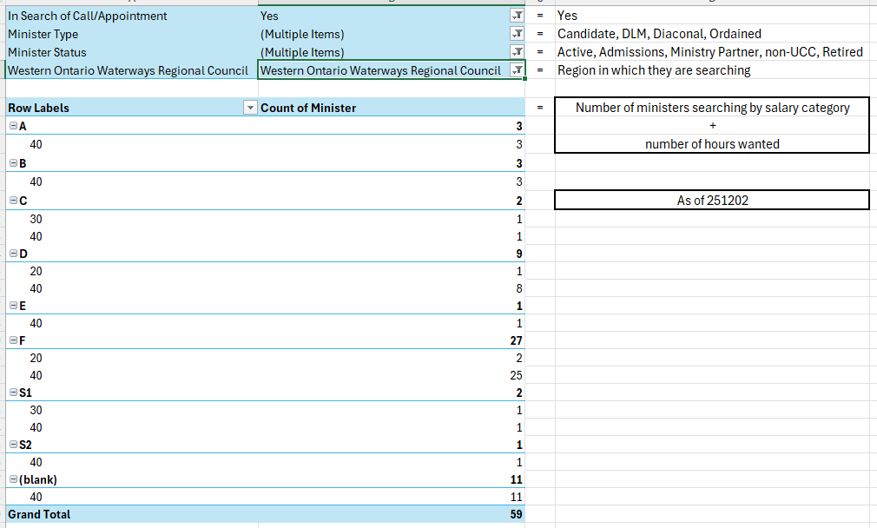
- Total number of ministers searching nationally = 196
- Total number of ministers searching only in WOW = 5

End of Items for Information
The Congregational Support Commission of Western Ontario Waterways Regional Council agrees by consensus to receiving all items for information.

Items for Discussion

Daniel Reed and Ron Ewart – Toronto United Church Council (TUCC) – Stated hour – 12:45 PM

Dublin St. UC, Guelph - SME support further discussion. Stated Hour – 1:00 PM (Michael Richardson and Jennifer Maddock)

Ministry Preparation Fund
Document
Ministry Preparation Fund - Stream One - Support for Ministry Education Sites.docx

Toward 2035
What powers/authority do we have and what do we wish we had.

Westminster United Church, Waterloo

Items for Decision

Bridgeport UC, Kitchener – Disbandment
MOTION Marg Krauter / Colin Snyder
that the Congregational Support Commission of Western Ontario Waterways Regional Council, having received confirmation that all processes are complete, disband Bridgeport Pastoral Charge, Kitchener / Bridgeport United Church, Kitchener effective December 11, 2025.
CARRIED

Hepworth/Sauble Beach PC – Community of Faith (CoF) Profile
Documents
Sauble Beach Demographics-Worksheet-2 (1).docx
Sauble Beach UC Financial-Viability-Worksheet 2025 10.docx
Sauble Beach Living-Faith-Story-Worksheet(3).pdf
Sauble - Real Property Worksheet 2025.jpg
St. A Real-Property-Worksheet.docx
St. A Demographics-Worksheet.docx
St. A Financial-Viability-Worksheet.docx
MOTION Bruce Gregersen / Marg Krauter
that the Congregational Support Commission of Western Ontario Waterways Regional Council receives the CoF Profiles from Sauble Beach United Church and St. Andrew’s United Church, Hepworth and agrees with the recommendation that Hepworth/Sauble Beach Pastoral Charge is viable to call/appoint a minister for up to 25 hrs at category F or equivalent.
CARRIED

Fergus: Melville PC – Community of Faith (CoF) Profile
Documents
02 Melville 2025 - CofF Financial-Viability-Worksheet.v1.Dec072025.docx
03 Melville 2025 - CofF Living-Faith-Story.v1.Dec072025.docx
01 Melville 2025 - CofF Demographics-Worksheet.v1.Dec072025.docx
2024 ANNUAL REPORT-updated Finance.pdf
Possible MOTION Colin Snyder / Marg Ruggles
that the Congregational Support Commission of Western Ontario Waterways Regional Council receives the CoF Profile from Melville United Church, Fergus and agrees with the recommendation that Melville Pastoral Charge, Fergus is viable to call/appoint a minister for up to 30 hrs at category D or equivalent.
CARRIED

Dublin St. United Church, Guelph – Student Ministry Education (SME) site support
MOTION Bruce Gregersen / Marg Krauter
that the Congregational Support Commission of Western Ontario Waterways Regional Council approve up to $15,000 To Dublin St. United Church, Guelph for each of 2026 and 2027 for Student Ministry Education (SME) site support, conditional upon an Student Ministry Education (SME) appointment.
CARRIED

Next Meeting: Date? (Regular meeting 2nd Thursday of the month at 1:00 pm)
Worship by: Marg Ruggles
Land Acknowledgement: John Neff

Adjournment

Policies
- PCS Payment Policy
- WOWRC Congregation Education and Training Fund

Blank Motions
Possible MOTION _____ / _____
that the Congregational Support Commission of Western Ontario Waterways Regional Council …
Possible MOTION _____ / _____
that the Congregational Support Commission of Western Ontario Waterways Regional Council receives the CoF Profile from ___ and agrees with the recommendation that ___ UC is viable to call/appoint a minister for up to __ hrs at category __ or equivalent.

