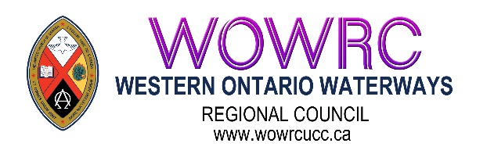
Western Ontario Waterways Regional Council of The United Church of Canada
Box 100, Carlisle, Ontario, L0R 1H0 | Main Phone: 1-833-236-0280 / 905-659-3343

Candidates:
Sandra Cable
Keith Lockhart
Ann Harbridge

