|  |  |
| --- | --- |
|  |  |

In Memoriam:

Western Ontario Waterways Regional Council of The United Church of Canada

Box 100, Carlisle, Ontario, L0R 1H0 | Main Phone: 1-833-236-0280 / 905-659-3343

Ruth Long, CDM

The Rev. David Black

The Very Rev., The Honourable Dr. Lois Wilson

Rev. Brenda Fawkes

The Honourable Murray Sinclair  
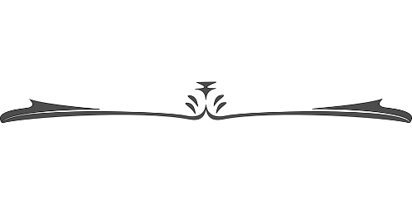Community of Faith Life Cycle Changes:  
  
**Disbandments**Bluevale United Church June 30, 2024  
  
**Collaborative Agreements**St. John's United Church, Chesley and Tara United Church beginning September 1, 2024.  
  
Emmanuel UC, First UC, Parkminster UC, Westminster UC all in Waterloo - Youth Program June 19, 2024  
  
Wingham UC and Knox UC, Belgrave beginning May 2024