WOW-We are One
Widening the Circle
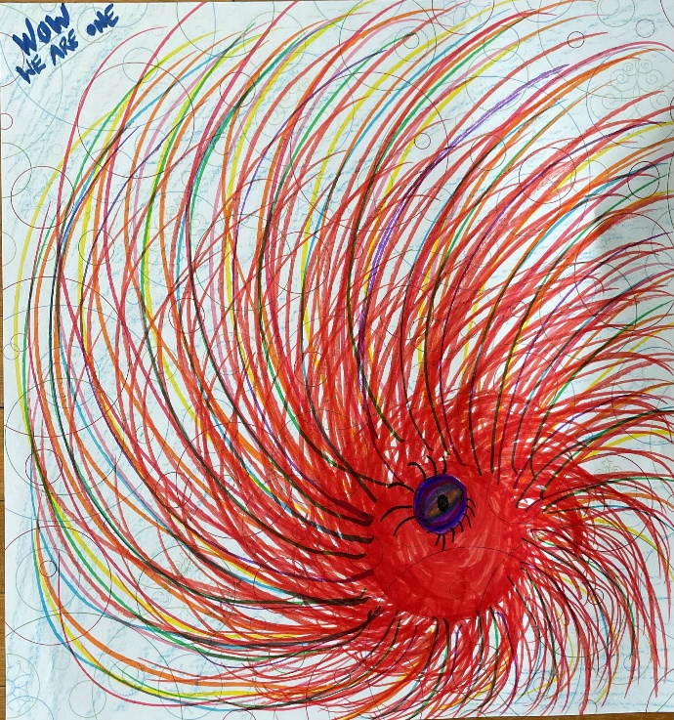
[Image: a small blue/black circle (perhaps an eye with eyelashes) in the bottom right quadrant of the paper
surrounded by a larger red circle with multicolour lines curving out from the circle in a spiral to the right
spreading as far as the edges of the paper and beyond. Blue printed words in the top left corner say “WOW: WE ARE ONE”]
When I went to compose my message for our Fall Meeting Workbook, I naturally pulled up the message I wrote for the Workbook for last fall’s meeting. What did I find? The piece of “art” (I use that term loosely) that I created in my Spiritual Mentoring session shortly after becoming President of the Western Ontario Waterways Regional Council. To my surprise and delight, the image spoke to me still as I considered the theme of our Fall Gathering “We are One: Widening the Circle”.
Well, truth be told, it was actually singing: “Draw the circle wide, draw it wider still! Let this be our song, no one stands alone, standing side by side, draw the circle wide.” (Gordon Light-More Voices #145 © 1994 Common Cup Company)
Within this picture, I see ever widening circles—the circle of our congregation, the circle of the region, reaching out to form the circle of the whole denomination.
This fall gathering, a significant part of our agenda will be dedicated to the proposals from our Regional Council to the General Council. As we do this work of faithfully considering where the spirit is calling us we are reminded that we are connected not just to those in our immediate vicinity but also to those in the wider church. We remember that we must take care with our words and decisions because they ripple out and affect many others in an ever widening circle. It is our responsibility to draw our circle wider and ensure that we are considering, caring for and making space for all in our work and witness.
In the lead up to the 100th Anniversary of the United Church of Canada we are especially mindful of all that we have accomplished through God—the stillpoint of the circle. As we gather together as the Western Ontario Waterways Regional Council may we centre ourselves in that love and standing side by side, draw the circle wide!
In love and hope,

Jennifer Irving, WOWRC President

