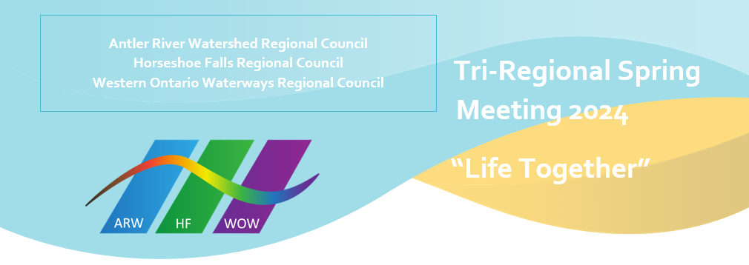
Greetings!
Welcome to this special tri-regional spring meeting of the regional councils of Western Ontario Waterways, Antler River Watershed and Horseshoe Falls. It seems very fitting to me that we would be gathering our regional councils together in this special meeting as we celebrate “Life Together” with our Moderator, the Right Reverend Dr. Carmen Lansdowne as our theme speaker.
I just finished listening to the little book “Life Together: The Classic Exploration of Christian Community” by Dietrich Bonhoeffer, that inspired the theme of our spring meeting. This book speaks of how we are to be in relationship with one another as followers of Christ and children of God. In it, Bonhoeffer recognizes the many challenges that arise in our common life together while lifting up the gifts when we are able to truly love one another. I look forward to hear the wisdom and insight our moderator will share with us from her reading.
Throughout my first year as President of the WOWRC, the importance of our connections with one another in sustaining and supporting us in all our living has become clearer to me than ever. Having a loving community around us that shares with us in both our grieving and our rejoicing is a blessing and a wonder to behold. We are blessed with a strong executive and faithful commissions and volunteers who work hard to keep us knit together in love and friendship.
Thank you to all who were able to respond to the call to cluster together with neighbouring churches, making and strengthening connections beyond your own community of faith. There is so much that we can do together that we cannot do alone but even more that we might be able to do alone but we know is better for our loving partnerships.
As we head into this Centennial year as the United Church of Canada, what we have been and can be when we are truly “united” will be lifted up and celebrated. For that I give thanks.
May our time together in this spring meeting encourage us as we draw the circle wide, encompassing each one, great and small, just as we are, in this life together where “we are one”.
In loving partnership,
Jennifer Irving, President, WOWRC

