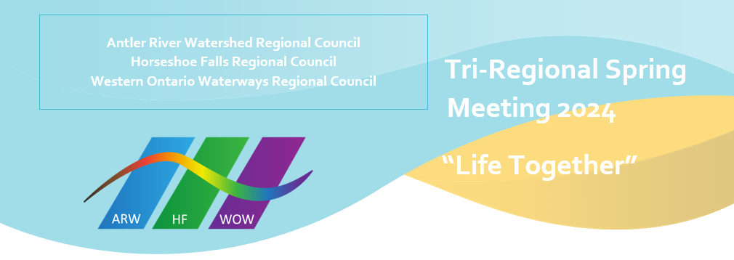
Candidates
Antler River Watershed Regional Council
Dan Leaver, Commissionand

Horseshoe Falls Regional Council
Jeff Learmonth, Ordinand
Carolin MacMillan, Ordinand

Western Ontario Waterways Regional Council
John Adeyemi, Ordinand

