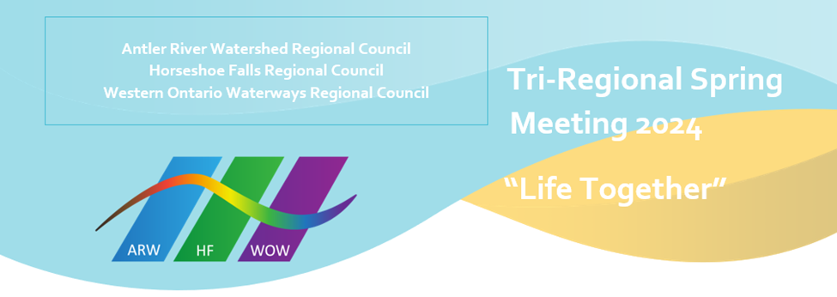
Welcome all in-person registrants to our Tri-Regional Council Meeting, May 24-26, 2024.

The Hospitality Team has been working tirelessly to make sure everything is in place to help you navigate the venue. Please take a moment to look at the interior map (below) of UNIFOR to familiarize yourself with the space (UNIFOR Family Education Centre, 115 Shipley Ave, Port Elgin).

Arrival at UNIFOR
The Hospitality Team will be onsite to welcome you! All volunteers will be wearing rainbow t-shirts for easy identification, as well as orange vests when stationed at outside entrances.

2 volunteers will be stationed at the most westerly entrance to the upper parking lot.
1 volunteer will be at the UNIFOR front desk entrance.

Signage
There will be 2 signs on UNIFOR property indicating that the United Church of Canada meeting parking is accessed at either entrance to the upper parking lot.

There will be a 3rd sign at the UNIFOR front desk.

There will be signage throughout the facility as well.

Assistance
If you have accessibility needs, including requiring porter services, please contact Sue Duliban sduliban@united-church.ca or Michele Petick mpetick@united-church.ca. They will provide you with the cell number for a Hospitality Team member.

If you find you need assistance when you arrive at UNIFOR, our volunteers will be there to help.

Registration
Registration is open at 1 PM on Friday. Please proceed to Assembly Hall once you are in the building. DO NOT go to the front desk first. The Hospitality Team volunteers will be taking groups of registrants to the registration desk, to help with traffic flow and ease any potential bottlenecks. You can leave your luggage in Assembly Hall while you register.
If you are staying at UNIFOR: Checkout is 10 AM.
Remember: ALL in person registrants need to register; even if staying offsite. You can pick up a lanyard for your Regional Council in Assembly Hall (if you have a lanyard from a previous meeting, please remember to bring it along!). You will be given a nametag and meal ticket when you register.
Where are we gathering?
Plenary, Celebration of Ministries Service: Assembly Hall
Antler River Watershed RC: Sisterhood Room
Horseshoe Falls RC: Bob White Boardroom
Western Ontario Waterways RC: Anishinaabe Meeting Room
Children’s Program: Youth Workers Salon
Youth Program: Abilities Salon
Bookroom: in the Alcohol Free Café

Celebration of Ministries Service, 2:30 PM, Saturday May 25th
The service starts at 2:30 PM on Saturday, May 25th. Volunteers will be available to provide direction to guests to and from the Service. Volunteers will not be available while the Service is in progress.

Notes
Meals will be served cafeteria style by the catering staff. Meals can be eaten in the dining room, Assembly Hall, on the deck (if open) and in Union Station, NOT in bedrooms. If you do eat outside of the dining room, please remember to take your used plate, cutlery, etc., back to the dining room.

Union Station bar will be open at 8:30 PM on Friday and Saturday nights.

Please bring your own writing implement(s), paper, if desired. You may bring a refillable water bottle if you wish.

For those participating online
Each Regional Council will have a Zoom community host. If you have questions/comments during the meeting, or are feeling disconnected from the community, please check in with your Zoom community host so they can assist you.

COVID 19 AND OTHER RESPIRATORY VIRUSES (COLD, FLU, AND/OR RSV)
UNIFOR POLICY
If you are feeling sick or unwell, please do not come to the Centre. If you start to feel sick or unwell while at the Centre, notify the Front Desk. Please stay in your room and arrangements will be made for you to return home. If you need further guidance on the severity of your symptoms. Complete the self-assessment tool located at https://www.ontario.ca/self-assessment/ and follow their guidelines.

