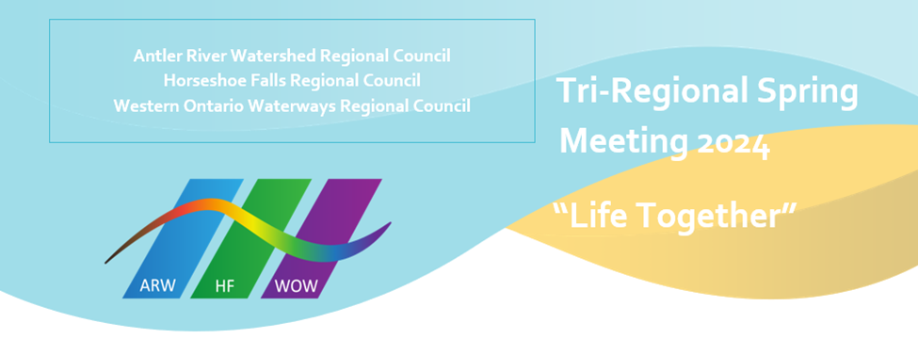Western Ontario Waterways Regional Council
Human Resources Commission
Spring Update

The Human Resources Commission continues to work with Pastoral Charges at the time of changes in Pastoral Relationships. The liaisons are working with many Communities of Faith assisting in navigating the paths that lead to a successful culmination of Search & Selection. The right fit is always our goal and to help relieve the stress when working through Community of Faith Profiles and the Position Description that are required on ChurchHub to make the search viable. The more accurate the paperwork is, the smoother the journey will be.

Our commission is still lacking in commissioners. We should have more lay people involved but the turnout of volunteers is sparse. We have been lacking for over a year and without these required positions being filled we lack some valuable insight when reaching decisions. Our commission meets once monthly on the third Tuesday at 10:00 AM via ZOOM. If you have the time and gifts to offer, the Volunteer Recruitment Team would gladly entertain your Expression of Interest.

Our areas of concern are Calls and Appointment, Licenced Lay Worship Leaders, Short and Long-Term Supply, and training for Ministry & Personnel Committees as well as training for Search & Selection Committees. Training can be online or in the case of Search & Selection, the appointed liaison can do the training in person. Our goal is to appoint liaisons early in the search process to better afford the support many Pastoral Charges need to fulfill their goal. Liaisons are trained to navigate the paperwork and to guide Search Teams to the appropriate handbooks and guidelines that will facilitate the process.

We have begun the initiative of conducting exit interviews when ministers and Communities of Faith agree to them. In this way we hope to build insight into doing what we do better, and to learn what the challenges are that each face to lead to a required change in Pastoral Relationships.

We have found an increasing number of retired ministers that are looking to return to the pulpit. We welcome these re-engaged pensioners and their experience and desire go a long way to filling some of the gaps we uncover.

I mentioned earlier some of the areas we engage in, but they are not all. The WOWRC website has many new restructured elements. Check out the Human Resources section to see if there is an area you feel drawn to. As a liaison you will have the opportunity to be involved in the Covenanting service between a new minister and the Pastoral Charge. In my opinion this is the highlight of the work we do. To see a Minister and Community of Faith that are on the same path at the same time with a common goal. These relationships grow and nurture an exciting future as we enter the 100th year of the United Church of Canada.

Respectfully submitted,
Douglas R. Hayward, Chair, Human Resources Commission

