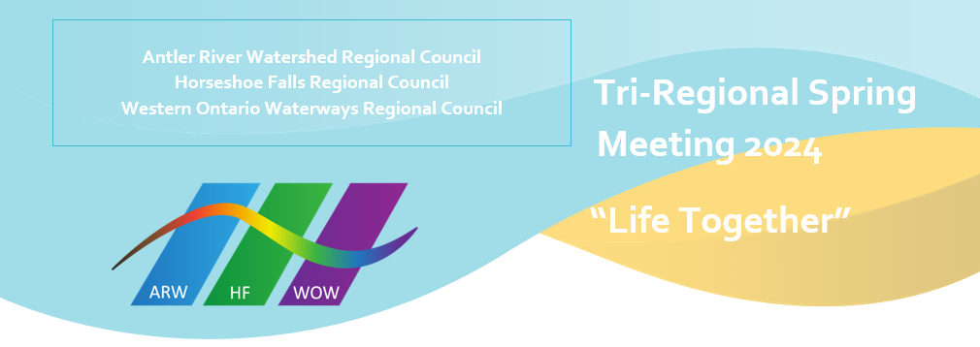
Retirees

Antler River Watershed Regional Council
Mary Dillon DLM
Joan Golden DM
John Lovering OM
Sheila MacGregor OM
Brenda MacMain DLM

Horseshoe Falls Regional Council
Laura Borgerson OM
Cathy Dilts OM
Brian Donst OM
Maureen Ellison DLM
Debra McGill OM
Kim Shantz DM
Karen Williams OM

Western Ontario Waterways Regional Council
Kate Crawford Mulrooney OM
Ed Laksmanis OM
Gwen Nicol-MacDonald OM
Cathy Paul OM
Joan Tuchlinsky DM

