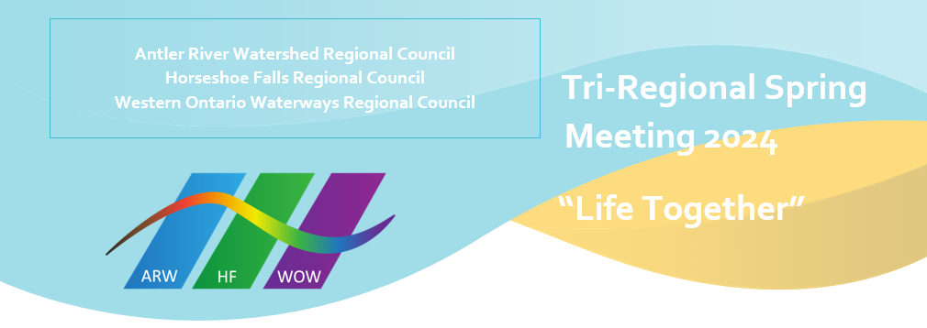
BRAVE: Commitment to Community Safety

We strive, in this time of co-learning, to be brave by
B – bring accountable for the impact of both our words and our silence
R – reflecting on and naming our own biases
A – actively listening
V – vocalizing questions that arise from our learning
E – encountering new ideas with curiosity and wonder

ARW, HF, WOW Regional Councils Affirming Ministries Vision Statement
SAFETY. SANCTUARY. UNCONDITIONAL LOVE

Striving to be faithful followers of Jesus in our time and place, Antler River Watershed / Horseshoe Falls / Western Ontario Waterways Regional Councils will continue to remove barriers to participation in the life and work of the regional council and society, committing ourselves to be open to the Spirit.

Resisting all forms of oppression, we welcome and celebrate people of any sexual orientation and gender identity, and all others who are marginalized.

The Regional Council, Staff, Executive, Commissions, networks, and members commit to working toward fulfilling the vision statement by:
- Continuing to remove barriers to participation in the life and work of Antler River Watershed/Horseshoe Falls/Western Ontario Waterways Regional Councils.
- Continuing to remove barriers to participation in society.
- Committing to be open to the Spirit.
- Resisting oppression.
- Welcoming and celebrating people of any sexual orientation and gender identity.

