Western Ontario Waterways
Regional Council

Connecting, Supporting, Transforming

Governance Handbook
February, 2024

The United Church of Canada/L’Église Unie du Canada

Western Ontario Waterways Regional Council
GOVERNANCE HANDBOOK

Purpose of Western Ontario Waterways Regional Council
Connecting, Supporting, Transforming

The following governance model has been designed to:
- Serve the purpose of the regional council.
- Support communities of faith in naming and claiming their role in God’s mission.
- Provide support for the formation of healthy pastoral relationships.
- Keep before communities of faith the call to be the church.
- Promote an open healthy and strong relationship between the regional council and communities of faith.
- Offer regional council representatives a variety of ways of serving.

As the regional council experiments with this model, there may be refinements along the way due to insights learned. There will be no change in the delegation of responsibilities of The Manual, Section C, without the approval of the regional council.

Contents
Contents 3
Governance Schematic 4
Position Description: Regional Council Representative 5
Regional Council 6
Regional Council Executive 8
Congregational Support Commission 10
Discipleship and Justice Commission 11
Human Resources Commission 12
Staff Support Committee Mandate 13
Volunteer Recruitment Team Mandate…………………………………………………………………….…………………...14
Funds and Grants 15
Congregation Education and Training Fund ………………………………………………………..…………………15 Learning Grants Fund 15
Ministry with Children, Youth, and Young Adults (Under 30) 16
Ministry Preparation Fund 16
Rural Ministry Leadership Fund 17
Kitchener-Waterloo Post-Secondary Chaplaincy Fund 18

Appendix A The Manual Section C.2 19
Appendix B WOWRC Investment Policy 24
Appendix C WOWRC Business Trust 26

Governance Schematic

Regional Council (RC)
(see The Manual, Section C.1 for Membership)
Elects
Regional Council Executive
(12 members plus President, President-Elect or Past President, Treasurer, Secretary, Executive Minister)

RC also elects

Congregational Support Commission | Discipleship and Justice Commission | Human Resources Commission

Congregational Support Commission  Staff Resources:  - Minister, Congregational Support  - Administrative Support Staff | Discipleship & Justice Commission  Staff Resources:  - Minister, Faith Formation  - Minister, Right Relations and Indigenous Justice  - Minister, Social Justice  - Administrative Support Staff | Human Resources Commission  Staff Resources:  - Minister, Pastoral Relations (primary)  - Minister, Pastoral Support (more limited)  - Administrative Support Staff

Position Description: Regional Council Representative
Membership of the Regional Council can be found in The Manual, Section C.1.

Skills and Gifts
A combination from among the following:
- An interest in fostering connections within various parts of the church.
- An interest in the life and work of the United Church.
- Energy and time.
- Curiosity and a willingness to learn.
- Interpersonal skills.
- Experience in wider church work would be helpful but is not required.

Requirements of Position
- For lay members - must be a full member of a community of faith within the regional council.
- Attend and participate in the regional council meetings.
- Serve as the connection in the covenant between the regional council and the community of faith bringing the experience of each to the other.
- Serve in one of either the two following ways:
  - Commitment of 3 years, renewable once, as a member of:
    - Regional Council Executive OR
    - One of three Regional Council Commissions
(Congregational Support Commission, Human Resources Commission, Discipleship and Justice Commission)
OR
  - Short-Term Volunteer working as the representative of the regional council with communities of faith OR working in the organizing and delivering of regional council events.
- Have access to technology along with a commitment to learn how to use it.
- A current police record check may be required for some roles.

Time Commitment
This is an estimate and will be tracked and adjusted based on experience.
An average of two half days/evenings per month. Depending upon the role chosen, the time commitment may be spread consistently over the year or may involve more intense involvement for a briefer period of time during the year.

Support and Benefits for regional volunteers as they serve the church
- Training to cover the role chosen and to improve use of technology.
- Opportunity to develop skills that will strengthen the life of the representative’s home community of faith.
- Opportunity to develop leadership skills.
- Opportunity to deepen and widen relationships across the church.
- Opportunity to learn from one another.

Regional Council
Mandate
The regional council will fulfill the following responsibilities as outlined in The Manual, Section C.2.

Delegation of Responsibilities
Appendix A reflecting Section C.2 of The Manual.
Responsibilities are assigned to: Regional Council (full meeting of the regional council): RC
Executive: EX
Congregational Support Commission: CS (formerly CC)
Human Resources Commission: HR
Discipleship and Justice Commission: D&J (formerly M&D)

Please note the following responsibilities as outlined in sections G, H, I and J of The Manual.
- Section G: Any references to the regional council in Section G are the responsibility of the Congregational Support Commission.
- Section H: Any references to the regional council in Section H are the responsibility of the full regional council.
- Section I: Any references to the regional council in Section I are the responsibility of the Human Resources Commission, with the exceptions of I.1.3.2a, I.1.4.1 concerning community of faith profiles which are delegated to the Congregational Support Commission.
- Section J: Any references to the regional council in Section J are the responsibility of the regional council Executive.

In some cases, two bodies share responsibility for the effective fulfillment of The Manual requirements.

Officers
President *4-year term in total: serving as President-Elect for 1 (one) year,
President for 2 (two) years, Past-President for 1 (one) year.

The Regional Council will elect a President for a two-year term. The President will:
- Preside at the communion table and business table of the regional council and its Executive.
- Serve as the spiritual leader for the regional council, offer a theme and vision for the regional council.
- Serve, along with the Executive Minister, as the official representative of the regional council.
- Strive to inspire the members of the regional council and its communities of faith toward health, joy and excellence.

During the two-year term as President, the home community of faith of a President who is in a pastoral relationship will receive an honorarium in the amount of $1,200.00 per year to assist with coverage for any absences of the President. Any President not in a pastoral relationship will be invited to designate to the United Church of Canada ministry of their choice a donation of 1,200.00 per year.

At the conclusion of the term, the former President, once no longer serving in that capacity, will receive an honorarium of $2,000.00.

Past President
If someone else, such as the Past President or President Elect needs to take on a significant role of President, it is up to the Executive to determine a reasonable honorarium in keeping with what is outlined above.

Travel expenses of the President, President-Elect and Past-President associated with the fulfilment of their roles will be reimbursed.

Treasurer
The regional council will elect a Treasurer for a three-year term, renewable once. The Treasurer will:
- Serve as one of the signing officers for financial matters of the regional council.
- Oversee the financial management of the regional council in partnership with the Executive Minister.
- Assist with the preparation of the budget for the regional council in partnership with the regional council Executive.

The Treasurer will have travel expenses associated with this role reimbursed. Each December, the Treasurer will be invited to name a United Church of Canada ministry to receive a donation of $1,000.00 in recognition of the Treasurer’s service.

Membership
See The Manual, Section C.1.
Under section C.1.2b, the following are also members of the Regional Council:
- Any Past President of Western Ontario Waterways Regional Council.
- Any past president of Hamilton or Toronto or London Conference or past chair of Bruce, Huron-Perth, Northern Waters, Waterloo Presbyteries who is a member of a community of faith in the regional council.
- Any retired Designated Lay Minister who retired while serving a community of faith in the regional council who is a member of a community of faith in the regional council.
- Provision will be made for youth and young adult members. This process is still being developed.

Under Section C.1.2, the Regional Council recognizes the following as members:
- Any past president of one of the Conferences (Hamilton, London, and Toronto Conferences) that became part of the regional council along with any past Chair of one of the Presbyteries (Bruce, Huron-Perth, Northern Waters, Waterloo) that became part of the regional council, who is a member of a community of faith in the regional council.
- Up to 10 youth (up to age 19) elected by the youth at a gathering prior to a Regional Council Meeting; and
- 50% of the Young Adults registered for a regional council meeting to a maximum of 10 to be elected from among the Young Adults attending. The balance to be corresponding members.

To honour the separation of oversight and discipline of ministry personnel established by the Office of Vocation and in recognition of the workload attached to Office of Vocation roles, those members serving with the Board of Vocation or the Committees of the Office of Vocation will not be considered for decision-making responsibilities in the regional council. Their involvement as members of a resource pool would be most welcome if their Office of Vocation duties allow for such a time commitment.

Meetings
The regional council shall have at least one in-person meeting per year.

Regional Council Executive
Mandate
The regional council Executive will fulfill the following responsibilities as outlined in The Manual, Section C.3.1.

The regional council Executive will also:
- Keep the purpose statement before the regional council and evaluate the life and work of the regional council and its commissions against this.
- Hold accountable the Congregational Support Commission, Human Resources Commission and Discipleship and Justice Commission for the responsibilities delegated to each respectively.
- Deal with any matter referred to it for action by one of these three commissions.
- Oversee the finances of the regional council including preparing a budget for the consideration of the regional council and taking responsibility for the administration of the assessment funds, Mission & Service grants and other resources of the regional council.
- Be accountable for the number and position descriptions of regional council staff.
- Serve as the Nominating Committee preparing a proposed slate for the consideration of the regional council.
- Work with the Executive Minister to ensure clear and timely communication within the regional council.
- Meet annually with the Executive of the neighbouring regional councils served by the same Executive Minister and Executive Assistant.
- Facilitate an annual event with the Congregational Support Commission, Human Resources Commission, and Discipleship and Justice Commission to focus on purpose and planning.

All members of the regional council Executive will be required to sign a confidentiality agreement concerning any information to which they may have access regarding pastoral relationships.

Membership
12 Members, plus President, President-Elect or Past President, Treasurer, Secretary and Executive Minister.
To be elected to the Executive by the regional council.

- 4 to be named by office or other
3 – 1 representative from each of the Commissions
Note: Commission members are elected by the regional council.
The members of the Commission will name their representative to Executive.
1 representative to be chosen by the Indigenous Ministries who belong to the regional council.

B. Of the remaining 8 positions, 3 are preferred positions:
1 position reserved for a youth or young adult
1 position to ensure racialized representation
1 position to represent sexual orientation/gender identity diversity

Any nominee not elected on the preferred position ballot, will be placed on the ballot for the election of the remaining five positions.

Any groups not named specifically, including the United Church Women (UCW) are encouraged to complete an expression of interest through the nomination process.
Nominations will be encouraged in advance of the regional council meeting and from the expressions of interest received this way a slate of nominees will be presented to the regional council for election.

Two key principles will be considered when preparing the list of nominees:
- Living into the mandate of diversity adopted by the preceding Conference(s) in the process by which it/they were named an Affirming ministry; and
- supporting the development of leaders by providing opportunities and support.

Meetings
The schedule for meetings will be reviewed following the election of new members and set for the coming year with a view to workload and personal schedules. The majority of meetings happen virtually.

Congregational Support Commission
Mandate
The Congregational Support Commission carries primary responsibility for the relationship between communities of faith and the regional council, and their partnership on matters requiring a decision by both the community of faith and the regional council, other than the pastoral relationship.

The responsibilities of the Commission include:
- The articulation of ministry and mission.
- The use of financial and property resources.
- Local governance.
- The overall health and well-being of communities of faith, such as changes in the life cycle, dealing with real property etc.

The Congregational Support Commission may assign a volunteer to resource a community of faith on matters requiring a joint decision.

The Congregational Support Commission will meet with representatives from a community of faith before acting on requests from the community of faith or exercising oversight and discipline of it.

All members of the Congregational Support Commission are required to sign a confidentiality agreement.

See The Manual, Section C.2 references for responsibilities delegated to the Congregational Support Commission (CS).

The Commission is accountable to the Executive through:
- A representative of the Commission who also serves as a member of the Executive (may be the Chair but not necessarily so); and
- the timely provision of minutes of its meetings according to the format established by the regional council Executive.

Membership
Minimum of 7 members and a maximum of 12 members, at least one-third of total membership to be ministry personnel and one-third of membership to be lay, elected by the regional council, one of whom serves on the Executive.

Meetings
The schedule for meetings will be reviewed following the election of new members and set for the coming year with a view to workload and personal schedules. The majority of meetings happen virtually.

Discipleship and Justice Commission
Mandate
The purpose of the Discipleship and Justice Commission is to provide information, education and opportunities for communities of faith and their members to deepen faith and strengthen service and witness.

The Commission provides both training and development opportunities as well as offering informed and timely responses to enable communities of faith to respond to emerging social and political situations.

The Commission encourages and equips communities of faith to enable their members to discern God’s call to different ministries and ways of service.

All members of the Discipleship and Justice Commission are required to sign a confidentiality agreement.

See The Manual, Section C.2 references, for responsibilities delegated to the Discipleship and Justice Commission (D&J).

The Commission is accountable to the Executive through:
- A representative of the Commission who also serves as a member of the Executive (may be the Chair but not necessarily so); and
- the timely provision of minutes of its meetings according to the format established by the regional council Executive.

Membership
Minimum of 7 members and a maximum of 12 members, at least one-third of total membership to be ministry personnel and one-third of membership to be lay, elected by the regional council, one of whom serves on the Executive.

Meetings
The schedule for meetings will be reviewed following the election of new members and set for the coming year with a view to workload and personal schedules. The majority of meetings happen virtually.

Human Resources Commission
Mandate
The Human Resources Commission carries responsibility for:
- The formation and nurturing of healthy pastoral relationships.
- The equipping and licencing of lay worship leaders.

In light of the sensitive nature of its work, all members of the Human Resources Commission are required to sign a confidentiality agreement.

The Human Resources Commission will meet with representatives from a community of faith before acting on requests from the community of faith.

See The Manual, Section C.2 references, for responsibilities delegated to the Human Resources Commission (HR).

The Commission is accountable to the Executive through:
- A representative of the Commission who also serves as a member of the Executive (may be the Chair but not necessarily so); and
- the timely provision of minutes of its meetings according to the format established by the regional council Executive.
- A Commission can choose to refer any matter delegated to it to the regional council Executive.

Membership
Minimum of 7 members and a maximum of 12 members, at least one-third of total membership to be ministry personnel and one-third of membership to be lay, elected by the regional council, one of whom serves on the Executive.

Meetings
The schedule for meetings will be reviewed following the election of new members and set for the coming year with a view to workload and personal schedules. The majority of meetings happen virtually.

Staff Support Committee Mandate
The Staff Support Committee oversees the implementation of the Ministry Sharing Agreement signed by Antler River Watershed Regional Council, Horseshoe Falls Regional Council and Western Ontario Waterways Regional Council as that agreement pertains to staff positions.

The Ministry Sharing Agreement states:
Staff Support
A Staff Support Committee will be formed to:
- Resource the Executive Minister in discussions of staff complement, recruitment, oversight and development;
- serve as the caring presence of the regional councils with their staff.
The Staff Support Committee will consist of six (6) members, two (2) from each regional council who are appointed by the regional council Commission or the regional council Executive and who serve for a period of three (3) years renewable once. Each regional council commits to provide the Staff Support Committee with a budget of $1,000 per year.

Resourcing the Executive Minister
The Staff Support Committee will meet with the Executive Minister regularly to review:
- Position Descriptions.
- Staff Changes: resignations, recruitment.
- Staff Development: supervision, performance reviews.
- Staff Team Building: meetings, retreats.
Any changes/decisions arising from the foregoing will be taken to the regional council Executives for action.
Serving as the Caring Presence of the Regional Councils
The Committee will consider ways to express care and appreciation:
- To the staff as a whole (e.g. such as at Christmas time).
- To assist the Executive Minister with recognizing individual staff at particular milestones (years of service, life events, resignation, etc.).
- To individual staff by serving as a liaison. Each member of staff support will be available to up to two staff to meet with them one-on-one for support and also available to accompany to performance reviews.
Concerns re: Performance
If concerns about the performance of a member of the staff team are brought to the attention of the Staff Support Committee, the Committee member will share them with the Staff Support Committee and Executive Minister to enable the Executive Minister to follow up on the matter.

If the concern involves inter-personal conflict, efforts will be made to facilitate face-to-face mediation between the individuals involved with the Staff Support Committee’s assistance.

If the concern involves the Executive Minister, the Staff Support Committee will bring this to the attention of the Executive Minister for discussion. Any matter not resolved in this way will be forwarded to the General Secretary as the supervisor of the Executive Minister.

Volunteer Recruitment Committee Mandate
The Volunteer Recruitment Committee will
- Seek volunteers throughout the year to fill vacancies as required on the Executive and Commissions as well as Staff Committee and any other committees or working groups needing volunteers and bring the names to the Executive for approval; with confirmation at the spring meeting of those appointments.
- Communicate with Communities of Faith through the newsletter, video and cluster conversations to raise awareness of the importance of appointing Regional Council Representatives and encourage networking.
- Track all volunteers in the Regional Council ensuring diversity and best use of volunteers’ gifts and experiences.
- Review and update the Expression of Interest form on the website regularly.
- After consulting with the Executive and Commissions, communicate vacancies to the regional council.
- Contact potential volunteers.
- Support the Executive and Commissions in finding volunteers for specific tasks.
- Acknowledge receipt of Expressions of Interest
- Review expressions of interest and prepare a slate to be accepted at the Spring Regional Council Meeting.
- Communicate the decision of the Regional Council with thanks and connect the volunteers with their respective Chairs
- Thank out going volunteers.
- Facilitate the elections of commissioners to General Council.

Two key principles will be considered when preparing the list of nominees:
- Living into the mandate of diversity adopted by the regional council's commitment to be an Affirming ministry; and
- supporting the development of leaders by providing opportunities and support.

Membership
2 members of the Executive, 1 or 2 members from the regional council to be appointed by the Executive and with a commitment of 3 years, renewable once.

Meetings
The schedule for meetings will be reviewed following the election of new members and set for the coming year with a view to workload and personal schedules. The majority of meetings happen virtually.

Funds and Grants

Congregational Education and Training Fund
Terms of Reference
Available Funds
Available funds per year: maximum of $7,000. Interest earned will be reinvested in the fund.

Granting Body and Oversight
WOWRC Congregational Support Commission
- Grants will be allocated based on needs identified by a Community of Faith and/or the Congregational Support Commission.

Criteria
- To be used by the Congregational Support Commission to facilitate educational events/workshops/learning opportunities for multiple communities of faith.
- Communities of Faith: Can apply for a matching grant of up to $2,000 for a multi-church educational event/workshop/learning opportunity.

Procedure
Applications to be completed by a Community of Faith and submitted to the WOWRC Congregational Support Commission.

Learning Grants Fund
Terms of Reference
Available Funds
The balance of the account to be topped up to $30,000 in November of each year for the following year.

Granting Body and Oversight
WOWRC Executive

Criteria
To provide financial assistance for learning events for lay leaders and ministry personnel within Western Ontario Waterways Regional Council to help recipients grow in leadership so they can assist their communities of faith in connecting, supporting and transforming their mission and ministry.

Grants will be limited to one-third (1/3) of the associated costs of a learning event, to a limit of five hundred dollars ($500), including any associated travel costs. (While Communities of Faith are encouraged to invest in educating their leaders, there is no expectation that the Community of Faith and applicant must share the remaining costs equally). (See: Learning Grants Fund Application for detailed criteria and application procedure)

Ministry with Children, Youth, and Young Adults (Under 30)
Terms of Reference
Available funds
All prior year interest earned plus up to 15% of principal to be granted annually.

Granting Body and Oversight
Discipleship and Justice Commission, WOWRC (Western Ontario Waterways Regional Council)
The Discipleship and Justice Commission will report annually, starting in 2021, to the regional council on how the funds have supported ministry with children, youth and young adults.

Criteria
Ministry with children, youth and young adults.
- Grants will normally be one-time grants to a maximum of $10,000;
- Grants in excess of this amount or for a multi-year project will require the applicant to meet with the Discipleship and Justice Commission.

Procedure
Applications to be submitted to the Discipleship and Justice Commission.
The Discipleship and Justice Commission will design the application form as best suits their needs.

Grant Payment
Approval will be forwarded to the WOWRC Treasurer and Executive Minister for payment and tracking.

Ministry Preparation Fund
Terms of Reference
Available Funds
A ministry preparation fund with two streams, each of which will be topped up annually in November to a minimum balance of $30,000.

Granting Body and Oversight
Stream One: WOWRC Congregational Support Commission
The Congregational Support Commission advises the Treasurer and Executive Minister for payment and recordkeeping.
Stream Two: WOWRC Executive Minister and Treasurer
The Executive Minister and Treasurer will confirm candidacy status and school enrolment with the Office of Vocation.

Criteria
Stream One: Support for Ministry Education Sites
Communities of Faith needing financial assistance to provide a ministry education experience for a candidate.
Stream Two: Support for Candidates
Candidates pursuing theological studies in a recognized United Church of Canada program.

Procedure
Stream One: Support for Ministry Education Sites
- Communities of Faith needing financial assistance to provide a ministry education experience for a candidate make application to the fund through the Congregational Support Commission.
- The Congregational Support Commission advises the Treasurer and Executive Minister for payment and recordkeeping.
Stream Two: Support for Candidates
- Bursary provided in the amount of $2,000 per year for a maximum of three years for candidates pursuing theological studies in a recognized United Church program.
- Applications to be made to the Executive Minister and Treasurer who will confirm candidacy status and school enrolment with the Office of Vocation.
*A candidate is expected to seek support only from either the regional council out of which
they became a candidate or the regional council in which they serve, but not from both.

Rural Ministry Leadership Fund
Opening Fund Balance: Approximately $71,000
Terms of Reference
Available funds
Prior year interest earned plus up to 15% of the principal per year.

Granting Body and Oversight
WOWRC Executive
The Executive to report annually, starting in 2021, to the regional council on how the funds have supported rural ministry leadership.

Criteria
Licenced Lay Worship Leader (LLWL) leadership, and rural ministry
- Up to 30% of the annual grants will be made available for LLWL leadership training;
- Resource opportunities focused on rural ministries.

Procedure
Applications to be submitted to the WOWRC Executive. The application form will be designed for events to which communities of faith with a rural postal code can apply.

Kitchener-Waterloo Post-Secondary Chaplaincy Fund
Terms of Reference
Available Funds
Up to $4,000 expended from the fund annually.

Granting Body and Oversight
WOWRC Discipleship and Justice Commission.
- Approved applications be forwarded to the Treasurer and Executive Minister for payment and tracking.
- The Discipleship and Justice Commission will report annually, starting in 2021, to the regional council on how the funds have supported post-secondary chaplaincy in Kitchener-Waterloo.
- The purpose of the fund will be reviewed in spring 2025 to determine the future of any unspent balance.

Criteria
To support ministry that connects with the students attending Kitchener-Waterloo post-secondary institutions.

Procedure
- Invite applications from communities of faith in Kitchener Waterloo for this ministry;
- Applications to be received and approved by the Discipleship and Justice Commission
- Approved applications to be forwarded to the Treasurer and Executive Minister for payment and tracking.
See: Financial Support, on the regional council website, for detailed criteria and application procedure.

Appendix A The Manual Section C.2
Note: CC, C now CS (Congregational Support Commission); M&D now D&J (Discipleship & Justice Commission)

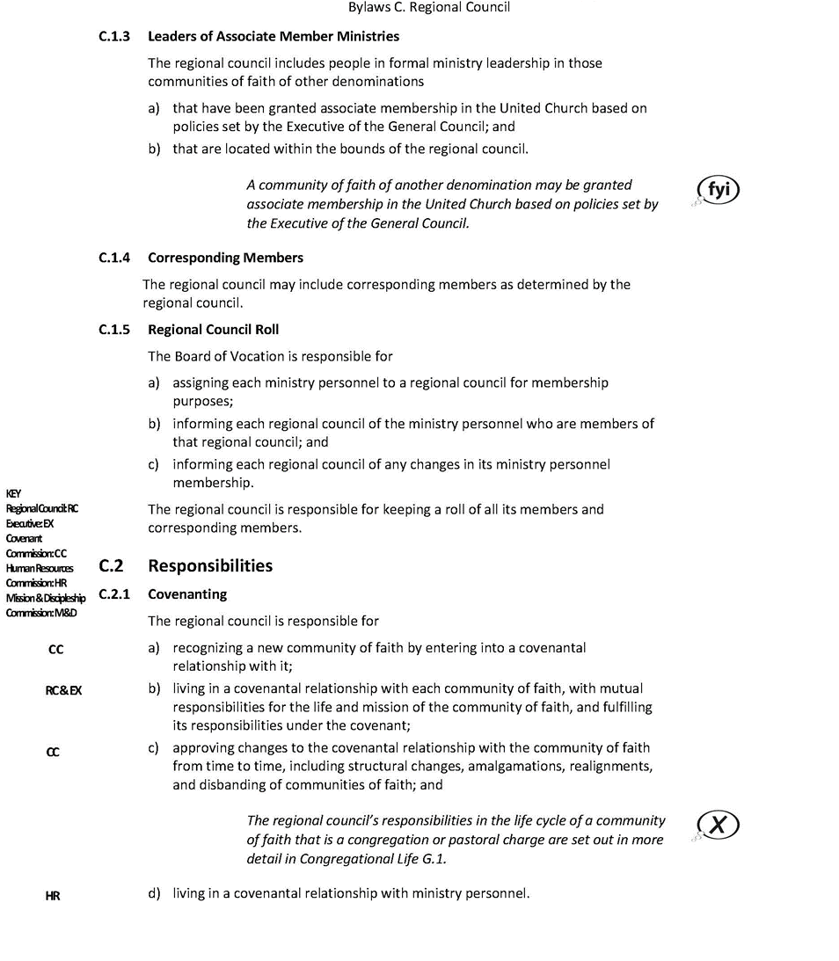
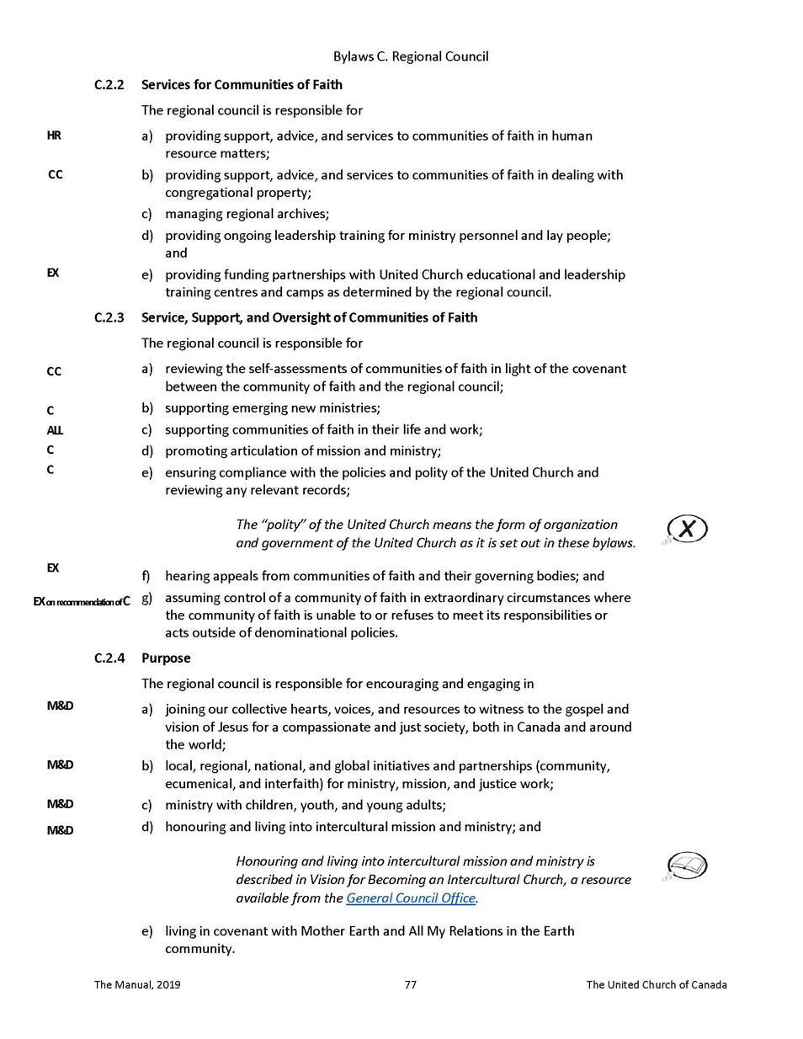

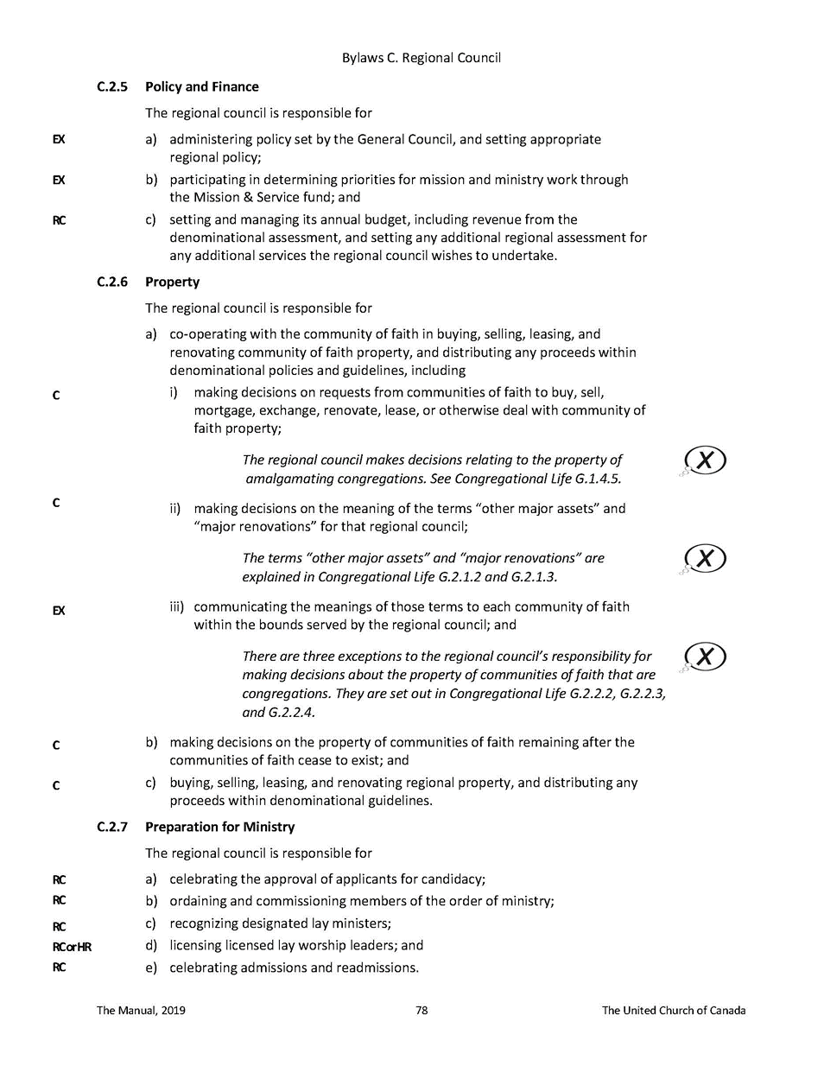

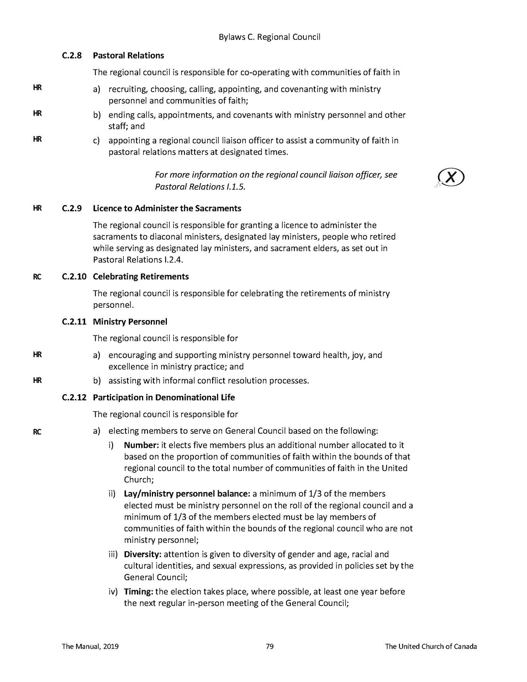

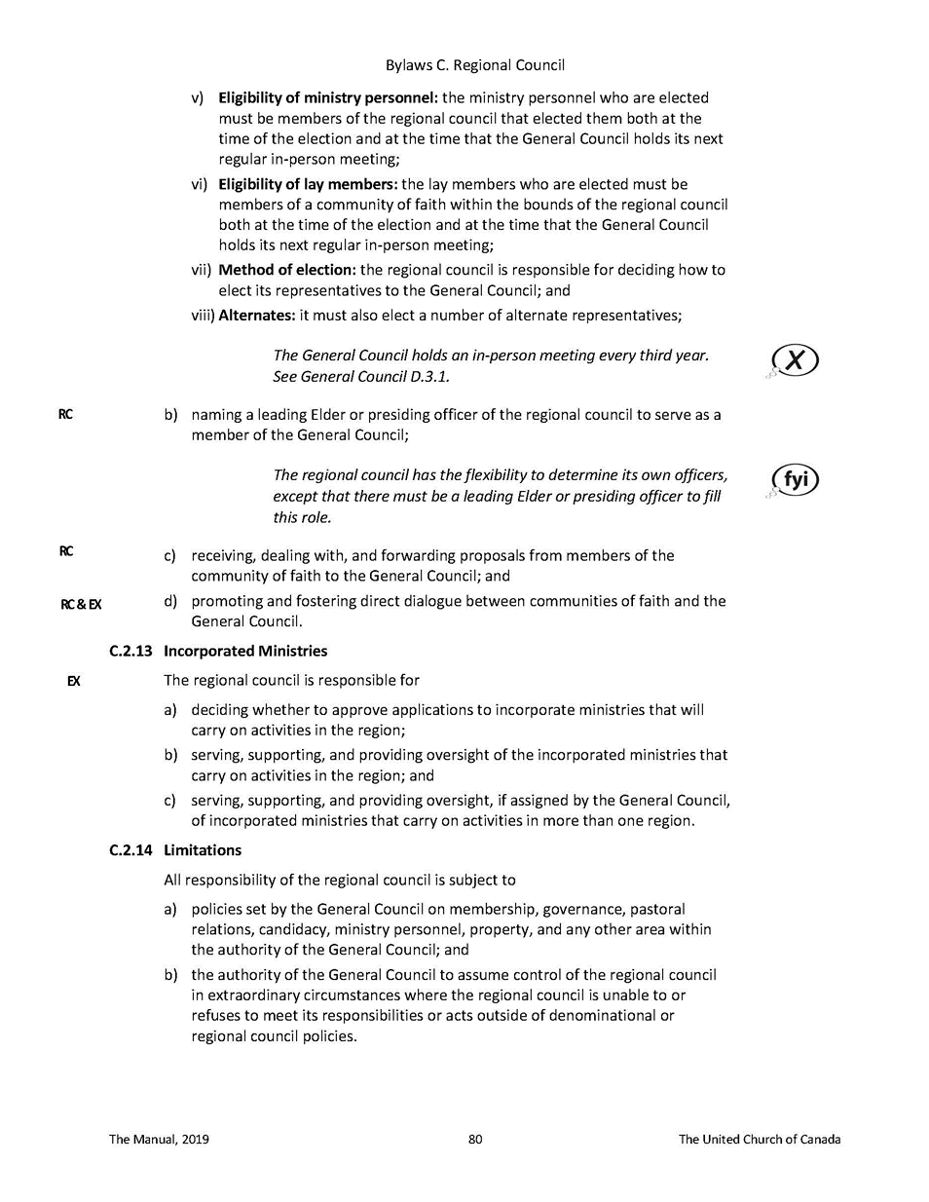

Appendix B WOWRC Investment Policy

Investment Policy
Purpose
The regional council invests money to
- Support the ministry of the regional council through the generation of income.
- Honour specific goals with designated funds.
- Provide financial resources as necessary to address emerging situations.

Guidelines
- All investments will meet the test of reasonableness as seen by a prudent investor.
- The investment accounts will be managed in partnership with a certified investment advisor.
- There will be no investment in any entity whose operations might reasonably be regarded as contrary to the mission of The United Church of Canada (arms, tobacco, alcohol, gambling, fossil fuels).
- The investments will be directed in accord with this policy by the Treasurer, Executive Minister, and two appointees named by the regional council Executive. All four will be invited to each consultation with the investment advisor and at least two must be present to take action.
- The investment team is authorized to move financial resources into investment vehicles provided the balance in the current account does not fall below $300,000 (over one quarter of annual expenses).

Investment Portfolio
The investment portfolio will normally be held as:
20% Tier 1
40% Tier 2
40% Tier 3
These percentages may vary up to 5% depending upon financial conditions and investment advice.

Tier 1
Definition
Assets that are likely to be turned into cash within one year.

Objectives
Security, liquidity and income.

Eligible Investments
- Deposits in Canadian Chartered banks.
- Debt instruments of the federal or provincial governments of Canada or Crown Corporations guaranteed by them, maturing within one year.
- Debt instruments of Canadian Trust Companies up to the limit of the Canada Deposit Insurance Corporation (CDIC) insurance, maturing within one year.
- Debt instruments of Ontario Credit Unions up to a limit of $100,000 maturing within one year.

Tier 2
Definition
Assets not likely to be turned into cash within a year but which could be required to address a specific situation or fund a new initiative.

Objectives
Security, income and liquidity.

Eligible Investments
- All investments listed in Tier 1 but with maturities up to five years.
- Debt instruments of Canadian companies rated as BBB/Bbb or higher or by Standard & Poors or Canada Bond Rating Service, maturing within five years.

Tier 3
Definition
Assets not likely to be turned into cash in the foreseeable future.

Objectives
Return on investments (including both income and capital gains), liquidity and security.

Eligible Investments
- All investments listed in Tier 2 above.
- Shares of Canadian companies listed on the Toronto Stock Exchange (TSE).
- Units of Canadian Income Trusts listed on the TSE.
- Units of Exchange Traded Funds (ETF’s).
- Shares of companies listed on the New York Stock or Nasdaq exchanges.

Policy Review
This policy shall be reviewed every three years. This will include a review of the appointed investment advisor.

Appendix C WOWRC Business Trust

Business Trust
The Western Ontario Waterways Regional Trust is for the benefit of the Regional Council. The beneficiary of the Regional Trust is the Regional Council and a wholly-owned affiliate United Property Resource Corporation (UPRC) is the corporate trustee of the Regional Trust.

The United Church of Canada (UCC) incorporated United Property Resource Corporation (UPRC) agrees that, in carrying out its mandate and conducting its operations, it will support and comply with, as fully as possible, the values, applicable policies and priorities of the United Church. This includes, without limitation:
- ensuring continued availability of space for worship and Christian faith formation for United Church communities of faith;
- providing housing in Canada, including affordable housing;
- tailoring facilities and space in the development and redevelopment of church properties to meet community needs, especially the needs of community members who face structural barriers to full inclusion; and
- creating environments that are accessible for all people.
In achieving these goals, the United Church recognizes the need to hold or develop properties to serve ministry needs when financially viable. To achieve these objectives, UPRC, through Kindred Works, has created a professional real estate team to identify, evaluate and institutionally manage and/or develop these properties in cooperation with the Regional Council in a streamlined portfolio approach that can support the above objectives.

The Regional Trust structure allows for one consolidated entity to be managed by Kindred Works on behalf and in cooperation with the Regional Council. In cases in which properties are currently held by the General Council Office on behalf of the Regional Council, the beneficial interest in the properties will be transferred from the Regional Council to the Regional Trust.

In addition, properties of disbanding congregations can also be transferred to the Regional Trust, after consultation between UPRC and the Regional Council with respect to each such property. Where title is still held by the disbanding congregation, title will be transferred to UCC or another nominee designated by UCC from time to time.

This structure is intended to facilitate retention of church properties where the Regional Council deems this to be strategically important and financially feasible. This structure facilitates a systematic and professional portfolio approach to holding property while following the polity of property of the United Church.

