To access a link in this newsletter, please press CTRL + mouse click on the highlighted link.

View this newsletter in your browser

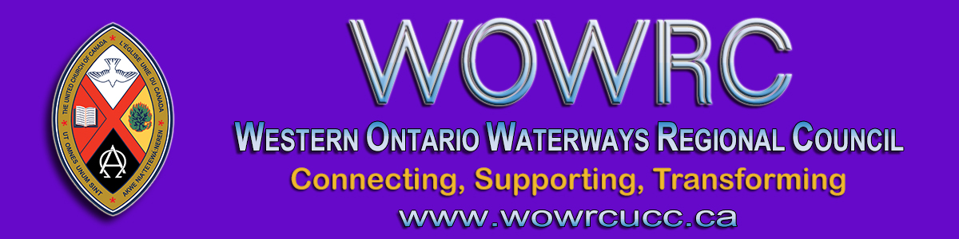

Regional Council Spring Meeting
Thursday, May 13 - Saturday, May 15
ʻGetting Kicked Out of the Boatʼ

Due to current provincial lockdown restrictions, the Celebration of Ministry Service will be postponed until the Fall 2021 Regional Council meeting.

Correction:
General Council Commissioner Nomination Form link has been corrected below and on the website page.

Register for Spring Meeting Sessions.

Thursday, May 13 | Zoom Orientation  Hymn Sing  Session Starts | 6:30 – 6:45 pm  6:45 – 7:00 pm  7:00 – 8:30 pm
Friday, May 14 | Afternoon Session  Evening Session | 4:00 – 5:30 pm  7:00 – 8:30 pm
Saturday, May 15 | Morning Session  Afternoon Session  *Celebration of Ministry  livestreamed from  Southampton United Church | 9:00 – 12:30 am  1:30 – 3:00 pm  7:00 pm
* ALL EVENTS ARE ONLINE, ZOOM LINKS WILL BE SENT *
Registration is for the Thursday, Friday and Saturday sessions.
The Celebration of Ministry will be livestreamed on the YouTube channel.

Register for Spring Meeting Sessions.

Election of Members to the Executive & Commissions

Fill out the Expression of Interest Form.
If you have questions about the work of the Commissions and/or Executive, feel free to contac President Gary Clark, or the Commission Chair for more details.
- President Gary Clark
- Covenant Commission Chair Ann Harbridge
- Human Resources Commission Chair Micol Cottrell
- Mission & Discipleship Commission Acting Chair Bruce Dickson
Thank you for your prayerful discernment of how you might serve.

Election General Council 44 Commissioners

Click to fill out the General Council Commissioner Nomination Form.
Western Ontario Waterways Regional Council will be electing 13 Commissioners to accompany then President Mark Laird to General Council 44, for a total of 14 Commissioners. As you consider General Council 44 Commissioner nominations, and who to vote for during the election of our WOW commissioners, remember the importance of reflecting the diversity of our denomination. Also, consider the diversity we as a church want (or need) as we seek to live out God’s mission. Ask yourself questions like:
- Whose voices need to be heard in this decision-making body of our church?
- Who’s missing from the table?
- Whose wisdom, insights and experience can best contribute to the conversations and actions at GC44?
Let these questions – and others that Spirit brings – aid you in your decision-making.

Proposals for General Council 44

Proposals have a set format:
- Title:
- Originating Body:
- What is the issue?
- Why is this issue important?
- What might the General Council do about it?
Detailed information is laid out in the The Manual, 2021. Click here to view the GC44 Proposal Template.
Feel free to be in touch with Executive Minister, Cheryl-Ann Stadelbauer-Sampa at csampa@united-church.ca for assistance.

The Western Ontario Waterways Regional Council newsletter welcomes submissions of upcoming events, regional news and educational opportunities. This is also the place to keep up-to-date on information from the regional office.
Check out the page and the channel!

Connecting, Supporting, Transforming

Western Ontario Waterways Regional Council
The United Church of Canada

SUBSCRIBE!

Copyright © 2021 The United Church of Canada, All rights reserved.
Want to change how you receive these emails?
You can update your preferences or unsubscribe from this list.

