To access a link in this newsletter, please press CTRL + mouse click on the highlighted link.

View this newsletter in your browser

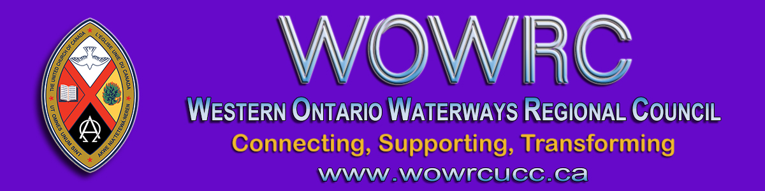

Regional Council Spring Meeting
Thursday, May 13 - Saturday, May 15
ʻGetting Kicked Out of the Boatʼ

Go to Registration Form.

Thursday, May 13 | Zoom Orientation  Hymn Sing  Session Starts | 6:30 – 6:45 pm  6:45 – 7:00 pm  7:00 – 8:30 pm
Friday, May 14 | Afternoon Session  Evening Session | 4:00 – 5:30 pm  7:00 – 8:30 pm
Saturday, May 15 | Morning Session  Afternoon Session  *Celebration of Ministry  livestreamed from  Southampton United Church | 9:00 – 12:30 am  1:30 – 3:00 pm  7:00 pm
* ALL EVENTS ARE ONLINE, ZOOM LINKS WILL BE SENT *
Registration is for the Thursday, Friday and Saturday sessions.
The Celebration of Ministry will be livestreamed on the YouTube channel.

Go to Registration Form.

Election of Members to the Executive & Commissions

Fill out the Expression of Interest Form.
The regional council fulfills its responsibilities through the decision-making work of the:
- Executive-oversight and management of the life of the regional council
- Covenant Commission—congregational health and change
- Human Resources Commission—forming and supporting pastoral relationships
- Mission and Discipleship Commission—equipping for ministry and mission
Details are provided on each in the Governance Handbook where the preferred positions to bring the wisdom of diversity to decision-making are outlined and the required balance of lay/ministry personnel is stated.
At the 2021 Spring Meeting, the regional council will fill the following vacancies through the election of new members:
- Covenant Commission: Minimum of 1 to elect, Can elect up to 5. Ministry personnel needed.
- Human Resources Commission: Can elect 3. Must elect 1 ministry personnel.
- Mission & Discipleship Commission: Can elect up to 5.
- Executive: Can elect up to 4. Preference for youth/young adult, and racialized. Lay members needed.
These positions are open to anyone who is a full member in good standing in a community of faith within the bounds of the regional council.
If you would be willing to let your name stand as a nominee for one of these positions, please complete the Expression of Interest Form below by FRIDAY, MAY 14 at midnight. This information (minus your personal contact details) will be available to regional council members for consideration before voting.
Fill out the Expression of Interest Form.
If you have questions about the work of the Commissions and/or Executive, feel free to contact President Gary Clark, or the Commission Chair for more details.
- President Gary Clark
- Covenant Commission Chair Ann Harbridge
- Human Resources Commission Chair Micol Cottrell
- Mission & Discipleship Commission Acting Chair Bruce Dickson
Thank you for your prayerful discernment of how you might serve.

Election General Council 44 Commissioners

Click to fill out the General Council Commissioner Nomination Form.
Western Ontario Waterways Regional Council will be electing 13 Commissioners to accompany then President Mark Laird to General Council 44, for a total of 14 Commissioners. As you consider General Council 44 Commissioner nominations, and who to vote for during the election of our WOW commissioners, remember the importance of reflecting the diversity of our denomination. Also, consider the diversity we as a church want (or need) as we seek to live out God’s mission. Ask yourself questions like:
- Whose voices need to be heard in this decision-making body of our church?
- Who’s missing from the table?
- Whose wisdom, insights and experience can best contribute to the conversations and actions at GC44?
Let these questions – and others that Spirit brings – aid you in your decision-making.

Proposals for General Council 44

Do you have an idea for a way to strengthen the United Church? If so, please consider preparing a proposal. (See The Manual, Section F) Proposals have a set format:
- Title:
- Originating Body:
- What is the issue?
- Why is this issue important?
- What might the General Council do about it?
Detailed information is laid out in the The Manual, 2021. Click here to view the GC44 Proposal Template. Proposals reach the General Council through the regional council. If submitting a proposal, please do so as soon as possible to allow the agenda and business team time to allow sufficient time for discussion.
If you would find advice helpful in framing the desired action or change as you craft a proposal, please feel free to be in touch with Executive Minister, Cheryl-Ann Stadelbauer-Sampa at csampa@united-church.ca for assistance. This would be help in terms of format and wording, not advice re the action itself.

The Western Ontario Waterways Regional Council newsletter welcomes submissions of upcoming events, regional news and educational opportunities. This is also the place to keep up-to-date on information from the regional office.
Check out the page and the channel!

Connecting, Supporting, Transforming

Western Ontario Waterways Regional Council
The United Church of Canada

SUBSCRIBE!

Copyright © 2021 The United Church of Canada, All rights reserved.
Want to change how you receive these emails?
You can update your preferences or unsubscribe from this list.

