To access a link in this newsletter, please press CTRL + mouse click on the highlighted link.

View this newsletter in your browser
Next Deadline for submissions: April 14 (April 19 Issue)

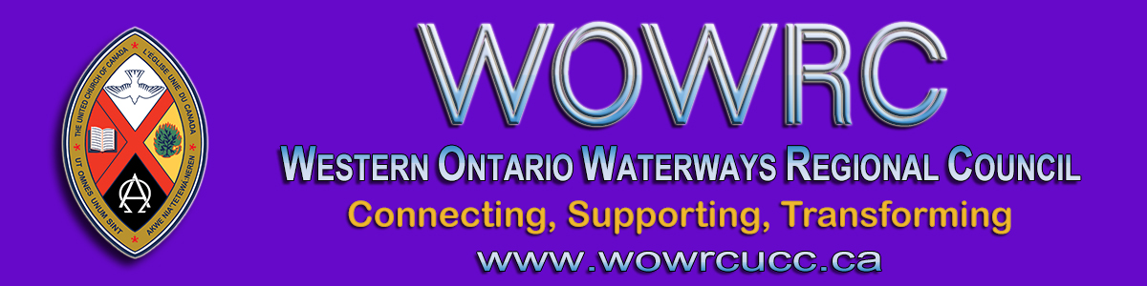

Right Relations & Indigenous Justice Events
in April and May

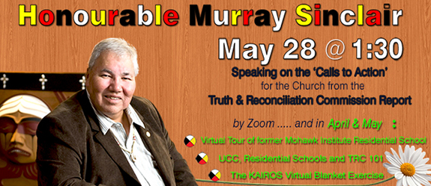

For more information and to register click here.

- Virtual Tour of former Mohawk Institute Residential School by the Woodland Cultural Centre. Limited to first 40 participants registered for each date.
  - April 13 at 2:00 pm (EDT)
  - April 20 at 7:00 pm (EDT)
- The United Church of Canada, Residential Schools and TRC 101. An introduction or refresher to key events and issues related to The United Church of Canada’s call to Right Relations between Indigenous and Non-Indigenous peoples.
  - April 29 at 10:30 am - 12:00 pm (EDT)
  - May 5 at 7:00 pm - 8:30 pm (EDT)
- KAIROS Virtual Blanket Exercise. This powerful activity has been adapted to offer all the learning and impact via Zoom. Limited to first 35 participants registered for each time.
  - May 3 at 9:30 am - 12:00 pm (EDT)
  - May 3 at 6:30 pm - 9:00 pm (EDT)

The Honourable Mr. Murray Sinclair is a recently retired member of the Canadian Senate and a ground-breaking First Nations lawyer. He was chair of the Indian Residential Schools Truth and Reconciliation Commission from 2009 to 2015. The Hon. Mr. Sinclair will be addressing the regional councils’ gathering on Friday, May 28 at 1:30 pm.
For more information and to register click here.
Whether you are new to the work of right relations and Indigenous justice, or are already active and involved, you will not want to miss the opportunity to hear the Honourable Mr. Sinclair speak.

Following these events, watch for a follow-up gathering to develop a plan of action based on what we have experienced, heard and learned.
With the Spirit’s help, together we can work to right wrongs,
and seek a more just society for all.

Funded & brought to you by the Regional Councils of Western Ontario Waterways, Antler River Watershed and Horseshoe Falls
as part of our commitment to the work of Right Relations & Indigenous Justice.

The Western Ontario Waterways Regional Council newsletter welcomes submissions of upcoming events, regional news and educational opportunities. This is also the place to keep up-to-date on information from the regional office.
Check out the page and the channel!

Connecting, Supporting, Transforming

Western Ontario Waterways Regional Council
The United Church of Canada

SUBSCRIBE!

Copyright © 2021 The United Church of Canada, All rights reserved.

