To access a link in this newsletter, please press CTRL + mouse click on the highlighted link.

View this newsletter in your browser
Next Deadline for submissions: March 10 (March 15 Issue)

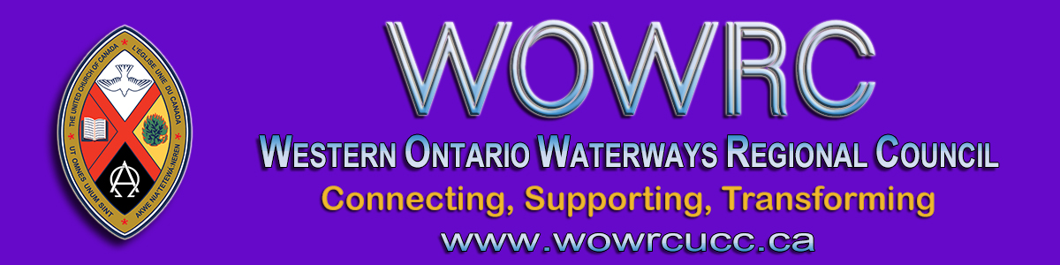

Greetings Friends In Faith,

You have already received a pastoral letter from me asking that you mark the first Anniversary of the Pandemic this Sunday March 14. Well, I was remiss in not also holding up P.I.E. Day which is also this Sunday.
Please see the video below from Moderator Richard Bott which explains it. In fact, I invite you, if you are able, to share this video with your congregation so that we are not only grieving the upheaval of the pandemic this Sunday but we are also celebrating that we are part of a denomination that promotes inclusion in Public, Intentional and Explicit ways.

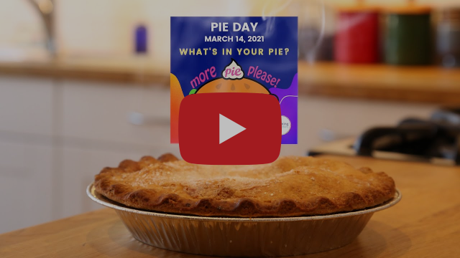
Moderator Richard Bott invites you to join him in celebrating Pie Day 2021!
Find out more (https://united-church.ca/worship-special-days/pie-day)!

It would seem that our whole global community is being forced to reassess how we have lived and how we have treated each other. Not accidentally, the theme for the Western Ontario Waterways Regional Council gathering this May is, "Getting Kicked Out of the Boat" from Jonah 1:15.
Change is not an option during this pandemic, but, the values we take with us into the changes matter a great deal. What we will look like as we emerge from the pandemic will depend on what values have guided us in its midst.

In this chrysalis time of the pandemic
surely God is forming us into a new thing.

I will be looking for our denomination and communities of faith to emerge with a calling to more fully embrace the vision of an Inclusive Church. For Jonah to serve God he had to leave the safety of what he had known and enter into the foamy chaos of the unknown. If a reluctant prophet can be a sign of salvation for a city then maybe a renewed church can be a sign of salvation for a country.

With this hope, I invite you to share some PIE this Sunday.
May God bless us and challenge us in this time,
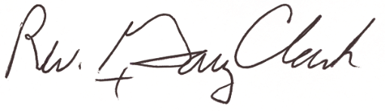
President, Western Ontario Waterways Regional Council

SAVE THE DATES
The Western Ontario Waterways Regional Council Gathering will be by Zoom again. Please save Thursday evening, Friday evening and all day Saturday of May 13 to 15. More information and registration coming soon.
The Affirming Celebration will be held Sunday, June 6. Time: tba
P.S. if your Community of Faith hasn't elected a delegate to the Regional Council please consider doing so.

The Western Ontario Waterways Regional Council newsletter welcomes submissions of upcoming events, regional news and educational opportunities. This is also the place to keep up-to-date on information from the regional office.
Check out the page and the channel!

Connecting, Supporting, Transforming

Western Ontario Waterways Regional Council
The United Church of Canada

SUBSCRIBE!

Copyright © 2021 The United Church of Canada, All rights reserved.
Want to change how you receive these emails?
You can update your preferences or unsubscribe from this list.

