To access a link in this newsletter, please press CTRL + mouse click on the highlighted link.

View this newsletter in your browser
Next Deadline for submissions: February 24 (March 1 issue)

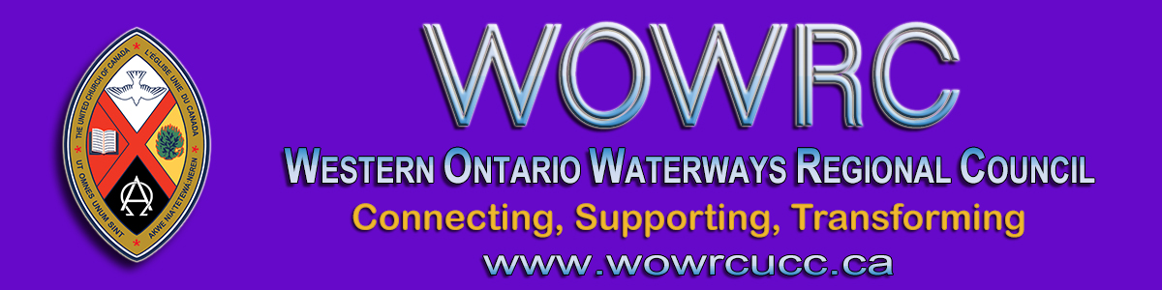

INVITATION to CLERGY (Ministry, please)
For an online gathering of clergy by Zoom
Thursday, February 18 - 2:00 - 3:30 pm
You are invited to take part in a gathering of clergy in your regional council. This is an opportunity to come together with your colleagues who are also ministering in these busy, difficult times. We will share information, ask questions and find support together.
Let's meet, online by Zoom, from the comfort & safety of your home or office on Thursday, February 18 from 2:00 - 3:30 pm.
Your hosts: Kevin Steeper, Diane Blanchard and Tanya Cameron

If you would like to join this gathering, click on this Zoom link.

To join by webcam:  Click on the Zoom link. Zoom will open in your web browser. If you are asked, enter  Meeting ID numbers: 958 6096 3694  Passcode: 459040 | To join by telephone audio only:  Call the Toll-free number 1-855-703-8985. When asked enter the  Meeting ID numbers: 958 6096 3694  Passcode: 459040

And sometimes, you are a cat ...
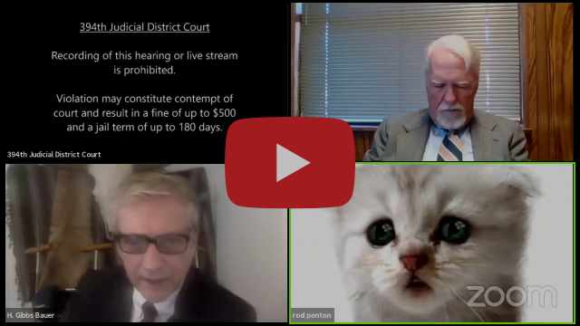

The Western Ontario Waterways Regional Council newsletter welcomes submissions of
upcoming events, regional news and educational opportunities.

Connecting, Supporting, Transforming

Western Ontario Waterways Regional Council
The United Church of Canada

Sign up for our newsletter.

For information, contact Pretima: pkukadia@united-church.ca
Our phone number is: 1-833-236-0280
Our mailing address is:
The United Church of Canada
PO Box 100
Carlisle, ON L0R 1H0
Canada
Add us to your address book
Copyright © 2021 The United Church of Canada, All rights reserved.

