To access a link in this newsletter, please press CTRL + mouse click on the highlighted link.

View this newsletter in your browser
Next Deadline for submissions: February 10 (February 16 Issue)

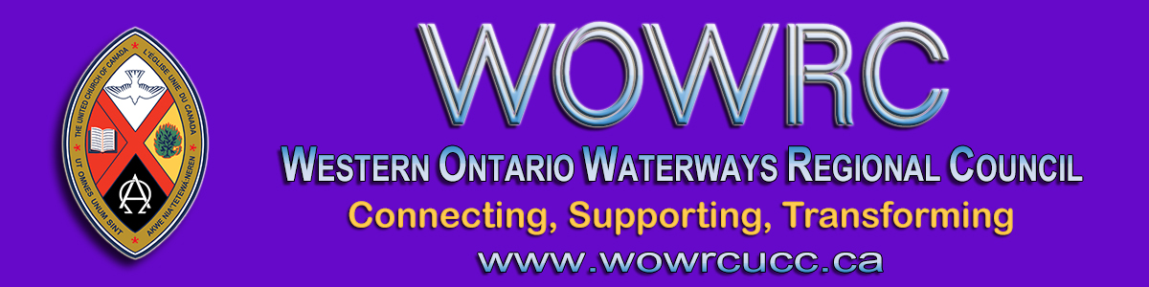

REGIONAL COUNCIL OFFICE NEWS

Greetings Friends in Christ,

Today I bring sad news. Like so many families who have lost loved ones during this time our WOWRC family has also been touched by death. This past week one of our Regional Staff, John Neff, lost his son Joshua Ukes to cancer. I know that you will join me as we pray for John’s family and Josh’s family for whom this death has been devastating.
Anyone wishing to send condolences may do so care of the Regional Office, Box 100, Carlisle, ON L0R 1H0 or to jneff@united-church.ca. If using email, please ensure the subject line reads Condolences. That will give John options as to when he reads these private messages compared to his waiting work ones.
Donations may be made to the Princess Margaret Hospital Brain Cancer Research Fund, Toronto Western Hospital Krembil Brain Institute or Residential Hospice of Grey Bruce, Chapman House.
At this point, John anticipates returning to work mid-February.
May God be with us all!
Peace,
Rev. Gary Clark
President, Western Ontario Waterways Regional Council

The Western Ontario Waterways Regional Council newsletter welcomes submissions of upcoming events, regional news and educational opportunities. This is also the place to keep up-to-date on information from the regional office.
Check out the page and the channel!

Connecting, Supporting, Transforming

Western Ontario Waterways Regional Council
The United Church of Canada

SUBSCRIBE!

Copyright © 2021 Western Ontario Waterways Regional Council, UCC, All rights reserved.
Want to change how you receive these emails?
You can update your preferences or unsubscribe from this list.

