To access a link in this newsletter, please press CTRL + mouse click on the highlighted link.

View this newsletter in your browser
Next Deadline for submissions: February 10 (February 16 Issue)

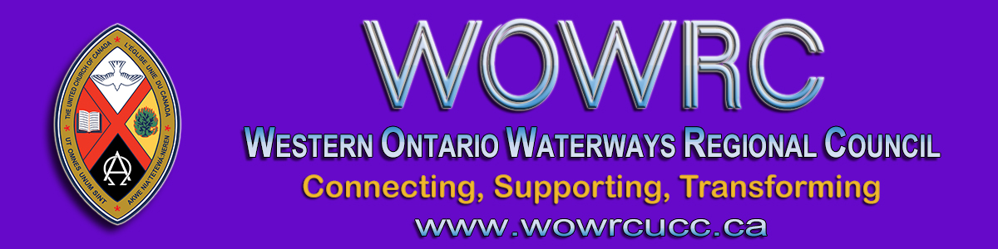

Greetings Friends in Christ,

John Neff's son's correct spelling and full name is: Joshua Mark Ufkes.
Peace,
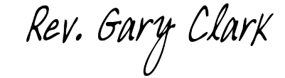
Rev. Gary Clark
President, Western Ontario Waterways Regional Council

The Western Ontario Waterways Regional Council newsletter welcomes submissions of upcoming events, regional news and educational opportunities. This is also the place to keep up-to-date on information from the regional office.
Check out the page and the channel!

Connecting, Supporting, Transforming

Western Ontario Waterways Regional Council
The United Church of Canada

SUBSCRIBE!

Copyright © 2021 Western Ontario Waterways Regional Council, UCC, All rights reserved.
Want to change how you receive these emails?
You can update your preferences or unsubscribe from this list.

