To access a link in this newsletter, please press CTRL + mouse click on the highlighted link.

View this newsletter in your browser
Next Deadline for submissions: January 20 (January 25 Issue)

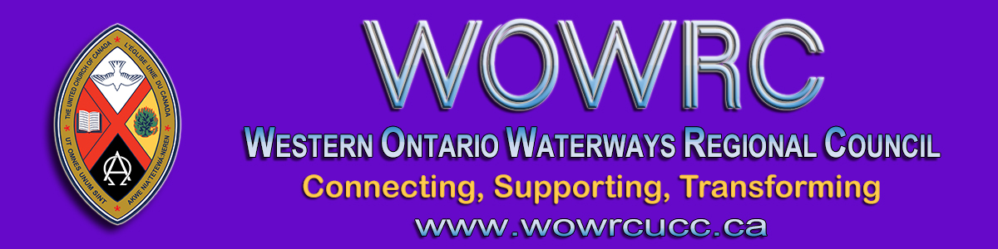

REGIONAL COUNCIL OFFICE NEWS

Our Christmas Staff Meeting - Just like yours!

Take care of yourselves and may the Christmas season
fill you with hope, peace, joy and love.
Regional Council staff

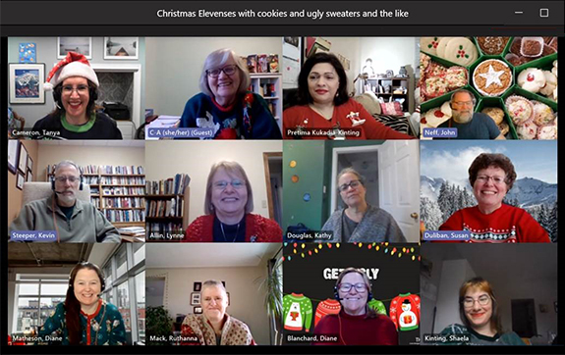

From top left: Tanya Cameron, Cheryl-Ann Stadelbauer-Sampa, Pretima Kukadia-Kinting, John Neff, Kevin Steeper, Lynne Allin, Kathy Douglas, Sue Duliban, Diane Matheson-Jimenez, Ruthanna Mack, Diane Blanchard, Shaela Kinting.

More Good Things To Know ... from the Covenant Commission

Recognizing that this has been a year like no other, the Covenant Commission has put together some important information to help you take care of your community of faith. You will find this package on the website Congregational Support Toolkits, Toolkit # 11. In this package you will find helpful tips and resources for:
- Preparing your annual report
- Planning your annual meeting
- Completing your community of faith profile and living faith story
- How to do an annual self-assessment and
- Updates on changes related to Covid-19
Take a look at this information and share it with members of your congregation’s governing body, ministry personnel etc. Thank you all for the incredible ministry you are doing!
Please contact John Neff, Minister Congregational Support and Mission, with any questions.

EVENTS

Caste by Isabel Wilkerson
Strathroy United Church
Thursday, January 28, 7:00 - 9:00 pm by Zoom Link

An interactive Zoom discussion of Isabel Wilkerson’s book Caste: The Origins of our Discontents, hosted by Brad Morrison and Gail Barker. Caste is a powerful and beautifully written examination of the unspoken caste system shaping our culture’s race relations. If you’re looking for an intelligent holiday read, ask Santa to put this book in your stocking. You are welcome to join the Zoom discussion event even if you haven’t read all (or any) of the book’s 495 pages.
The 2 hour discussion will spark your thinking about anti-black racism. To register, email Brad Morrison for the Zoom link. If the cost of the book is an obstacle, get in touch with Brad.
The discussion is sponsored by Strathroy United Church and financial support from the Centre for Practical Theology (CPT). Download the poster for complete information.

Evolving Christianity
Sydenham-Heritage United Church, Brantford
Starting January 11 at 7:00 pm by Zoom Link

Join this book discussion group once a week for 6 weeks. Evolving Christianity takes a reflective and scientific look at Christianity and asks the simple question, "Can Christianity be made to work better today fighting racism and sexism?"
The book is available at the Five Oaks bookstore, on Amazon or from the trunk of Rev. Paul Shepherd's car.
Download the brochure. Email Paul Shepherd for more information.

The Western Ontario Waterways Regional Council newsletter welcomes submissions of upcoming events, regional news and educational opportunities. This is also the place to keep up-to-date on information from the regional office.
Check out the page and the channel!

Connecting, Supporting, Transforming

Western Ontario Waterways Regional Council
The United Church of Canada

SUBSCRIBE!

Copyright © 2020 Western Ontario Waterways Regional Council, UCC, All rights reserved.
Want to change how you receive these emails?
You can update your preferences or unsubscribe from this list.

