To access a link in this newsletter, please press CTRL + mouse click on the highlighted link.

View this email in your browser
Next Deadline for submissions: TBA
Forward this to a friend to sign up for this newsletter.

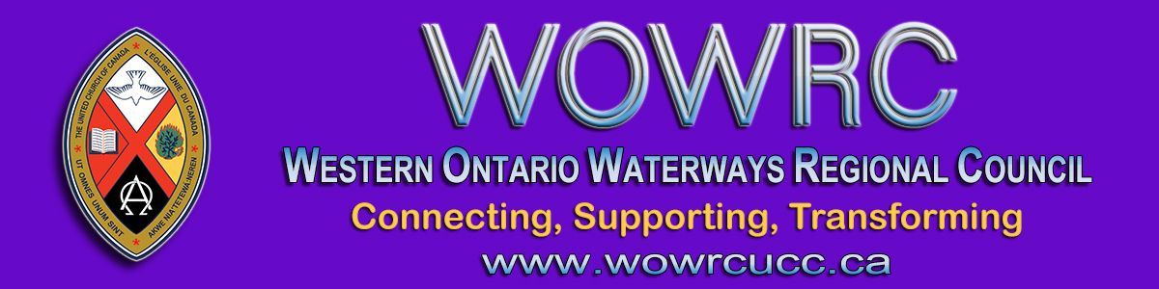

Next Week is Our First Ever
Virtual Regional Council Meeting!

Dear Members of Western Ontario Waterways Regional Council,
Click to Register before midnight Friday!
All ministry personnel, representatives from communities of faith and guests joining the meeting must register by the registration deadline:
Midnight, Friday, October 9.
Tuesday morning, October 13, registrants will receive:
- The link to the Workbook for the meeting with reports, background information and meeting materials;

- The link to the financial webinar scheduled for Tuesday, October 13 at 7:00 p.m.

- The link for the meeting sessions. The same link will be used for Thursday, Friday and Saturday.
The live-streamed Celebration of Ministry service on Sunday at 10 a.m. can be found here: https://youtu.be/_P2mzF8I6oc and on the regional council YouTube channel. Please share this link with your community of faith - this service is open to all.
Attached is a worship service (MS Word and for others) you can share with worshipers who do not have access to the Internet.
Thank you for your patience as we prepare. Enjoy the Thanksgiving weekend (please, register)! Looking forward to our time together.

October 13 | Tuesday  Finance Webinar | 7:00 – 8:00 pm
- - - - - - - - - - - - - - - - - - - - - - - - - - - - - - - - - - - - - - - - - - - - - - - - - - - - - - - - - - - - - - - - - - - - - - - - - - - - - -
October 15 | Thursday | 6:00 – 7:30 pm
October 16 | Friday | 4:00 – 5:30 pm
October 17 | Saturday | 9:30 – 11:00 am &  1:00 - 2:30
October 18 | *Sunday | 10:00 am
*The Celebration of Ministries Service will be livestreamed.
Rev. Keith Reynolds, Avondale United Church, Stratford, will preach.

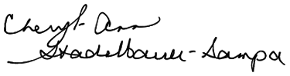
Blessings,
Executive Minister, Western Ontario Waterways Regional Council

The Western Ontario Waterways Regional Council newsletter welcomes submissions of upcoming events, regional news and educational opportunities. This is also the place to keep up-to-date on information from the regional office.

Connecting, Supporting, Transforming

Western Ontario Waterways Regional Council
The United Church of Canada

Sign up for our newsletter.
For information, contact Pretima: pkukadia@united-church.ca
Our phone number is: 1-833-236-0280
Our mailing address is:
Western Ontario Waterways Regional Council, UCC
PO Box 100
Carlisle, On L0R 1H0
Canada
Add us to your address book
Copyright © 2020 Western Ontario Waterways Regional Council, UCC, All rights reserved.

