To access a link in this newsletter, please press CTRL + mouse click on the highlighted link.

View this email in your browser
Next Deadline for submissions: tba
Forward this to a friend to sign up for this newsletter.

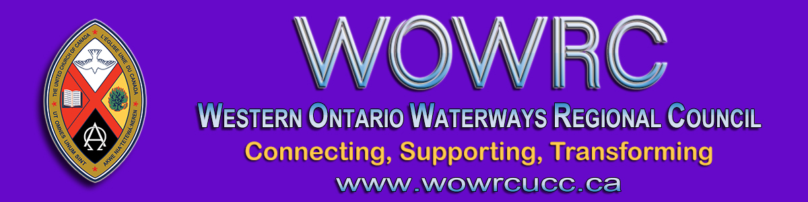

Wesley United Church Donations
Firefighters were called to Wesley United Church at 1:30 a.m. Monday morning to the first of three church fires in Saugeen First Nation.
(Story in Owen Sound Sun Times)

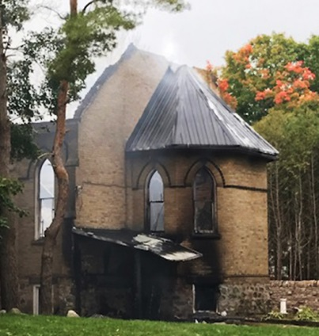
The regional council is collecting financial donations in support of Wesley United Church on the Saugeen First Nation following Monday’s devastating fire.
* We will advise you on the Facebook Group as other donation options become available.

Please forward support by mailing a cheque payable to Western Ontario Waterways Regional Council with WesleyUCFire in the memo line, to:
Western Ontario Waterways Regional Council
Box 100
Carlisle, Ontario L0R 1H0
Thank you for your prayers and any financial support you can offer.

The Western Ontario Waterways Regional Council newsletter welcomes submissions of upcoming events, regional news and educational opportunities. This is also the place to keep up-to-date on information from the regional office.

Connecting, Supporting, Transforming

Western Ontario Waterways Regional Council
The United Church of Canada

Sign up for our newsletter.

For information, contact Pretima: pkukadia@united-church.ca
Our phone number is: 1-833-236-0280
Our mailing address is:
Western Ontario Waterways Regional Council, UCC
PO Box 100
Carlisle, On L0R 1H0
Canada
Add us to your address book
Copyright © 2020 Western Ontario Waterways Regional Council, UCC, All rights reserved.

