To access a link in this newsletter, please press CTRL + mouse click on the highlighted link.

View this email in your browser
Next Deadline for submissions: TBA
Forward this to a friend to sign up for this newsletter.

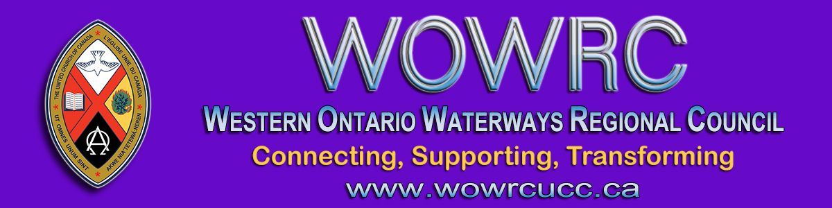

Registration for Fall Regional Council Meeting
Thursday, October 15 - Sunday, October 18
* ALL EVENTS ARE ONLINE, ZOOM LINKS WILL BE SENT *

Click here to register

Thursday, October 15 | 6:00 – 7:30 pm
Friday, October 16 | 4:00 – 5:30 pm
Saturday, October 17 | 9:30 – 11:00 am  1:00 - 2:30 pm
Sunday, October 18  Celebration of Ministries Service LIVE STREAMED | 10:00 am

Registration is for Thursday, Friday and Saturday meetings.
Registration not required for Sunday. Please note: it will be live streamed.

The Western Ontario Waterways Regional Council newsletter welcomes submissions of upcoming events, regional news and educational opportunities. This is also the place to keep up-to-date on information from the regional office.

Connecting, Supporting, Transforming

Western Ontario Waterways Regional Council
The United Church of Canada

SUBSCRIBE!

Copyright © 2020 Western Ontario Waterways Regional Council, UCC, All rights reserved.

