To access a link in this newsletter, please press CTRL + mouse click on the highlighted link.

View this email in your browser
Next Deadline for submissions: TBA
Forward this to a friend to sign up for this newsletter.

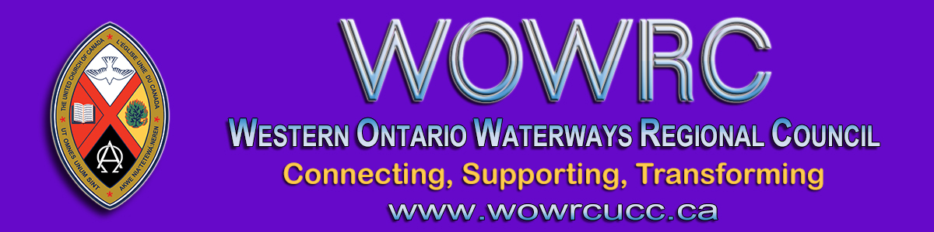

Affirming Our Communities, Affirming Our Faith
“Love one another as I have loved you.”
Join us on the Affirming Journey: Affirm Network Workshop
Tuesday, September 22 from 3:00 to 4:30 pm
What is the workshop about? At local, regional and national levels we have a part to play and this workshop offers – in plenary and small group discussion - information, education and humour for living out this call.
At the Fall Meeting of the regional council you will be asked to vote on a remit to add to the wording for Article 10.0 of the Basis of Union.
The question is: Does the regional council agree that
a) the Order of Ministry be open to persons of all gender
identities; and
b) the Basis of Union be amended to reflect this change.
Read the Affirming Ministries Action Plan.

Join us Tuesday, September 22 at 3:00 pm, click on this Zoom link

To join by webcam:  Click on the Zoom link. Zoom will open in your web browser. If asked, enter  Meeting ID numbers: 913-3888-0811 | To join by telephone audio only:  Call the Toll-free number 1-855-703-8985. When asked enter the  Meeting ID numbers 913-3888-0811

The Western Ontario Waterways Regional Council newsletter welcomes submissions of upcoming events, regional news and educational opportunities. This is also the place to keep up-to-date on information from the regional office.

Connecting, Supporting, Transforming

Western Ontario Waterways Regional Council
The United Church of Canada

Sign up for our newsletter.

For information, contact Pretima: pkukadia@united-church.ca
Our phone number is: 1-833-236-0280
Our mailing address is:
Western Ontario Waterways Regional Council, UCC
PO Box 100
Carlisle, On L0R 1H0
Canada
Add us to your address book
Copyright © 2020 Western Ontario Waterways Regional Council, UCC, All rights reserved.

