To access a link in this newsletter, please press CTRL + mouse click on the highlighted link.

View this email in your browser
Next Deadline for submissions: TBA
Forward this to a friend to sign up for this newsletter.

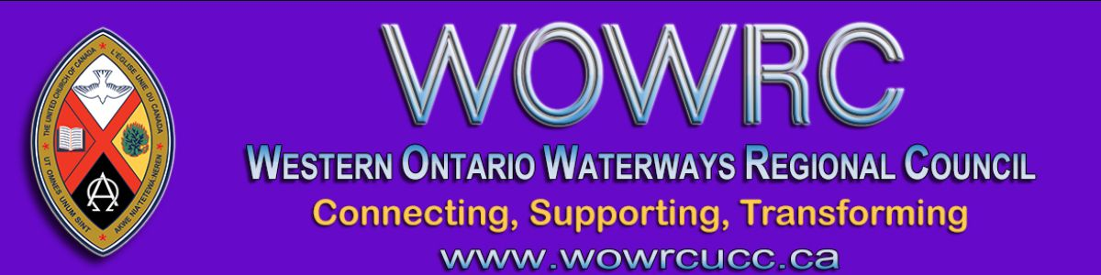

Connecting, Supporting, Transforming during COVID-19
A Conversation about Safe Re-entry
Thursday, September 17th, 7 pm to 8:30 pm on Zoom
President Gary Clark and members of the WOWRC Executive invite ministers and lay people to connect on September 17th to share what is working for your community of faith, support one another as we face these challenging times, and imagine how our churches might be transformed by this experience.
There is not one right path and our purpose in gathering is to listen and support one another so we can discern our individual paths going forward.

Things to think about to help guide the conversation
Where are you now?
How are you connecting as a community of faith?
What is working?
What is a blessing your community of faith has received?
What are you finding challenging?

Join the conversation at 7 pm on September 17th by clicking on the following Zoom link https://united-church.zoom.us/j/98134725193
Meeting ID: 981 3472 5193

To join by phone: 855 703 8985 (Canada Toll-free)
Meeting ID: 981 3472 5193

Leadership will be available at 6:50 pm if you need support with Zoom.
Please call 519-265-7385 if you have difficulty connecting.

The Western Ontario Waterways Regional Council newsletter welcomes submissions of upcoming events, regional news and educational opportunities. This is also the place to keep up-to-date on information from the regional office.

Connecting, Supporting, Transforming

Western Ontario Waterways Regional Council
The United Church of Canada

Sign up for our newsletter.

For information, contact Pretima: pkukadia@united-church.ca
Our phone number is: 1-833-236-0280
Our mailing address is:
Western Ontario Waterways Regional Council, UCC
PO Box 100
Carlisle, On L0R 1H0
Canada
Add us to your address book
Copyright © 2020 Western Ontario Waterways Regional Council, UCC, All rights reserved.

