To access a link in this newsletter, please press CTRL + mouse click on the highlighted link.

View this email in your browser
Next Deadline for submissions: TBA
Forward this to a friend to sign up for this newsletter.

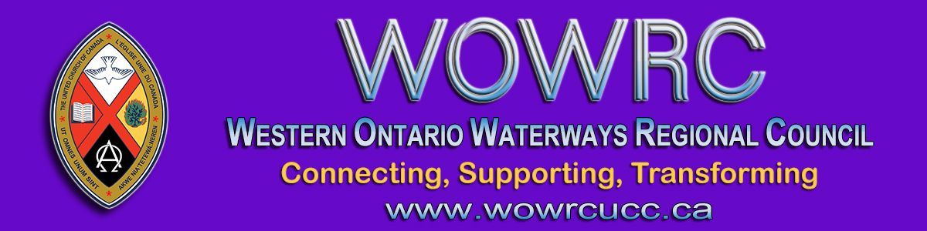

First Ever Virtual Regional Council Meeting

Western Ontario Waterways Regional Council is holding our FIRST EVER virtual regional council meeting! We will make history.
Save these meeting dates & times!
October 15 | Thursday | 6:00 – 7:30 pm
October 16 | Friday | 4:00 – 5:30 pm
October 17 | Saturday | 9:30 – 11:00 am &
 |  | 1:00 - 2:30 pm
October 18 | *Sunday | 10:00 am
*The Celebration of Ministries Service will be livestreamed.
Rev. Keith Reynolds, Avondale United Church, Stratford, will preach.
Celebration of Ministries Service
Plan now for your congregation to join the livestreamed service from Avondale United Church, Stratford, on Sunday morning. All communities of faith are invited to join the regional council service. Ministry Personnel are entitled to take this Sunday off for the regional council meeting. Instead of providing an alternate service for congregational worship, a link will be shared to enable us to worship as one -- a new and exciting experience!

To Prepare for the Meeting
Each Community of Faith is asked to
- Ensure that their representative(s) to the regional council have been selected according to the formula set out in The Manual C.1.2.
- Share the news of our joint Sunday worship service with all your members.
For Regional Council Representatives and Ministry Personnel
Information will be available in September for you to register for the meeting. Prior registration is essential for online voting.
Information is available on the website for regional council representatives and ministry personnel to
- Consider openings on the Executive and Commissions and discern how you might become involved. The work of the Executive and Commissions is detailed in the Governance Handbook.
- Consider if you are our regional council's next President (to take office in the spring of 2021).

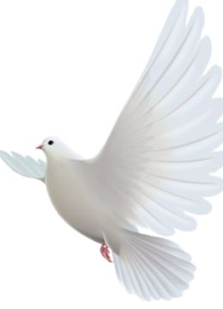
Further details/information and the registration form will be available in September. Watch for emailed newsletters or check the Regional Council Meeting page on the website.
This is such an exciting opportunity for us to learn to do something different together! We'll need patience and imagination and the blessing of the Spirit!

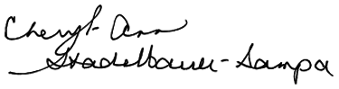
Blessings,
Executive Minister, Western Ontario Waterways Regional Council

Upcoming Events - SAVE THE DATES
Connecting, Supporting, Transforming during COVID-19
A Conversation about Safe Re-entry
September 17th, 7 to 8:30 pm on Zoom
The WOWRC Executive invites ministers & lay people to connect and share what is working for your community of faith, support one another as we face these challenging times and imagine how our churches might be transformed by this experience. The link to this session will be shared soon.

AFFIRM NETWORK Webinar
Tuesday, September 22nd, 3 to 4:30 pm on Zoom
The link to this important advance session, in preparation for discussion at the Fall Meeting, will be shared soon.

The Western Ontario Waterways Regional Council newsletter welcomes submissions of upcoming events, regional news and educational opportunities. This is also the place to keep up-to-date on information from the regional office.

Connecting, Supporting, Transforming

Western Ontario Waterways Regional Council
The United Church of Canada

Sign up for our newsletter.

For information, contact Pretima: pkukadia@united-church.ca
Our phone number is: 1-833-236-0280
Our mailing address is:
Western Ontario Waterways Regional Council, UCC
PO Box 100
Carlisle, On L0R 1H0
Canada
Add us to your address book
Copyright © 2020 Western Ontario Waterways Regional Council, UCC, All rights reserved.

