To access a link in this newsletter, please press CTRL + mouse click on the highlighted link.

View this email in your browser
Next Deadline for submissions: TBA
Forward this to a friend to sign up for this newsletter.

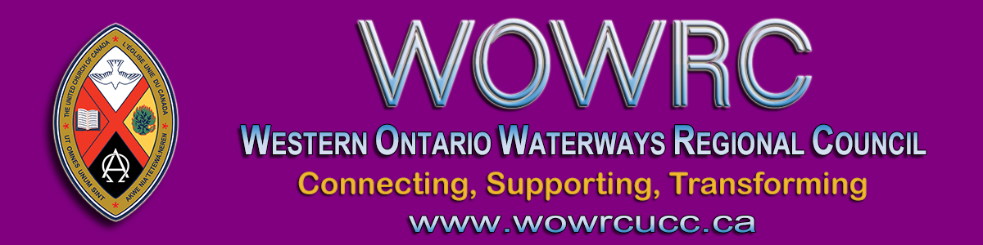

Dear Members of the Regional Council,

Are you our next regional council President? Do you care about Connecting, Supporting, Transforming? If so, this is one way to participate in that ministry!
At the October 2020 Fall meeting the regional council will be electing its next President. This person will serve as President-Elect until the May 2021 regional council meeting. Then they will serve for two years as President followed by one last year as Past-President.
More details, including the Position Description, can be found in the Governance Handbook.
Is this the next great adventure God has waiting for you?
Being President is an opportunity that you do not want to miss. There is no other single event in my years in ministry that had the impact being President of Conference did. It shaped my understanding of myself and of how I offer leadership. I am grateful for what I learned and how I was formed for ministry through the experience of being President.
Consider yourself tapped on the shoulder!
If you would be willing to let your name stand as a nominee for president, please complete the Expression of Interest Form by FRIDAY, OCTOBER 16 at 6 PM. This information (minus your personal contact details) will be available to regional council members for consideration before voting. Nominees will be speaking to the regional council before the election for up to 5 minutes via Zoom on Saturday morning, October 17th.
Please prayerfully consider letting your name stand as a nominee.

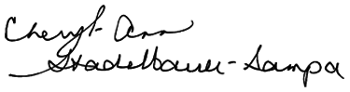
Cheryl-Ann Stadelbauer-Sampa
Executive Minister

The Western Ontario Waterways Regional Council newsletter welcomes submissions of upcoming events, regional news and educational opportunities. This is also the place to keep up-to-date on information from the regional office.

Connecting, Supporting, Transforming

Western Ontario Waterways Regional Council
The United Church of Canada

Sign up for our newsletter.

For information, contact Pretima: pkukadia@united-church.ca
Our phone number is: 1-833-236-0280
Our mailing address is:
Western Ontario Waterways Regional Council, UCC
PO Box 100
Carlisle, On L0R 1H0
Canada
Add us to your address book
Copyright © 2020 Western Ontario Waterways Regional Council, UCC, All rights reserved.

