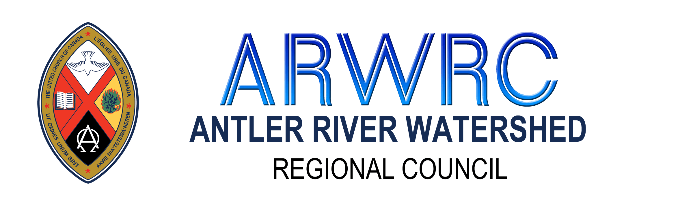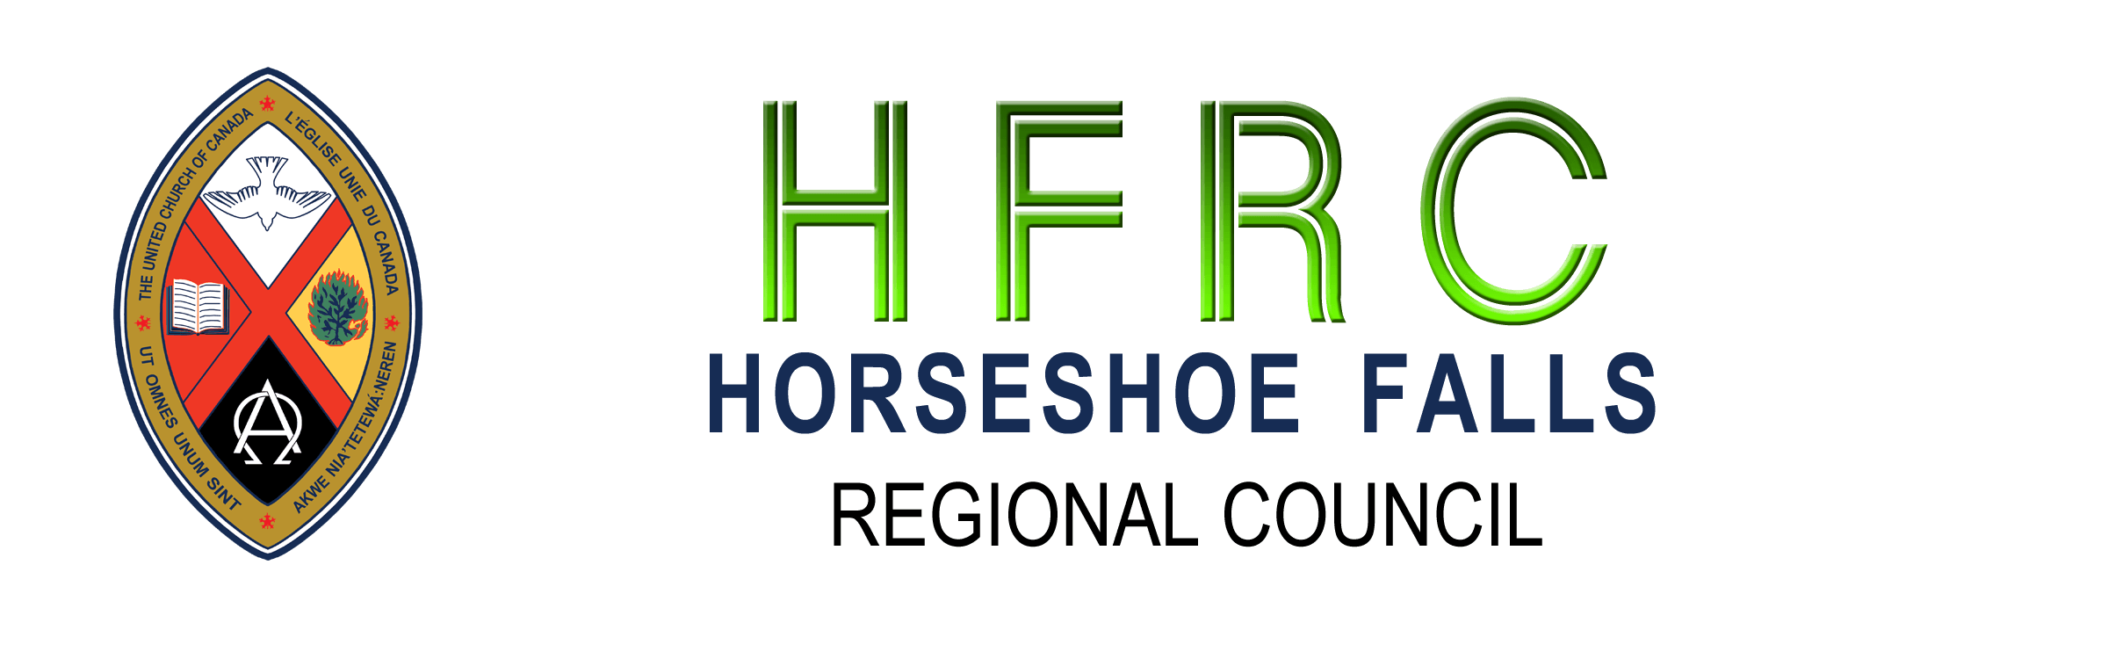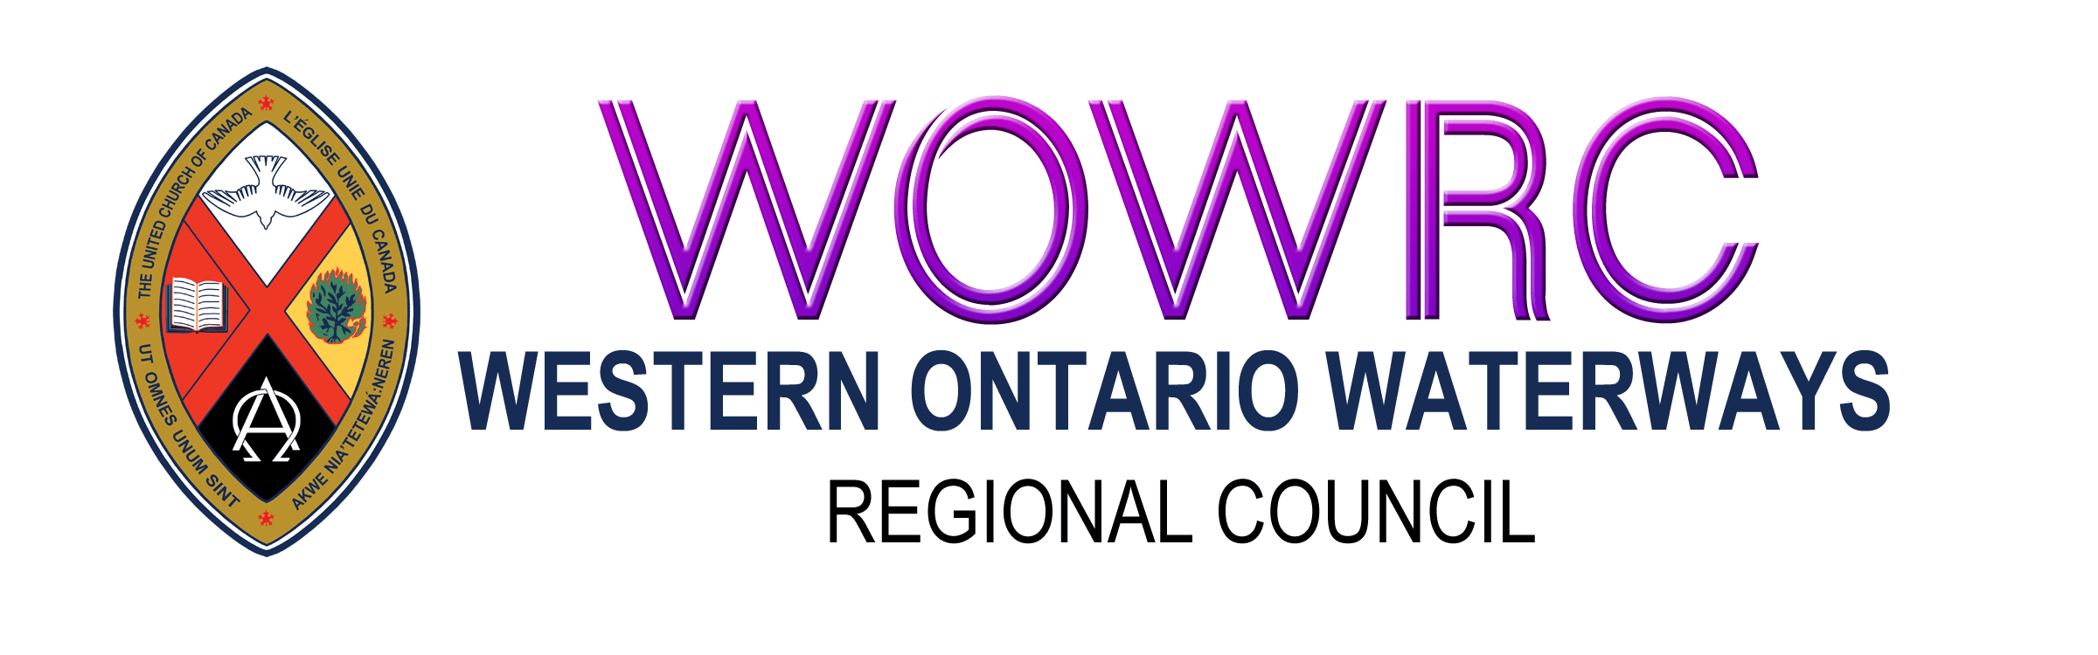
Disbanding Community of Faith: Information and Asset Disbursement
Instructions
Completing the Form:
Page 1. Contact Information:
- Please provide all contact information. The Covenant Commission will set the disbanding date.
Page 2. Net Asset Calculation:
- Enter the dollar amounts for assets and outstanding expenses.
- Subtract outstanding expenses from assets to calculate Total Amount Available for Disbursement.
Page 3. Disbursement of Assets:
- List the United Church Ministries proposed by the congregation and approved by the Covenant Commission. Indicate the percentage of the total amount available for disbursement and the dollar figure. Refer to the Handbook Disbanding: Steps for Closing Well for details on selecting United Church Ministries.
- Record the appropriate motion from the congregation on page 4 of the Asset Form.
- Calculate the dollar amount of the remaining percentage of the assets based on the Regional Council Property Policy. At this point everything is filled in except the disbanding date, cheque numbers, cheque date and final motion of disbanding from the covenant commission.
Next Steps:
- Send the form to the Minister, Congregational Support and Mission for review by the Covenant Commission.
- Once the Covenant Commission has set the disbanding date, that information will be added to the form and it will be returned to the congregation.
- Complete payment of any outstanding expenses
- Prepare and send cheques to the United Church Ministries identified on the Disbursement form. Add cheque numbers and dates to the Asset form. Email a copy of the Information and Asset Distribution form to the Minister, Congregational Support and Mission.
- Prepare a cheque payable to the Regional Council for the remaining percentage and mail it to Regional Council Office P.O. Box 100, Carlisle, ON L0R1H0. Please include a copy of the completed Information and Asset Distribution Form with the cheque.

