To access a link in this newsletter, please press CTRL + mouse click on the highlighted link.

View this email in your browser
Next Deadline for submissions: TBA
Forward this to a friend to sign up for this newsletter.

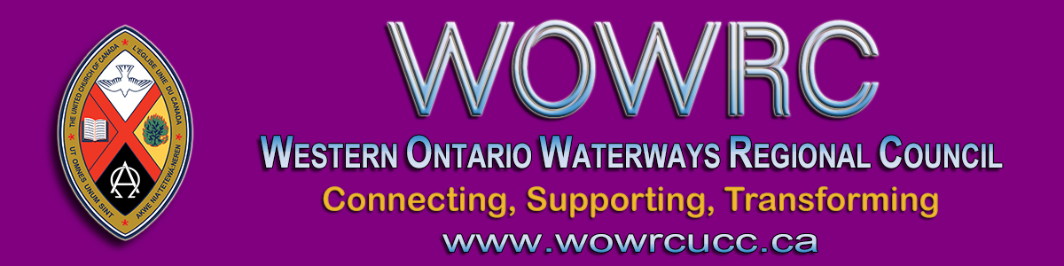

Dear Friend,

The United Church of Canada regional councils of Ontario agreed upon a common policy for licences to marry to facilitate the transfer of current licence holders into the new regional councils. This new policy aligns with the legislation which states that the issuing of a licence to marry must be attached to pastoral responsibilities for this function.
Retired members of the Order of Ministry, unless they are in appointment or have entered into a Voluntary Associate Minister relationship with a community of faith, will not hold an active licence to marry. The licence to marry will be cancelled as per the time frame below:
- Retired members of the Order of Ministry:
  - four (4) months following the end of the pastoral relationship
- Members of the Order of Ministry on restorative care/long term disability when retirement is taken:
  - six (6) months following the end of the pastoral relationship
- Designated Lay Ministers who have retired:
  - immediately upon retirement
I liken it to a plumber’s van: The plumber only needs the van when employed in making house calls as a plumber. In the same way, a minister only needs a marriage licence when fulfilling a pastoral role that requires it. This is outlined in the marriage policy posted on the regional council website under Pastoral Relations Toolkit #5.
Effective September 15, 2020, retired members of the Order of Ministry who currently have an active licence to marry will have their licence cancelled if they are not in appointment or in a VAM relationship. Those who were designated lay ministers and have retired, will also have their licence cancelled as of September 15, 2020.
Note: retired members of the Order of Ministry are eligible to apply for a temporary marriage licence up to three (3) times only per calendar year.
Our records indicate you are not in an appointment but still maintain an active licence to marry, so therefore, unless you will be starting an appointment or entering into a VAM relationship, your licence to marry will be cancelled in September.
If you have a special request to perform a marriage service up until December 15, 2020, please contact Sue Duliban, Governing Official, at sduliban@united-church.ca by September 1, 2020. We will not be able to accommodate any special requests after December 15, 2020.
If our records are in error, please email Sue Duliban, Executive Assistant/Governing Official and/or Diane Blanchard, Minister Pastoral Relations. Any questions regarding licence to marry registration/cancellation/clergy updates should be directed to Sue Duliban.

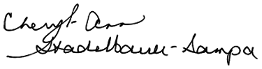
Blessings,
Executive Minister, Antler River Watershed Regional Council

Click here to download a copy of this Marriage Licence Policy letter.

The Western Ontario Waterways Regional Council newsletter welcomes submissions of upcoming events, regional news and educational opportunities. This is also the place to keep up-to-date on information from the regional office.

Connecting, Supporting, Transforming

Western Ontario Waterways Regional Council
The United Church of Canada

Sign up for our newsletter.

For information, contact Pretima: pkukadia@united-church.ca
Our phone number is: 1-833-236-0280
Our mailing address is:
Western Ontario Waterways Regional Council, UCC
PO Box 100
Carlisle, On L0R 1H0
Canada
Add us to your address book
Copyright © 2020 Western Ontario Waterways Regional Council, UCC, All rights reserved.

