To access a link in this newsletter, please press CTRL + mouse click on the highlighted link.

View this email in your browser
Next Deadline for submissions: TBA
Forward this to a friend to sign up for this newsletter.

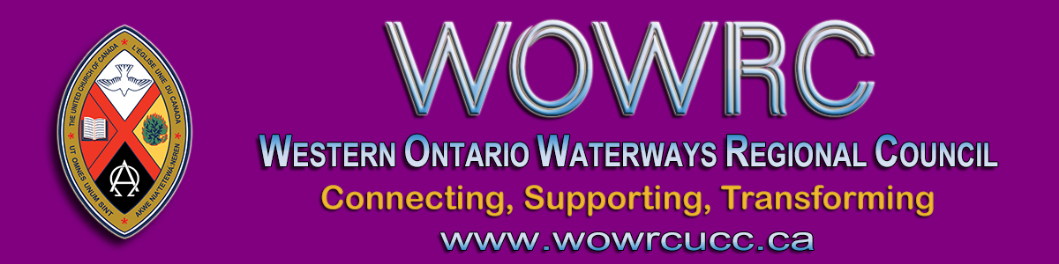

Hello Commissioners
A debriefing meeting has been set up with Zoom
Tuesday, July 14 at 7:00 pm

The discussion of anti-black racism at the June 20th meeting of the General Council was unsettling for many.

If you would like an opportunity to debrief, Teresa Burnett Cole, one of the equity monitors has indicated she would be willing to meet with us. I am also reaching out to Katie Curtis, the second equity monitor, to ask if she would assist.

- - - Cheryl-Ann Stadelbauer-Sampa, Executive Minister - - -

If you would like to join this gathering, click on this Zoom link.

To join by webcam:  Click on the Zoom link. Zoom will open in  your web browser. If you are asked, enter  Meeting ID numbers: 998 8642 3023  Download the Zoom instructions. | To join by telephone audio only:  Call the Toll-free number 1-855-703-8985.  When you are asked, enter the  Meeting ID numbers 998 8642 3023  Download the Zoom instructions.

The Western Ontario Waterways Regional Council newsletter welcomes submissions of upcoming events, regional news and educational opportunities. This is also the place to keep up-to-date on information from the regional office.

Connecting, Supporting, Transforming

Western Ontario Waterways Regional Council
The United Church of Canada

Sign up for our newsletter.

For information, contact Pretima: pkukadia@united-church.ca
Our phone number is: 1-833-236-0280
Our mailing address is:
Western Ontario Waterways Regional Council, UCC
PO Box 100
Carlisle, On L0R 1H0
Canada
Add us to your address book
Copyright © 2020 Western Ontario Waterways Regional Council, UCC, All rights reserved.

