To access a link in this newsletter, please press CTRL + mouse click on the highlighted link.

View this email in your browser
Next Deadline for submissions: TBA
Forward this to a friend to sign up for this newsletter.

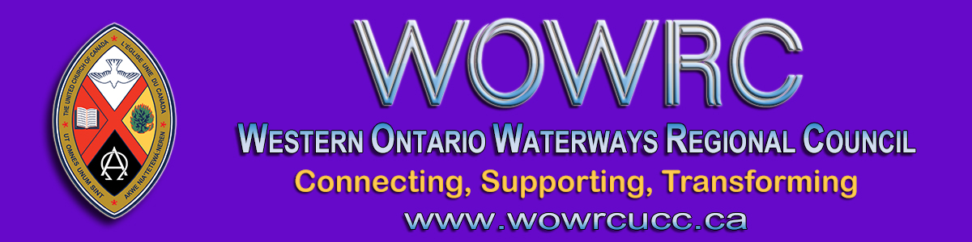

INVITATION to CLERGY (Ministry, please)
For an online gathering of clergy by Zoom
Thursday, July 9 - 1:00 - 2:30 pm
You are invited to take part in a gathering of clergy in your regional council. This is an opportunity to come together with your colleagues who are also ministering in these difficult times. We will share information, ask questions and find support together.
Let's meet, online by Zoom, from the comfort & safety of your home or home office on Thursday, July 9 from 1:00 - 2:30 pm.
Your hosts: Kevin Steeper, Diane Blanchard and Tanya Cameron

If you would like to join this gathering, click on this Zoom link.

To join by webcam:  Click on the Zoom link. Zoom will open in your web browser. If you are asked, enter Meeting ID numbers: 958-6096-3694 | To join by telephone audio only:  Call the Toll-free number 1-855-703-8985. When asked enter the Meeting ID numbers 958-6096-3694

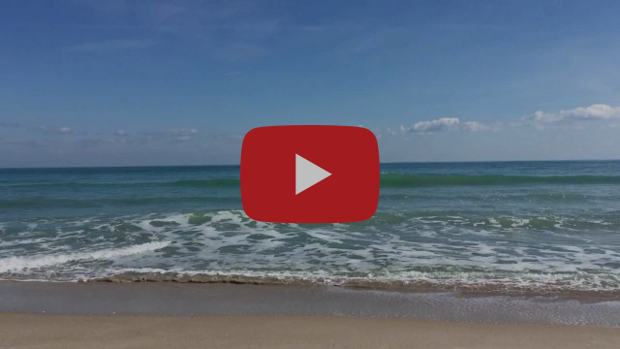
5 Minutes to Calm: A Short Guided Relaxation

The Western Ontario Waterways Regional Council newsletter welcomes submissions of upcoming events, regional news and educational opportunities. This is also the place to keep up-to-date on information from the regional office.

Connecting, Supporting, Transforming

Western Ontario Waterways Regional Council
The United Church of Canada

Sign up for our newsletter.

For information, contact Pretima: pkukadia@united-church.ca
Our phone number is: 1-833-236-0280
Our mailing address is:
Western Ontario Waterways Regional Council, UCC
PO Box 100
Carlisle, On L0R 1H0
Canada
Add us to your address book
Copyright © 2020 Western Ontario Waterways Regional Council, UCC, All rights reserved.

