To access a link in this newsletter, please press CTRL + mouse click on the highlighted link.

View this email in your browser
Next Deadline for submissions: TBA
Forward this to a friend to sign up for this newsletter.

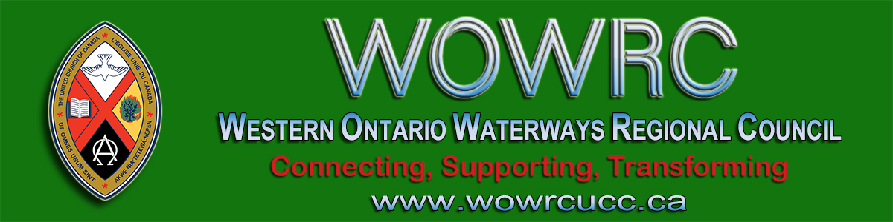

Letter from the Covenant Commission
To Congregations & Ministry Personnel
- - - From Ann Harbridge, Chair - - -
I am writing to you on behalf of the Covenant Commission of Western Ontario Waterways Regional Council, to ask,
"How you are doing in the midst of these pandemic times?"
It is certainly challenging as we seek to be the church when we are forced to be physically apart. So much of what we do is about relationships and being together. Many of us are finding new ways of doing this, with a great reliance on technology and the telephone. Even good old fashion snail mail has found a resurgence in popularity.

With the recent announcement of the Provincial Government that churches may reopen with a 30% capacity we are faced with making decisions on what is the wisest course of action to be taken. While we yearn to gather, we also have a responsibility to protect our most vulnerable members. May God’s grace and wisdom be with you as you have these difficult discussions, set safety protocols and make your decisions.

Grace and peace to you from God our Creator,
and from Jesus Christ.

The covenant commission has been meeting regularly in order to facilitate a quick response to emergent needs, particularly as things change with regard to government assistance and programs being offered. It is our goal to be as supportive as we can be as we work within the polity and policies of the church. In that regard, we made the decision to extend the date granting permission for the use of Presbytery/Regionally restricted funds to cover payroll costs, if needed to ensure the viability of your church. The date has been extended to August 31, 2020. We would still ask that you advise the Covenant Commission if you do draw on restricted funds during this time.

We are also trying to keep track of how our congregations are managing during this time. In that vein, we would appreciate if you would advise us when you are making application for the various government programs

being offered, whether you have been successful in your applications, and whether these sources of funding have been helpful.

As we continue to navigate these unprecedented times, please be kind to one another. Paul in his writings often began with a greeting to the various churches. Grace and peace to you from God our Creator, and from Jesus Christ. (Paul used Father, but I prefer Creator). I offer this same greeting to you, as you continue to be the church in your community, meeting the challenges that come before you.

Blessings,
Ann Harbridge
Chair, Covenant Commission,
Western Ontario Waterways Regional Council

- - - Download a copy of the letter - - -

The Western Ontario Waterways Regional Council newsletter welcomes submissions of upcoming events, regional news and educational opportunities. This is also the place to keep up-to-date on information from the regional office.

Connecting, Supporting, Transforming

Western Ontario Waterways Regional Council
The United Church of Canada

Sign up for our newsletter.

For information, contact Pretima: pkukadia@united-church.ca
Our phone number is: 1-833-236-0280
Our mailing address is:
Western Ontario Waterways Regional Council, UCC
PO Box 100
Carlisle, On L0R 1H0
Canada
Add us to your address book
Copyright © 2020 Western Ontario Waterways Regional Council, UCC, All rights reserved.

