To access a link in this newsletter, please press CTRL + mouse click on the highlighted link.

View this email in your browser
Next Deadline for submissions: March 20
Sign up for our newsletter & forward this one to friends.

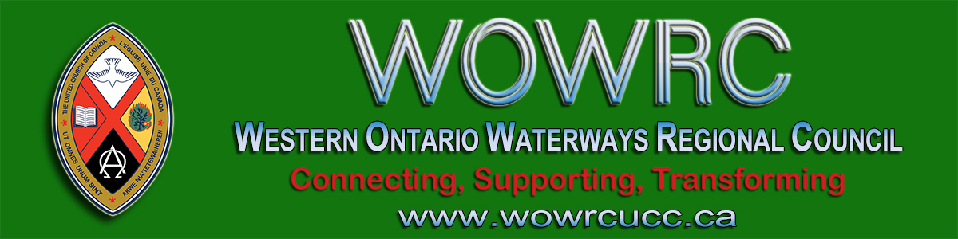

Greetings Brothers and Sisters in Faith,
Subject: The suspension of worship and any ministry gatherings.

Like you the Regional Council has been watching the news and is aware of the rise of the Covid-19 virus in Ontario and the rest of Canada. Medical authorities predict its continuing spread. While no immediate cause for fear or panic exists, prudence requires some degree of preparation on the part of congregations in the Western Ontario Waterways Regional Council.

I want to share with you that it is with that idea of prudence that the Council of Forest Hill United Church, Kitchener, where I minister, voted last night to suspend all gathering for public worship and ministries led by Forest Hill United Church. This is in accordance with The United Church of Canada Emergency Plan and is simply for the good health of our congregation and country. I recommend this course of action for all the congregations in our region.

It was a heart wrenching decision for our local council but we worked through a spiral decision-making process offered by our diaconal minister Rev. Ellen Baynton-Walker. We discovered that our primary concern was for the health of our congregation.
"When that was clear, the decision to suspend worship and other gatherings was much easier."

Since gathering together is central to who we are as a community of faith I recommend putting in place ways that allow your congregation to gather virtually:
- Encourage your Lay Pastoral Visitor Team to make phone calls to all those they would normally visit.
- Encourage your Hospitality folks who might put on the coffee or hand out bulletins at worship to instead step up and volunteer to call folks in the congregation so that all of us have that special verbal connection with other members.
- OneLicense, which is a major copyright company, is offering a free month license to live stream music in their catalog. This is an opportunity for your congregation to explore a web based worship service.
- I recommend you continue communicating regularly through emails and on your web page.

It is a strange truth about humanity that we just keep doing what we have done in the past because it is easy. It is only when there is some external change that we are jolted out of our rut and up into creative new options. It is my prayer that a phone ministry actually draws us closer together and we open the door to a whole new internet presence. Who knows what new possibilities the Holy Spirit will reveal to us in this strange new land.

Whatever your congregation chooses to do I trust that we will come out the other side feeling stronger and affirmed that our God and your faith community loves and care for all.
I believe that if we are conscientious about our prudent behavior, we, as a church and community will weather this virus until a vaccine is developed or the spread contained.

In Faith
Rev. Gary Clark,
President
Western Ontario Waterways Regional Council

The Western Ontario Waterways Regional Council newsletter welcomes submissions of upcoming events, regional news and educational opportunities. This is also the place to keep up-to-date on information from the regional office.

Connecting, Supporting, Transforming

Western Ontario Waterways Regional Council
The United Church of Canada

Sign up for our newsletter.

Copyright © 2020 Western Ontario Waterways Regional Council, UCC, All rights reserved.
Want to change how you receive these emails?
You can update your preferences or unsubscribe from this list.

