To access a link in this newsletter, please press CTRL + mouse click on the highlighted link.

View this email in your browser
Next Deadline for submissions: TBA
Forward this to a friend to sign up for this newsletter.

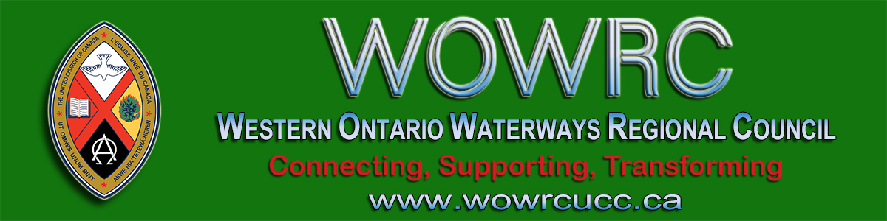

Letter to Ministry Personnel and
Ministry & Personnel Committees
- - - From the Human Resources Commission - - -
We send you greetings in the name of Jesus Christ and pray that you, your communities of faith and all you love are well in this time of pandemic. Thank you for your faithfulness and your encouragement of one another. Thank you for seeking out and learning new ways of being together. Thank you for finding time for deep reflection in this extraordinary period of human history.

Jesus invited the disciples to come away to a quiet place for rest and prayer and we encourage ministry personnel to do that.

We have heard, both from some M&P committees and from some ministry personnel, wonderings about vacations and continuing education. We encourage ministry personnel and all church staff to plan vacation time with your respective M&P committees. Although it may not be possible to travel or do the things one normally looks forward to, it remains important to have time away from the responsibilities of pastoral work. Jesus invited the disciples to come away to a quiet place for rest and prayer and we encourage ministry personnel to do that. The restraints of the pandemic may last several months, and our summers are fleeting. Taking Sabbath time is a vital spiritual practice.

Think about how you might connect with neighbouring communities of faith and their leaders in order to provide access to on-line worship and urgent pastoral care while ministers take vacation in the coming summer and fall. So many of you have put many hours into learning and developing new skills with technology - alternatives to in-person worship. Some of you are already encouraging your people to take advantage of Sunday worship alternatives while you focus on study or reflection or prayer groups.

There are many ways of supporting one another as colleagues to enhance the life of discipleship. And one way to support is to provide pastoral and worship leadership so everyone gets a real break from work responsibilities.

The pandemic is causing many continuing education opportunities to move on-line. The United Church of Canada is providing webinars weekly and there are other exciting resources. M&P committees and ministers can consider which of these helps deepen skills or stimulate reflection or provide inspiration. Three weeks’ leave for continuing education is the equivalent of 15 days if it is broken into smaller units which might include the Sunday.

Be well. Care for yourselves as well as one another.

- - - From the Human Resources Commission - - -

The Western Ontario Waterways Regional Council newsletter welcomes submissions of upcoming events, regional news and educational opportunities. This is also the place to keep up-to-date on information from the regional office.

Connecting, Supporting, Transforming

Western Ontario Waterways Regional Council
The United Church of Canada

Sign up for our newsletter.

For information, contact Pretima: pkukadia@united-church.ca
Our phone number is: 1-833-236-0280
Our mailing address is:
Western Ontario Waterways Regional Council, UCC
PO Box 100
Carlisle, On L0R 1H0
Canada
Add us to your address book
Copyright © 2020 Western Ontario Waterways Regional Council, UCC, All rights reserved.

