To access a link in this newsletter, please press CTRL + mouse click on the highlighted link.

View this email in your browser
Next Deadline for submissions: April 10
Sign up for our newsletter & forward this to a friend.

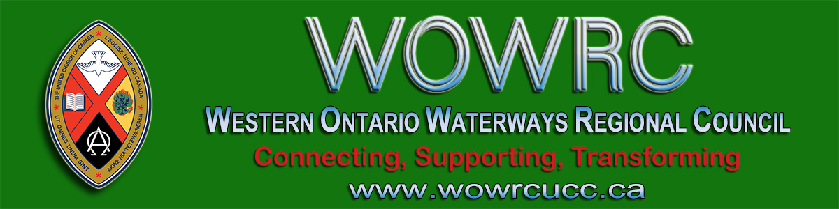

INVITATION to TOWN HALL MEETING
We are looking forward to our first regional council gathering
by Zoom link on Wednesday, March 25th from 1:00 p.m. to 2:30 p.m.
Two people from each community of faith are invited!
Your host is President, Gary Clark

Here's what you need to know in advance:
- The meeting will open with an orientation to using Zoom today
  - For this meeting we will use the CHAT box in Zoom
- YOU will shape the meeting in two ways:
  - Email questions & input you would like to raise at the Town Hall to: wowrc@united-church.ca by midnight Tuesday, March 24. Your input will guide the presentations.
  - During the meeting we ask that you freely share your ideas & feedback in the CHAT box. These ideas will be shared in the regional council newsletter.
  - For those who are joining by phone, we ask that you send your input ahead of time to wowrc@united-church.ca. It will also become part of the CHAT that is shared in the newsletter.

AGENDA - FOR TOWN HALL MEETING
- Orientation to Zoom
- Acknowledgement of the Land: President Gary Clark
- Opening Devotion: President Gary Clark
- Advice for Communities of Faith (to be amended with your input)
  - Pastoral Relations and Employment Concerns
Diane Blanchard, Minister, Pastoral Relations
  - Community of Faith Meetings, Finances, Other Concerns
John Neff, Minister, Congregational Support and Mission
  - Supporting Giving
Dave Jagger, Stewardship and Gifts Officer
  - May Regional Meeting and General Council Update
Cheryl-Ann Stadelbauer-Sampa, Executive Minister
* Staff are available to provide information in their area of expertise.

You are invited to share your responses by email or in the CHAT box to the following two questions:
"How is your community of faith staying connected as a worshiping community, and as a caring community, during this time?"
~ ~ ~ ~ ~
"What are you finding helpful for your personal well-being
during this time of many demands?"
* Please remember! Kevin Steeper, Pastoral Support Minister, is available to ministry personnel during this period of time by email and phone, 1-833-236-0280 ext. 8.

You may join the meeting by:
- Computer, tablet or smartphone for video and/or audio access,
- Telephone for audio access only.
As we are hoping for a lot of people to join the Town Hall, we are conserving bandwidth by having participants enter with video and microphones off.
Internet speed and reliability may be a problem. If so, and you lose the link, please rejoin on a different device or by phone. The Zoom phone-in number may experience heavy traffic. In that case, please try again.
NOTE for telephone users: If you have technical difficulties during the meeting, please call Kathy at 519-441-0656 for assistance.

"Thank you for your patience!"
This is a stressful time and this Town Hall is a chance for all of us to be helpful. There will be questions for which there is no answer--or at least no answer yet. Our goal is to provide answers to questions many are asking, as we can, and, even more importantly, to provide an opportunity for you to share your wisdom with others in the regional council.
CHAT box and email have their limitations but they also offer a connection and sharing as we begin this experiment with online meetings! Let's build online connecting skills together that you can then use with your community of faith.
Looking forward to receiving your questions and gleaning your wisdom,
Shalom,
Cheryl-Ann Stadelbauer-Sampa
Executive Minister

ZOOM LINK
If you would like to join this gathering, click on this Zoom link.
Zoom is very much like Skype, and easy to use.

To join by computer/webcam:  Click on the Zoom link. Zoom will open in your web browser. If you are asked, enter these numbers: 504-423-107. | To join by telephone audio only:  Call the Toll-free number 1-855-703-8985. When asked enter the Meeting ID numbers 504-423-107.

The Western Ontario Waterways Regional Council newsletter welcomes submissions of upcoming events, regional news and educational opportunities. This is also the place to keep up-to-date on information from the regional office.

Connecting, Supporting, Transforming

Western Ontario Waterways Regional Council
The United Church of Canada

Sign up for our newsletter.

For information, contact Pretima: pkukadia@united-church.ca
Our phone number is: 1-833-236-0280
Our mailing address is:
Western Ontario Waterways Regional Council, UCC
PO Box 100
Carlisle, On L0R 1H0
Canada
Add us to your address book
Copyright © 2020 Western Ontario Waterways Regional Council, UCC, All rights reserved.

