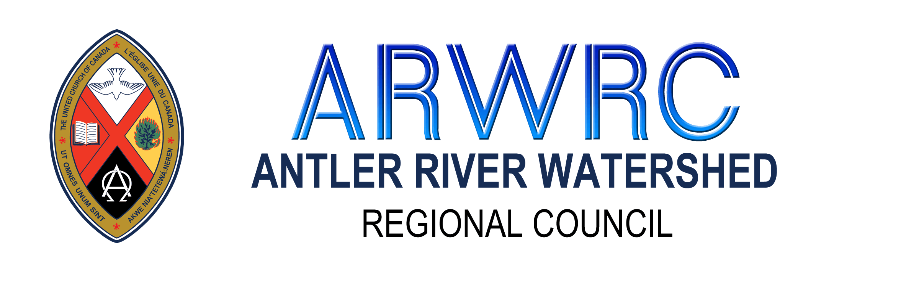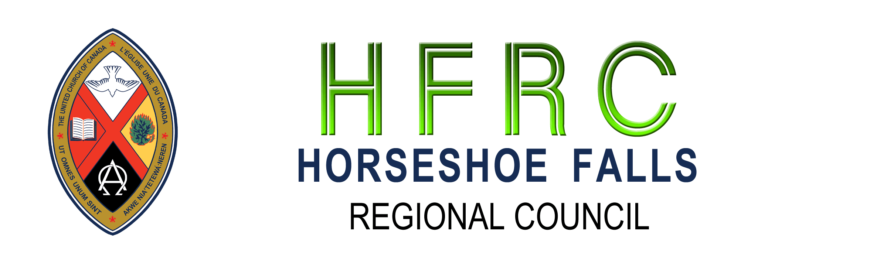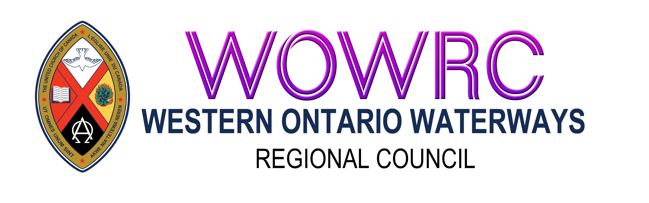
The Canada Emergency Business Account Reporting

Instructions
The covenant commissions of Antler River Watershed, Horseshoe Falls, and Western Ontario Waterways regional councils have pre-approved congregations who wish to apply for the Canada Emergency Business Account (CEBA). If you meet the government requirements and are approved for this loan, please complete this document and send a digital copy to the Minister, Congregational Support and Mission along with the requested attachments.
Community of Faith/Congregation
Pastoral Charge
Regional Council
Date of Approval by Governing Body (Council/Board)
Copy of Motion Directing Board of Trustees to Apply for the CEBA Loan

Contact Information: Please provide 2 contacts
Name:
Position with the Community of Faith:
Email Address: Phone Number:

Name:
Position with the Community of Faith:
Email Address: Phone Number:

Financing Information:
Please list all loans/lines of credit that have already been granted for Covid-19 and the amounts.
Please attach a digital copy of:
- Completed Financial Viability Worksheet Financial Viability Worksheet
- Annual Report for 2019 *If you do not have a digital copy of your annual report, please have it scanned and sent by email with this form, and the financial viability worksheet.
- Send all to: Minister for Congregational Support. Lynne Allin (ARW, HF); John Neff (WOW)

