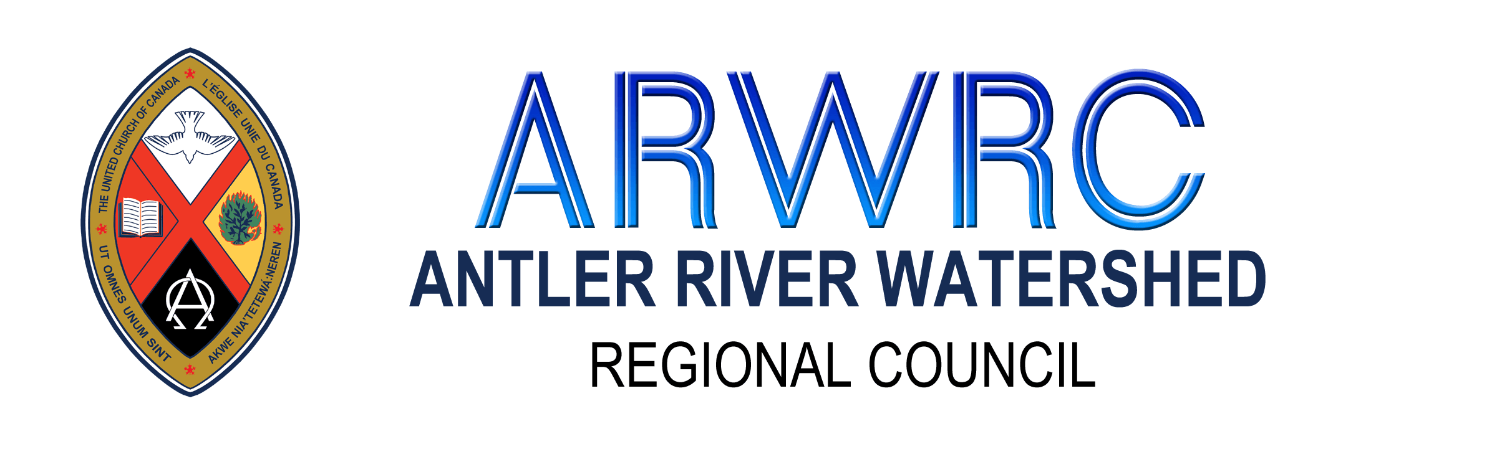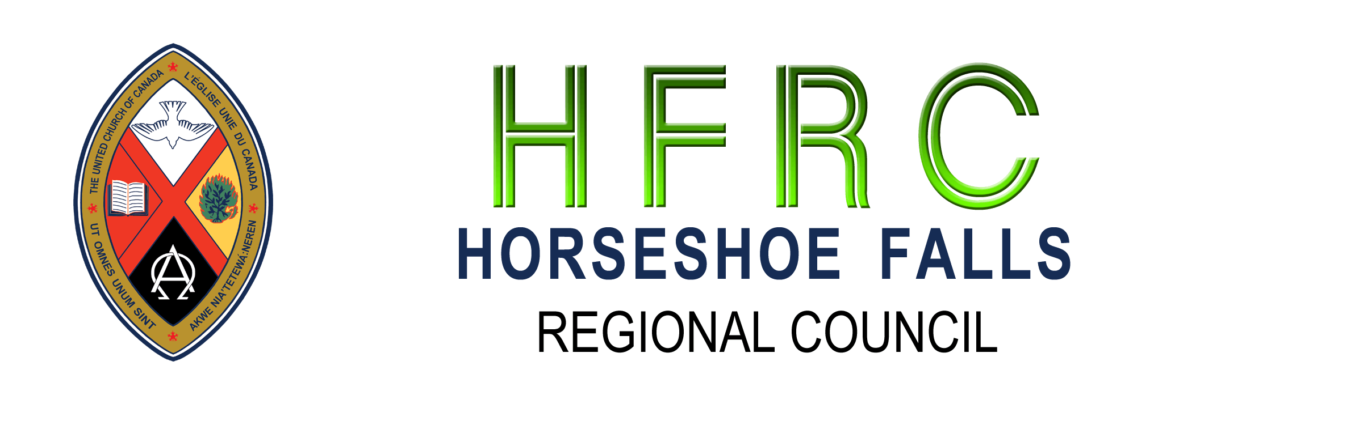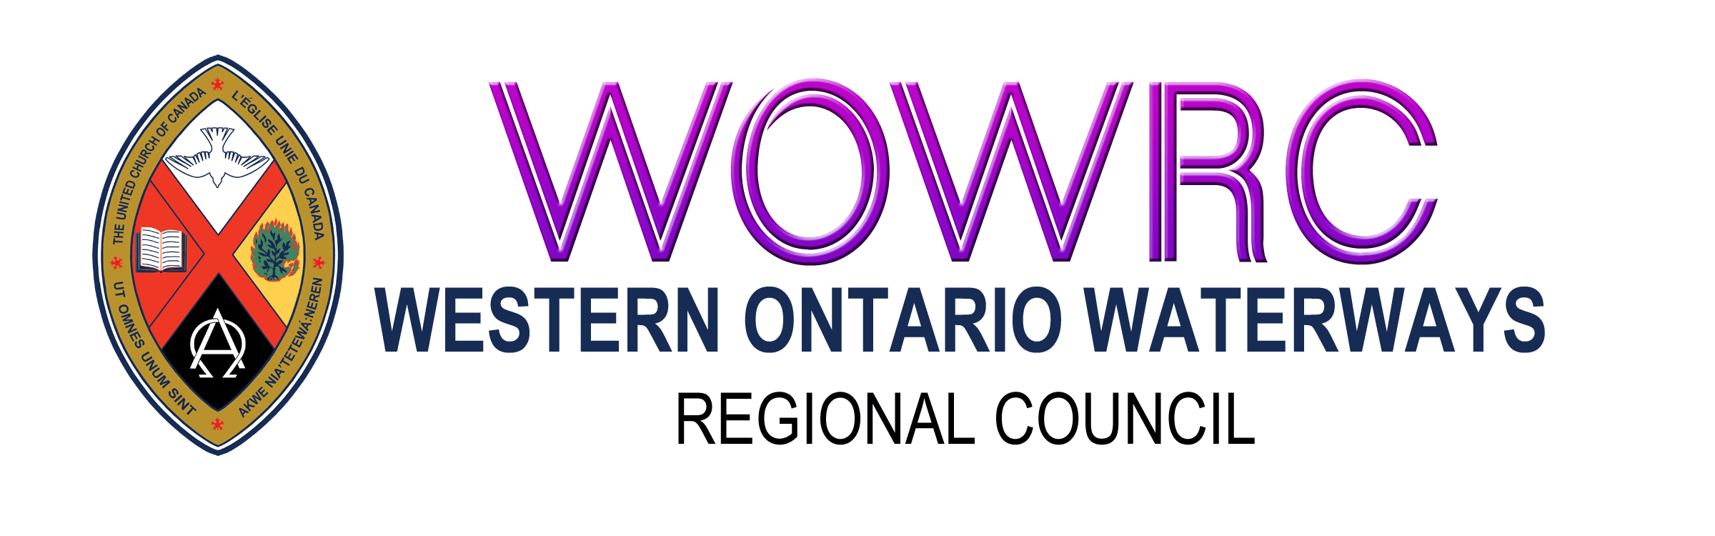
United Church Pandemic Response Bridging Loan
Please complete this form and send a digital copy* to: ARWRC, HFRC, WOWRC
Community of Faith/Congregation
Pastoral Charge (if different)
Regional Council
Date of Approval by Governing Body (Council/Board)
Contact Information: Please provide 2 contacts
Name:
Position with the Community of Faith:
Email Address: Phone Number:

Name:
Position with the Community of Faith:
Email Address: Phone Number:

Required Information:
Please make sure you have met all the requirements and answered all the questions on the UCC Covid-19 Emergency Bridging Loan Application.
In addition to the UCC requirements on the Loan Application please provide the following to the Regional Council so they can make an informed decision based on available funds, volume of applications, need, and viability.
- Digital copies of
  - Financial Viability Worksheet
  - Living Faith Story (if available)
  - Annual Report for 2019
  - Motion by Governing Body (Council/Board) directing Board of Trustees to apply for the United Church Pandemic Response Bridging Loan
- What are you doing to maintain your ministry and connect with people during the pandemic?
Click or tap here to enter text.
- List all loans/lines of credit that have already been granted for Covid-19 and the amounts.
Click or tap here to enter text.
- Do you prayerfully believe your community of faith will be able to make this request with an expectation and commitment to continuing your existing ministry until Dec. 31, 2022? ☐Yes ☐ No
- Please explain how you intend to use this money.
Click or tap here to enter text.
* The office is closed so paper copies will not be received. Digital copies of the application and all supporting documentation are to be emailed to your Minister for Congregational Support. (ARWRC, HFRC – Lynne Allin; WOWRC – John Neff)
Note: The Covenant Commissions are meeting weekly in order to expediently process applications. Applications received by Friday will be addressed the following week.

