Subscribe Past Issues
Translate
RSS

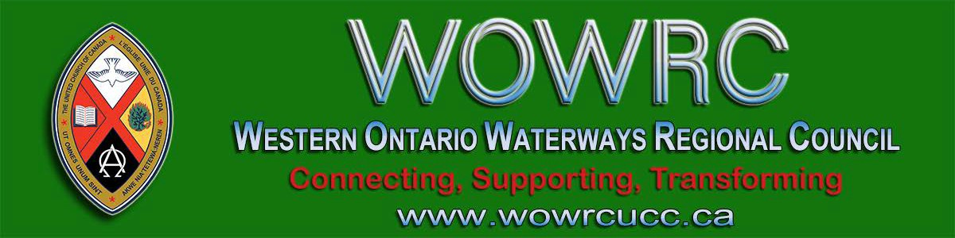

View this email in your browser

Next Deadline for submissions: February 7
Sign up for our newsletter & forward this one to friends.

Covenanting Service Sunday, January 26 @ 3:00 pm St. Marys United Church

The congregation of St. Marys United Church is covenanting with Jason Richards. Presiding over the service will be Rev. Dr. HyeRan Kim-Cragg! Come celebrate with us Sunday, January 26 at 3:00 pm as we start this new ministry.

Feel free to send greetings to administrator@stmarysunitedchurch.org if you can't attend. We are at 85 Church Street S, in St. Marys.

Ministry with Kids/Youth
Youth Group, Faith Formation Programs, Wider Church Connections

Tuesday, February 18
6:00 pm - 7:30 pm
Harcourt United Church, Guelph
87 Dean Ave, Guelph

Join us for a light supper-free will donation RSVP, please: Pamela Girardi yourweeklymanna@gmail.com or Kathy Douglas kdouglas@united-church.ca

* Share your struggles and celebrations in children and youth ministry.
* Connect with other faith formation leaders
* Meet Kathy Douglas, Faith Formation Minister for

Western Ontario Waterways Region

Connecting, Supporting, Transforming

Western Ontario Waterways Regional Council
The United Church of Canada

Sign up for our newsletters.

Copyright © 2020 Western Ontario Waterways Regional Council, UCC, All rights reserved.

Want to change how you receive these emails?
You can update your preferences or unsubscribe from this list.

