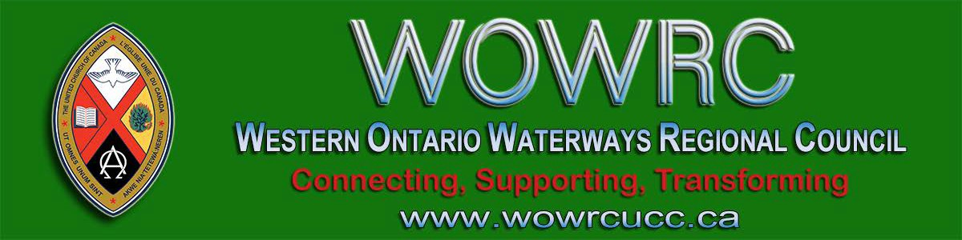
Subscribe |  | Past Issues |  | Translate |  | RSS
View this email in your browser

Next Deadline for submissions: February 7
Sign up for our newsletter & forward this one to friends.
From Rev. Gary Clark, President, Western Ontario Waterways Regional Council

For me saying, “Happy New Year” never gets old. I love it because I feel in it the hope, the potential and the invitation for happiness to rush into our everyday.

This year (and I hope every year after) we, at Forest Hill United Church, had an opportunity to bring the regional council of Western Ontario Waterways into our Happy New Year celebration. On January 5th Rev. Cheryl Ann-Stadelbauer-Sampa, representing the
regional council , shared in our Covenanting Service. No, we weren’t covenanting because we had new ministry staff ...

We made a covenant with each other and the regional council because: we believe that all relationships need to be renewed and commitments need to be spoken on an annual basis. We covenant so that we know what our responsibilities are and what we can expect from each other in this New Year. The service gave young
and older at Forest Hill a glimpse into the wider church and invited all ages to be part of the covenanting.

It made concrete that wonderful line our creed, “We are not alone.” It gave us an opportunity to commit to the ministry and mission we see as important in 2020. We expect that all things will change within

relationships and it is great knowing where we stand today. That clarity and the opportunity to stand with each other and the region really opens the door for happiness to rush in all year long.

I invite you and your congregation to make time for re-covenanting this year and every year that we might know the support and the calling that “All might be one” in Christ.
Happy New Year

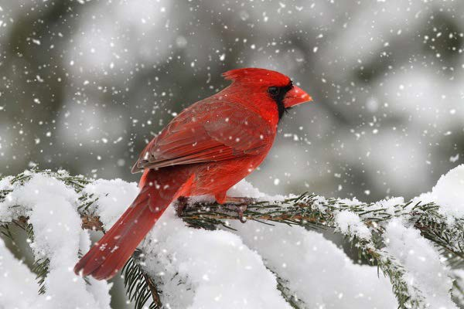giftswithvision

Looking for inspiring new gift ideas or perhaps would rather not give family and friends the same old clothes/toys/chocolates, Gifts with Vision presents a better way to celebrate special occasions. A gift that can help change lives!
M & P Workshop
Saturday, January 25, 10-12 pm
Forest Hill UC, Kitchener

A Ministry & Personnel workshop is being held Saturday, January 25 from 10:00
a.m. to noon at Forest Hill United
Church,121 Westmount Rd E, Kitchener.

Register with Ruthanna Mack to reserve your seat and/or for your group.

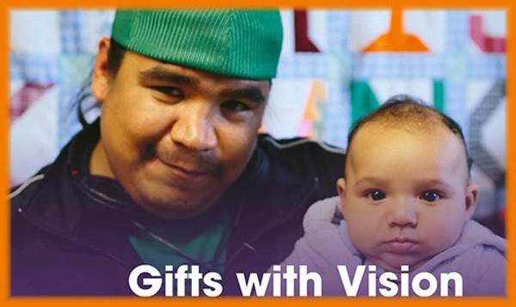

Everyone will find something in Gifts with Vision worth sharing with the special people in their lives. Gifts are available in a range of dollar amounts, as well as for many areas of need — hunger, shelter, education, health, safety, and more...

Worshiplude in Ottawa!!! January 31 - February 3

Click to go to the registration form. Skate on the Rideau Canal, ride ice
slides, see amazing ice sculptures and more, as part of Ottawa's Winterlude.

Contemporary worship, dinner and the Alt Space Event with other youth and young adults. For more information email Dana Ducette.

Go directly to the registration form.

Do you want to be on the
Pulpit Supply List?

We are looking for ministry personnel
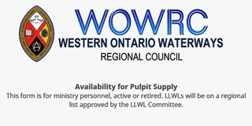who are willing to be available to do pulpit supply in our regions. Licensed Lay Worship Leaders (LLWLs) do much pulpit supply and that list is often sent out.

Click on the photo to go to the form. Right now we are gathering the names of
ministry personnel who are interested in being on a list for supply. Look under
'Pastoral Relations Toolkits' on the Antler River Watershed website. We look forward to hearing from you!

Toronto United Church Council
Upcoming Opportunities

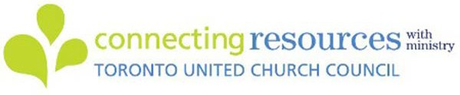

Communities of Faith and Social Enterprise: An Afternoon with Shaun Loney
Turn your underused church space into meaningful, problem-solving space! Sunday, January 19, 1:00 – 4:30 pm Trinity United Church, 461 Park Avenue, Newmarket.
$25 per person (free for Living Presence
Ministry congregations).

Help Communities of Faith with
Mission/Justice/Faith Formation

Besides helping congregations with the above, you will also help with resources, guidance and support to enable communities of faith to do the best
ministry possible in their communities and the world.

The mandate includes working in right relations with Indigenous partners, supporting Affirming ministries with LGBTQ2SIA+ members, making safe space, open dialogue and strengthening relationships everywhere.

The Mission & Discipleship Commission could use your help. Read the letter and mandate from the Commission. Then apply through the Expression of Interest form. Hope to see you soon!

Exciting Work of the Human
Resource Commission

Currently seeking people to serve on the HR Commission and on the Licensed Lay Worship Group.

Mandate: formation & nurturing healthy pastoral relationships and the equipping and licensing of lay worship leaders.

position descriptions
changes in pastoral relations sacramental privileges sabbatical requests
liaisons to work with communities of faith
regional United Fresh Start program

For more information, read the full letter,

Read the TUCC newsletter for complete information and registration.

Racial Justice Workshops
2020 Dates

For Indigenous, Racialized, Bi-racial
People: January 25
April 25
June 20
September 19
November 14

For White People:

February 1
May 2
June 27
September 26
November 21

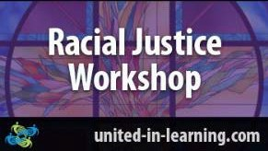

"The racial justice training is particularly commended to people serving in any leadership capacity within the church."
www.united-in-learning.com

Curriculum Workshop Saturday, January 25 10-3pm Emmanuel UC, Waterloo

Curricula that engages children but it's yours

from Chair Micol Cottrell. Email Micol or call him at 519-364-3550.

Week of Guided Prayer

A Unique and Meaningful Opportunity for Deepening your Relationship with God. Encourage your Congregation to Hold a Week of Guided Prayer. A Retreat Guided by the Holy Spirit in the Midst of Daily Life.

Find out more through the website. Purchase the 94-page manual and materials with this form and start your congregation on your chosen Sunday.

Rendez-Vous: Bold Faith. Brave
Space. Brazen Grace.

Rendez-vous, an M&S supported event, brings together youth (grade 9 and up to any age), young adults and their leaders from across the country (and beyond!) for a celebration of vibrant music, inspiring speakers, and dancing like there is no tomorrow.
on a shoe-string budget: Free!! It's
home -grown, tried and true, and best of all, it's free for those who attend. Ministers and lay leaders will be introduced to three curricula and how to
implement them in your ministry context.

Three workshops with presenters Alana
Martin and Pat Morrison.

Find out more: Curriculum Workshop

Confirmation Retreat & Faith Refresher 'What Will Find You' February 21-23

Confirmation PLUS is designed to prepare United Church teens for confirmation but is open to any and all teens in grades 7-12 regardless of whether or not they are confirmed or ever intend to be.

Confirmation PLUS is open to Region 7,
8, 9 and beyond and is hosted at Pearce Williams (Fingal, Ontario). It is sponsored and led by The Centre for Practical Theology, The Swell, Ecumenical
Campus Ministry of the University of
Guelph and Western Ontario Waterways.

This retreat weekend playfully engages teens in the exploration of A New Creed, energetic worship, and lots of recreation, all lead by seasoned adult ministry personnel with decades of experience in youth ministry.

Get involved. Find out how. Email Kathy or call her at 519-441-0656.

Human Resource Commission
Looking for Members

The Human Resources Commission invites you to join us! We do the work of the formation and nurturing of healthy pastoral relationships and equipping lay worship leaders. Our work includes:

training and providing liaisons who work with communities of faith in times of search and transitions, overseeing Licensed Lay Worship Leaders,
approving changes in pastoral relationship and calls/appointments, setting and reviewing policy, overseeing licences to administer sacraments,
overseeing United Fresh Start, and more.

We are especially looking for ministry personnel to meet a more equitable balance. We meet monthly for about an hour and a half by Zoom and documents are shared using Dropbox. If you are interested in joining our committee or have questions please contact Micol Cottrell or apply through the Expression of Interest form.

Liaison Training for Free! Almost ...

The Human Resources Commission is looking for people wanting to train as liaisons. Liaisons help support and equip congregations during search and in times of transition. If you are interested or if you
Adults/Ministers are encouraged to attend this event with their teens.

Come and find out What Will Find You!

Your Covenant Commission

Your Covenant Commission is dedicated to supporting communities of faith throughout various processes including property matters, use of capital funds, grants, etc.

To make informed decisions it is helpful for the Covenant Commission to have completed community of faith profiles to which it may refer. All communities of
faith are encouraged to have their profiles completed before January 2021. After this date requests will be deferred until the profile is completed.

If you have any questions or need assistance please contact John Neff, your Minister, Congregational Support and Mission.

Songs for the Holy Other

A new resource from the Hymn Society of the United States and Canada , Hymns Affirming The LGBTQIA2S+ Community! Hymns for the Holy Other is an online hymnal that emerged from a desire to make queer hymns — hymns by, for, or about the LGBTQIA2S+ community — accessible to a wider range of congregations.

We celebrate the contributions of those who have paved the way for this collection, and hope to create a dynamic resource of additional resources that are

would like more information please
contact Micol Cottrell or apply through the
Expression of Interest form.

Nominations: General Council
Positions

Please check the General Council Nominations page regularly. General Council is inviting Expressions of Interest:

Committees of the National Indigenous Organization Indigenous Candidacy Board National Indigenous Committees

Deadline for all of the above: January 23.

Marketing/Animation and Funding
Development Subcommittee, Sing
2025
Web Content Development
Subcommittee, Sing 2025

Deadline: February 10.

Want to include something here?

Do you know of a region-wide event or happening that would be of interest to ministry personnel and/or lay members? To have it posted in this regional newsletter, send an email with the information to pkukadia@united- church.ca.

The next deadline is February 7.

Become a Youth Ministry Friend on Facebook - Friends4ever

Follow Regions 7-
8-9 Youth

available to congregations in the near future.

Another Great Year for The
Healing Fund - 2019

In 2019, The Healing Fund provided more than $300,000 to support Indigenous communities in language and culture programs. Read More ...

Question & Answer Column

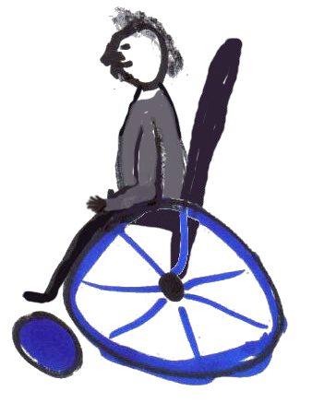Question
Does our church have to be physically accessible by
2025?

Answer
A Community of Faith is a non-profit with usually under 20 employees and does not need to make their building physically accessible by 2025. Under Ontario's Building Code, it is grandfathered. The exception is if you do a new construction or redevelopment (renovation).

Ministry Network on Facebook and always be in the know.

There is so much coming up, it's hard to stay on top of it! Here is a peek of what you'll find on Facebook:

Interfaith Event for Young Adult Women. Feb 14-17 @ Five Oaks Show me the $. March 3-5 @ the Regional Office
Confirmation Event. April 3-5 @ Five Oaks
Youth Rally. April 23-26 @ Pearce- Williams Camp

Hello, HELLO!

Welcome to Western Ontario Waterways Regional Council, Sonja van der Hoef- Fraser. She has joined us at St. Paul’s United Church in Milverton as of this January.

Welcome also to Louise Von Massow. She is already settling in at Thames
Road-Elimville since the beginning of this new decade!

Guess Who Has a Newsletter?

The WOW United Church Women!!! Read how THE WOMEN coped with CHANGE and LEARN.
For more information see: Accessing Accessibility Under the Building Code, the AODA and the OHRC.

From your friendly Regional Council
Covenant Commission. :)

Stewardship Updates
M&S Deadline: January 31

If you are looking for encouragement, new ways to think about stewardship, resources, help to implement Congregational Giving, Mission & Service, Planned Legacy Giving, United Church Foundation and investing opportunities
for your congregation, and personalised support to help grow strong generous thankful disciples, then contact Dave Jagger and let’s talk. January News !

SW Ontario Candidacy Board

The SW Ontario Candidacy Board is looking for new members; we meet monthly and the 2020 dates are set.

Show Me the $$$ Regional Office, Hamilton Tuesday, March 3

Finding, Writing, Getting Grant$

RSVP required by February 19. Email Ruthanna Mack or call 1-833-236-0280 ext. 0. Two opportunities: 12:00 - 2:30 pm (light lunch provided-donation) or 6:00 -
8:30 pm (light supper provided-donation).

Connecting, Supporting, Transforming

Western Ontario Waterways Regional Council
The United Church of Canada

Sign up for our newsletters.

Copyright © 2020 Western Ontario Waterways Regional Council, UCC, All rights reserved.

Want to change how you receive these emails?
You can update your preferences or unsubscribe from this list.

