Subscribe Past Issues
Translate
RSS

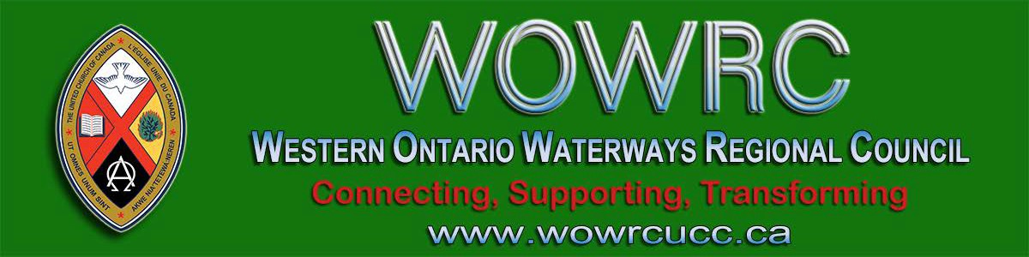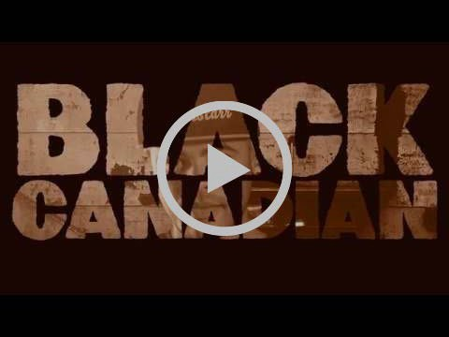

View this email in your browser

Next Deadline for submissions: February 28
Sign up for our newsletter & forward this one to friends.

BLACK HISTORY MONTH

This year is the mid-point of the
International Decade for People of African Descent

Black Canadian by Rapper D. O. Gibson
Black History Month
United Church Worship, Prayers, Resources & more
Canadian Council of Churches: Info Sheet & Resources

“During the 19th Century, thousands of slaves escaped to freedom through a secret network known as the Underground Railroad. It is believed that, along the way, spiritual songs were used as secret coded messages to escaping slaves. ‘Wade in the Water’ warned them to flee dry land for the water so that the dogs and owners
chasing them couldn’t track their scent.”

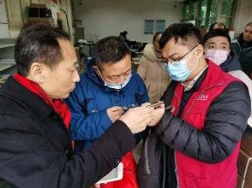United Church Responds to the Coronavirus

Please pray for the sick and those who have lost their lives, as well as the families, caregivers, medical responders, and communities affected by this outbreak around the world.

United Church Mission & Service partner, the Amity Foundation, has requested emergency medical supplies for use by
Licensed Lay Worship Committee
Needs Members - Maybe YOU!

The Human Resources Commission is looking for individuals to be part of our Licensed Lay Worship Committee. This committee will oversee Licensed Lay Worship Leaders (LLWL) in Western Ontario Waterways Regional Council.

We are looking for Ministry Personnel from any stream, lay people who are not LLWL and LLWLs to be on this committee. This will be a one to three year term position with the option of renewal for one term.

The primary responsibilities for this committee will be:

Interviewing potential LLWLs and recommending licensing to the Human Resources Commission.

medical first responders and communities in Wuhan. The United Church is collaborating with the American Baptist International Ministries, which is coordinating the provision of these supplies to address the crisis.

Find out more ...

Lent is coming! give, Give, GIVE

What if we not only give up something, but GIVE something for Lent?

Find ideas here on what to give ... and download the flyer from Dave Jagger.

3rd Annual Inter-Youth Group
Games Day: February 9
Wellington Square UC

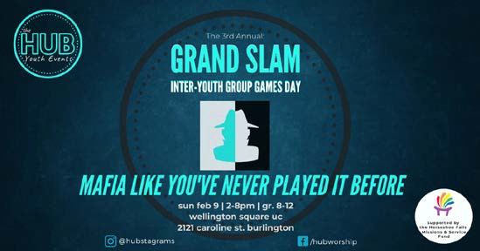

Download the full-size promo card.

Have a Heart Day
A Sunday in February

Interviewing and recommending current LLWLs for relicensing every
3 years.
Ensuring LLWLs have completed mandatory workshops and have a current Police Records Check. Ensuring the recognition of a newly licensed LLWL at a service of worship.
Providing ongoing support and guidance to LLWLs.

If being on this committee is something that interests you, please complete an Expression of Interest form (also found on the Western Ontario Waterways Regional Council website).

Do you want to be on the
Pulpit Supply List?

We are looking for ministry personnel
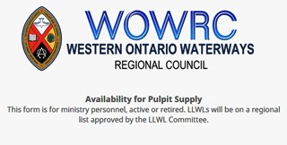who are willing to be available to do pulpit supply in our regions. Licensed Lay Worship Leaders (LLWLs) do much pulpit supply and that list is often sent out.

Click on the photo to go to the form. Right now we are gathering the names of
ministry personnel who are interested in being on a list for supply. Look under
'Pastoral Relations Toolkits' on the Western Ontario Waterways Regional Council website. We look forward to hearing from you!

A project of the First Nations Child and Family Caring Society. Led by Dr. Cindy Blackstock, the Caring Society educates about and advocates for the rights of Indigenous kids across Canada.

We hope non-Indigenous kids can learn about the different experiences of kids in Canada and take action out of a sense of compassion. We also hope Indigenous kids can speak from their hearts about what they want and need.

Download the Sunday School Activities.

Help Communities of Faith with
Mission/Justice/Faith Formation

Besides helping congregations with the above, you will also help with resources, guidance and support to enable communities of faith to do the best
ministry possible in their communities and the world.

The mandate includes working in right relations with Indigenous partners, supporting Affirming ministries with LGBTQ2SIA+ members, making safe space, open dialogue and strengthening relationships everywhere.

The Mission & Discipleship Commission

(Not in Western Ontario
Waterways, but ...)
An Uplifting Church Story from TVO.org

This is a great story featured by TVO.org that lives into Eric Law's Holy Currencies principles (a webinar that may come back soon to United-in-Learning.com).

My favourite line is when Rev. Anne
Hines says, "Renting out space is nothing new for struggling churches, but Roncesvalles United’s approach goes beyond that, she says: “[The tenants] are not here paying to allow us to do our mission. They are our mission.”

Racial Justice Workshops
2020 Dates

For Indigenous, Racialized, Bi-racial
People: April 25
June 20
September 19
November 14

For White People:

May 2
June 27
September 26
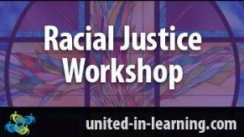November 21

could use your help. Read the letter and mandate from the Commission. Then apply through the Expression of Interest form. Hope to see you soon!

Exciting Work of the Human
Resource Commission
"The racial justice training is particularly commended to people serving in any leadership capacity within the church."
www.united-in-learning.com

Missional Leadership Diploma Atlantic School of Theology June 2020

Currently seeking people to serve on the HR Commission and on the Licensed Lay Worship Team.

Mandate: formation & nurturing healthy pastoral relationships and the equipping and licensing of lay worship leaders.

position descriptions
changes in pastoral relations sacramental privileges sabbatical requests
liaisons to work with communities of faith
regional United Fresh Start program

For more information, read the full letter, from Chair Micol Cottrell. Email Micol or call him at 519-364-3550.

Week of Guided Prayer

A Unique and Meaningful Opportunity for Deepening your Relationship with God. Encourage your Congregation to Hold a Week of Guided Prayer. A Retreat Guided by the Holy Spirit in the Midst of Daily Life.

Find out more through the website. Purchase the 94-page manual and materials with this form and start your congregation on your chosen Sunday.
Learn the keys to thriving ministry in the
21st Century. Starts in June - Apply now! Only 25 spots available. For more details on this leading edge program download this information sheet and/or contact Dr. Stephen Harper.

Confirmation Retreat & Faith Refresher 'What Will Find You' February 21-23

Confirmation PLUS is designed to prepare United Church teens for confirmation but is open to any and all teens in grades 7-12 regardless of whether or not they are confirmed or ever intend to be.

Confirmation PLUS is open to Region 7,
8, 9 and beyond and is hosted at Pearce Williams (Fingal, Ontario). It is sponsored and led by The Centre for Practical Theology, The Swell, Ecumenical
Campus Ministry of the University of
Guelph and Western Ontario Waterways.

This retreat weekend playfully engages teens in the exploration of A New Creed, energetic worship, and lots of recreation, all lead by seasoned adult ministry personnel with decades of experience in youth ministry.

Adults/Ministers are encouraged to attend

this event with their teens.

Come and find out What Will Find You!
Nations Uniting Programs
for the month of February

Rendez-Vous: Bold Faith. Brave
Space. Brazen Grace.

Rendez-vous, an M&S supported event, brings together youth (grade 9 and up to any age), young adults and their leaders from across the country (and beyond!) for a celebration of vibrant music, inspiring speakers, and dancing like there is no tomorrow.

Get involved. Find out how. Email Kathy or call her at 519-441-0656.

Bridges Out of Poverty United-in-Learning February 19 at 1:00 pm

Make a difference in your community. Challenge your assumptions about poverty, economic class and community sustainability. Bridges Out of Poverty is a highly successful initiative that is transforming communities. This program is successful because it puts the under-
resourced people it seeks to assist, in 'the driver’s seat'.

Register here .
Come and explore The Seven Grandfather Teachings at Nations Uniting in Ohsweken through Bible Study,
Sharing Circle, Film Showings and
Parallel Path with Renee Thomas Hill.

Download the flyer, or check out the website.

Confirmation Retreat
Five Oaks, April 3 - 5

Colour Outside the Lines, Unravel Faith, Resurrect Hope and Create Radical Beauty on Earth with Ruth Noble, Alana Martin and Kathy Douglas.

A retreat to support & enrich the confirmation process of your congregation. For both youth & leaders. Come, share the journey!

For information email Kathy Douglas.

Your Covenant Commission

Your Covenant Commission is dedicated to supporting communities of faith throughout various processes including property matters, use of capital funds, grants, etc.

Discoverment for Yats
'What Will Frame You' February 21-23

Whether you are creating an Instagram profile, a resume, or a life in the Way of Jesus - the decisions we make about how we frame our experience have a lot of power to shape our future. What do we focus on? What do we crop out? What opportunities do we pursue? Which ones do we forego? Who do we listen to as we make those decisions?

What Will Frame You? for YATS is open to young adults from any and all denominations and is hosted at Pearce Williams (Fingal, Ontario). The event is sponsored and led by The Centre for Practical Theology, The Swell, Ecumenical Campus Ministry of the University of Guelph, and Western Ontario Waterways.

Come find out What Will Frame You!

Liaison Training for Free! Almost ...

The Human Resources Commission is looking for people wanting to train as liaisons. Liaisons help support and equip congregations during search and in times of transition. If you are interested or if you would like more information please
contact Micol Cottrell or apply through the
Expression of Interest form.

Please Share this Newsletter
To make informed decisions it is helpful for the Covenant Commission to have completed community of faith profiles to which it may refer. All communities of
faith are encouraged to have their profiles completed before January 2021. After this date requests will be deferred until the profile is completed.

If you have any questions or need assistance please contact John Neff, your Minister, Congregational Support and Mission.

Youth Rally 2020: Escape! April 23 - April 26
Pearce-Williams Christian Camp

High-School aged youth: Do you love to be inspired, challenged to think, meet new people & hang out with good
friends ??? Do you enjoy being in an open
& welcoming community where you are free to be completely yourself ? Well, faith, fellowship and connection is what Youth Rally is all about.

Come join us for Youth Rally 2020: Escape! Registration closes when full.

There is limited space! Register Early. Deadline for registration: April 9.

For more information email Shannon.

Question & Answer Column

Question What is surprisingly one in three in Western Ontario

Please share this newsletter widely. It is especially helpful for people involved in leadership roles in your community of faith to know what upcoming events are planned that they might find helpful.

Invite people to subscribe for themselves by including the following with the announcements: Stay in touch with the wider church: subscribe to the regional council newsletter.

The Search Begins .....

After accepting current General Secretary Nora Sanders’ notice that she will retire in September 2020, the Nominations Committee put out a call to the church for a search committee. Many nominations were received. Read the bios here.

Canada Summer Jobs is Open

Have a new idea but need help to get it off the ground?

New ways of communicating? A Vacation Bible School?
A community garden?
Maybe to bring in new ideas?

If you want to hire someone under 30 to work at your community of faith now is the time to apply for Canada Summer Jobs through the Federal Government!

Waterways Regional Council?

Answer
Approximately one-third of the pastoral charges in our regional council are without ministry personnel. Each one of them needs a PASTORAL CHARGE
SUPERVISOR. Please contact John Neff, Minister, Congregational Support & Mission at jneff@united-church.ca if you can help with this important work.
Training is available and travel costs are reimbursed.

From your friendly Regional Council
Covenant Commission. :)

Christian Resource Centre
Hwy 8 & Hwy 23, Mitchell

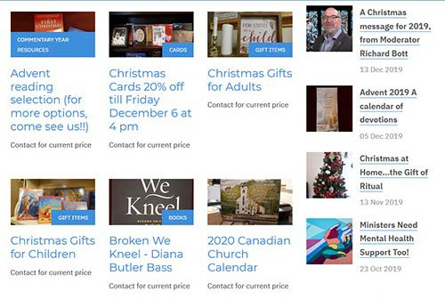

The Resource Centre: a warm & inviting space where all are welcome to browse our vast array of theological resources, bibles, books & gift-ware. We are blessed by all who walk through our door. Give us a call, send us an email. Our common language is love & inclusivity.

Leadership Development and Continuing Education For lay people and clergy who want to learn, explore, and question, the Centre for Christian Studies is offering two one-week learning circles: Oppression and Resistance (Apr 15-21) and Ages and Stages (April 23-29). Application deadline this month. Both will be in Winnipeg. Click on the name of the circle to find out more. If you have questions call 204-783-4490 or e-mail info@ccsonline.ca.

Grey-Bruce Healthcare Chaplaincy: A Mission & Service Ministry

Although Chatsworth United Church closed their doors in the Grey - Bruce area, they were able to turn their past- ministry into a future-ministry that will continue to look after those who become hospitalized.

Read the Mission & Service story.

Want to include something here?

Do you know of a region-wide event or happening that would be of interest to ministry personnel and/or lay members? To have it posted in this regional newsletter, send an email with the information to pkukadia@united- church.ca.

The next deadline is February 7.
The Grandmothers Tea
Mount Pleasant United Church
February 26 at Noon

Download Grandmother's Tea flyer from
Nations Uniting.

Show Me the $$$ Regional Office, Hamilton Tuesday, March 3

Finding, Writing, Getting Grant$

RSVP required by February 19. Email Ruthanna Mack or call 1-833-236-0280 ext. 0. Two opportunities: 12:00 - 2:30 pm (light lunch provided-donation) or 6:00 -
8:30 pm (light supper provided-donation).

Treasurers: Charity Returns
We Have An Answer for You

In response to the following question on the T3010 Charity Return:

Was the charity in a subordinate position to a head body?

Ministry with Kids & Youth
Tuesday,
February 18, 6:00 -7:30 pm
Harcourt United Church, Guelph

Share your struggles and celebrations in children and youth ministry. Connect with other Christian Education leaders and meet Kathy Douglas, Faith Formation Minister for Western Ontario Waterways Regional Council.

This event is for anyone who leads or supports programming with children and families in Western Ontario Waterways Regional Council.

For details and to RSVP (for donation supper) email or call Kathy at 1-833-236-
0280.

Crossan is coming to Westdale
United Church, Hamilton
April 3 and 4

Contemporary Spiritual Voices present: A
weekend with John Dominic Crossan.
The foremost historical Jesus scholar will be at Westdale UC from a Friday evening talk through all day Saturday.

Register online or download the flyer and get all the details and information.

Sisters Together: Clergy Women's Retreat for Women in Ministry - April 20 - 24

The theme of this 5-day event is 'Voices of Hope in Challenging Times'. The event features Rabbi Elyse Goldstein, Rev. Dr.
Answer: The United Church of Canada
Bn # 108102435RR0003

Thanks for all you do at this busy time of year to help United Church communities of faith understand their financial picture and direct their assets to the service of God's mission.

Video Licensing Available for May 2020 to April 2021

Video licensing information is available online at Buying United. Those who had video licenses last year should have received their invitation for this year. Please share this information as widely as you can. The deadline for applications for this round is Friday, March 27.

Contact Alexandra Belaskie or at 1-800-
268-3781 x4157 for more information.

SW Ontario Candidacy Board

The SW Ontario Candidacy Board is looking for new members; we meet monthly and the 2020 dates are set.

Community of Faith Representative(s) to the Regional Council

Be sure to elect your community of faith’s representatives to the regional council. A position description for this role can be

HyeRan Kim-Cragg and Diamond
Fotiadis. The Blanket Exercise with Kairos found on page 5 of the Governance
Canada will also be presented. Handbook.

Download the poster for information, go The number of representatives is based to the Facebook page, send an email to on the number of full members. (See sistersandministers@gmail.com, or go Manual C.1.2.a)
directly to the registration form.

Limited to the first 50 participants. PIE Day Worship,
Facing Queerphobia Video from Affirm United

Find out about the activities happening on
March 14. Check out www.pieday.ca.

Download the February - March newsletter from Affirm United.
The Western Ontario Waterways Regional Council newsletter welcomes submissions of upcoming events, regional news and educational opportunities. This is also the place to keep up-to-date on information from the regional office.

Connecting, Supporting, Transforming

Western Ontario Waterways Regional Council
The United Church of Canada
Sign up for our newsletter.

Copyright © 2020 Western Ontario Waterways Regional Council, UCC, All rights reserved.

Want to change how you receive these emails?
You can update your preferences or unsubscribe from this list.

