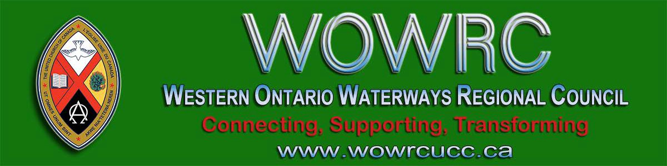
Subscribe |  | Past Issues |  | Translate |  | RSS
View this email in your browser

Next Deadline for submissions: January 17
Sign up for our newsletter.

Western Ontario Waterways Regional Council Website https://wowrcucc.ca/

Antler River Watershed Regional Council's website is live. Check out the many tools and resources that you will find here. Content is being added regularly so be sure to check back often. Some of the current features are:

Staff Directory
Pastoral Relations Toolkits
Congregational Support Toolkits
Minutes of Transition Council and Executive

Find a Community of Faith
Stewardship Resources

https://wowrcucc.ca/

Advent Unwrapped
New Resources

Get ready for Christ(mas)! Advent—the holy, four-week countdown to Jesus’ birthday—which began on Sunday, December 1! Get ready to make room for Christ and the radical, countercultural messages that Christ brings.
Covenanting Service!!!
Thursday, December 12 @ 7 pm
Ebenezer United Church

Come celebrate with Candidate Supply Carolin MacMillan and the Ebenezer Pastoral Charge in this new covenant of ministry.

Jack Findlay is the Regional Council Liaison and Rev. Sonia Ireson will be preaching. Rev. Heather Leffler will be presiding, and music will be provided by Ebenezer’s own accomplished jazz pianist, John Zadro.

Download the flyer for more information.

Throughout the season, videos, prayers, family resources, and reflections on this page will introduce and explore the Christmas story. For more worship resources visit our Advent and Christmas worship pages. Follow our Advent Unwrapped Facebook page for regular updates on all kinds of resources.

giftswithvision

Looking for inspiring new gift ideas or perhaps would rather not give family and friends the same old clothes/toys/chocolates, Gifts with Vision presents a better way to celebrate special occasions. A gift that can help change

United Church Video Licenses Now Available - Apply NOW Deadline: December 31st

EDGE is pleased to offer Public Performance Video Licenses at great cost savings for your community of faith!
They enable your church to show full- length or clips from movies or TV shows as a part of worship, fundraisers, family nights, youth group events or educational programs. Showing films without a public performance license is a breach of Canadian Copyright Laws.

lives!

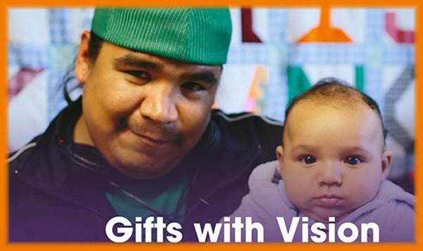

Everyone will find something in Gifts with Vision worth sharing with the special people in their lives. Gifts are available in a range of dollar amounts, as well as for many areas of need — hunger, shelter, education, health, safety, and more...

Christmas Beer & Hymns
Monday, December 16
7 - 9 pm in Kitchener

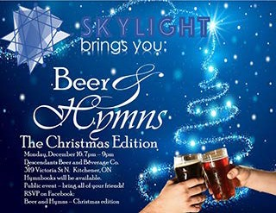Skylight Festival, a festival of Faith, Arts and Justice, supported by the UCC EDGE Network, is hosting its first-ever event outside of festival weekend - Christmas Beer 'n Hymns in Kitchener.

Click to download the full-size poster!

We have negotiated video licensing agreements with Criterion Pictures and Audio Ciné Films (ACF) Inc. who represent most of the major distributors including Paramount, Universal, Alliance Atlantis, New Line Cinema, Miramax, Disney, Veggie Tales and many more!

Visit: http://buyingunited.net/video - licensing for all the information. Application deadline for a 2020 license is December 31, 2019. Email or call Alexandra at 1-800-268-3781 x4157.

SAVE-THE-DATE
Saturday, January 25, 10-12 pm
M & P Workshop

A Ministry & Personnel workshop will be held on Saturday, January 25 from 10:00 am to noon. The location is still to be determined somewhere in the region.

Register with Ruthanna Mack to reserve your seat and/or for your group.

Do you want to be on the
Pulpit Supply List?

We are looking for ministry personnel
who are willing to be available to do pulpit supply in our regions. Licensed Lay Worship Leaders (LLWLs) do much pulpit supply and that list is often sent out.

Come on out to 319 Victoria Street N. in

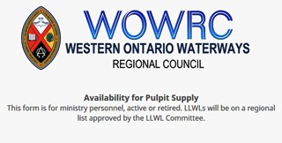Kitchener. Hymnbooks will be there! Bring your friends. RSVP on Facebook.

Worshiplude in Ottawa!!! January 31 - February 3

Click to go to the registration form. Skate on the Rideau Canal, ride ice
slides, see amazing ice sculptures and more, as part of Ottawa's Winterlude.

Contemporary worship, dinner and the Alt Space Event with other youth and young adults. For more information email Dana Ducette.

Go directly to the registration form.

Centre for Christian Studies
Common Threads

Cookies and Carols 2019
If you're in the Winnipeg area on December 10th, why not join us from 4-6 pm for festive singing and holiday treats ?

Companion of the Centre 2020
The Centre for Christian Studies is pleased to announce that the 2020 recipient of the Companion of the Centre

Click on the photo to go to the form. Right now we are gathering the names of
ministry personnel who are interested in being on a list for supply. Look under
'Pastoral Relations Toolkits' on the Antler River Watershed website. We look forward to hearing from you!

Toronto United Church Council
2 Upcoming Opportunities

Communities of Faith and Social Enterprise: An Afternoon with Shaun Loney
Turn your underused church space into meaningful, problem-solving space! Sunday, January 19, 1:00 – 4:30 pm Trinity United Church, 461 Park Avenue, Newmarket.
$25 per person (free for Living Presence
Ministry congregations).

Innovative Ministry Centre Call for
Participants
The Innovative Ministry Centre is seeking two United Church communities of faith to take part in a new program along with three congregations that have already signed up. Our mission is to help
churches develop and sustain new, innovative missional ministries that can reach people who are not at present connected with church. The program is geared toward capacity building for communities of faith who are currently or who have previously participated in forms

Award is ...

Spiritual Practice 2019
Students spent a week exploring spiritual practice as a tool for pastoral care. Check out some images.

A Room Full of Mentors
Regional gatherings of diaconal ministers provide an opportunity for students to make connections and form identity.

What I Learned at CCS and Why Our
News Reading Habits Matter
Ray McGinnis uses the critical analysis skills he gained at CCS to take a closer look at news from Bolivia.

Sharing Our Stories, Claiming Our
Names: Kim Uyede-Kai

Kim Uyede-Ka, the region's Minister of Right Relations,i writes from the Asian Ecumenical Women’s Assembly, a “herstorical” assembly where women could hear one another’s stories be given voice, some for the first time.
of innovative ministry..

Read the TUCC newsletter for complete information and registration.

Curriculum Workshop Saturday, January 25 10-3pm Emmanuel UC, Waterloo

Curricula that engages children but it's yours on a shoe-string budget: Free!! It's
home -grown, tried and true, and best of all, it's free for those who attend. Ministers and lay leaders will be introduced to three curricula and how to
implement them in your ministry context.

Three workshops with presenters Alana
Martin and Pat Morrison.

Find out more: Curriculum Workshop

A Time to Prepare for . . . Annual Meetings!

1. Extension of Voting Rights to
Adherents
A community of faith may now extend voting rights to adherents on any matter. To be able to do this, the congregation must first identify who are adherents. This information is often kept informally in a congregation. Prior to the Annual
Meeting, the governing body should recognize the names of adherents in order to be able to extend voting rights to them.

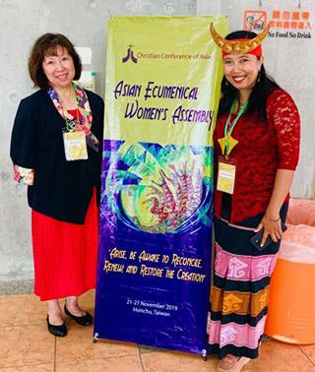Kim starts her (first-ever) blog with a question she was asked often, "What country are you from? Indonesia? Korea? Taiwan?” “No, Canada.” “But your face looks like…!”

Read the rest of the blog ...

Meet Joan Tuchlinsky
Minister, Social Justice
2. Budget 2020
Attendance at Regional Council Meetings Please remember to include a line to cover the cost for ministry personnel and lay representatives to attend the regional council meetings. Two meetings are planned for 2020:
May 29-31 in Port Elgin
Fall 2020 in the regional council

Assessment: An assessment update will be issued by the General Council in December.
Any community of faith that moved to the target assessment will have learned their
2020 assessment figure as the final step of submitting their 2018 statistics online.

Any community of faith that opted for the
10% maximum increase in assessment will have the same assessment fee in
2020. In this case, the congregation might want to consider gradually increasing their assessment over the next two years so that the end of the grace period does not bring a significant increase over the
previous year.

jtuchlinsky@united-church.ca

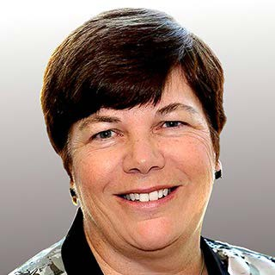"So good to meet everyone at our recent
Region Council meeting! Thank you for
3. Nominating Committee
Ministry personnel do not serve as part of the Nominating Committee. Please
ensure your community of faith elects its regional council representatives. There is a minimum of one representative per congregation.

the warm welcome and your commitment to sharing our gender-specific and
gender-neutral pronouns (download & share) at the meeting. As we continue to do this in other gatherings and places we are creating a welcoming and safe space for everyone.

If you want any support in working on a social justice issue with other communities of faith in your area, please feel free to contact me at jtuchlinsky@united-church.ca."

Week of Guided Prayer

A Unique and Meaningful Opportunity for
Deepening your Relationship with
God. Encourage your Congregation to Hold a Week of Guided Prayer. A Retreat Guided by the Holy Spirit in the Midst of Daily Life.

Find out more through the website. Purchase the 94-page manual and materials with this form and start your congregation on your chosen Sunday.

Want to include something here?

Do you know of a region-wide event or happening that would be of interest to ministry personnel and/or lay members? To have it posted in this regional newsletter, send an email with the information to pkukadia@united- church.ca.

The next deadline is January 17.

Additional representatives are elected on the following basis:

Two representatives from each community of faith with 101 to 200 members;
Three representatives from each with 201 to 300 members;
Four representatives from each with more than 300 resident members

Manual (2019) Section C 1.1.2 a)

4. Board of Trustees
It is helpful for the community of faith to confirm the membership of their Board of Trustees at the Annual Meeting. Please remember there is no criteria for being an "Honorary Trustee"; if a long-time Trustee has retired and the community of faith wishes to acknowledge the important role they played, please call them a "Trustee Emeritus." This avoids any confusion under the law.

Songs for the Holy Other

A new resource from the Hymn Society of the United States and Canada , Hymns Affirming The LGBTQIA2S+ Community! Hymns for the Holy Other is an online hymnal that emerged from a desire to make queer hymns — hymns by, for, or about the LGBTQIA2S+ community — accessible to a wider range of congregations.

We celebrate the contributions of those who have paved the way for this collection, and hope to create a dynamic resource of additional resources that are available to congregations in the near future.

Connecting, Supporting, Transforming

Western Ontario Waterways Regional Council
The United Church of Canada
Sign up for our newsletters.

Copyright © 2019 Western Ontario Waterways Regional Council, UCC, All rights reserved.

Want to change how you receive these emails?
You can update your preferences or unsubscribe from this list.

