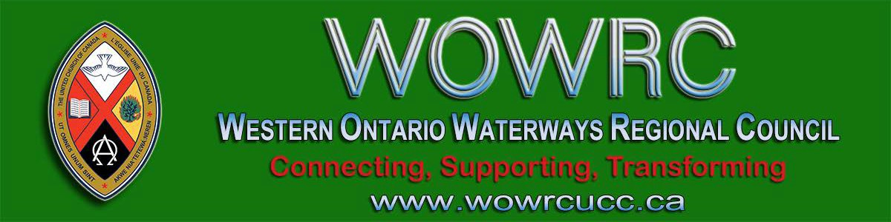
Subscribe |  | Past Issues |  | Translate |  | RSS
View this email in your browser

Next Deadline for submissions: February 28
Sign up for our newsletter & forward this one to friends.
Covenanting Service: Sunday, March 1 @ 2:00 pm
Trinity United Church

54 Benton Street, Kitchener N2G 3H2
The congregation of Trinity United Church is covenanting with Sydney Elias. Come celebrate with us on Sunday, March 1 at 2:00 pm as we start this new ministry.

Light refreshments will be served after the service. If you can't attend, send greetings or best wishes to office@trinityunitedkw.ca.

Access the chapel from Church
Street, around the corner from 54
Benton Street in Kitchener.
Connecting, Supporting, Transforming

Western Ontario Waterways Regional Council
The United Church of Canada
Sign up for our newsletters.

Copyright © 2020 Western Ontario Waterways Regional Council, UCC, All rights reserved.

Change how you receive these emails, update your preferences or unsubscribe from this list.

