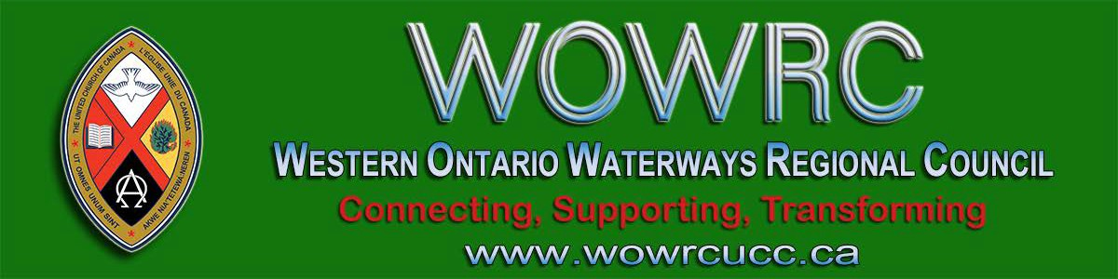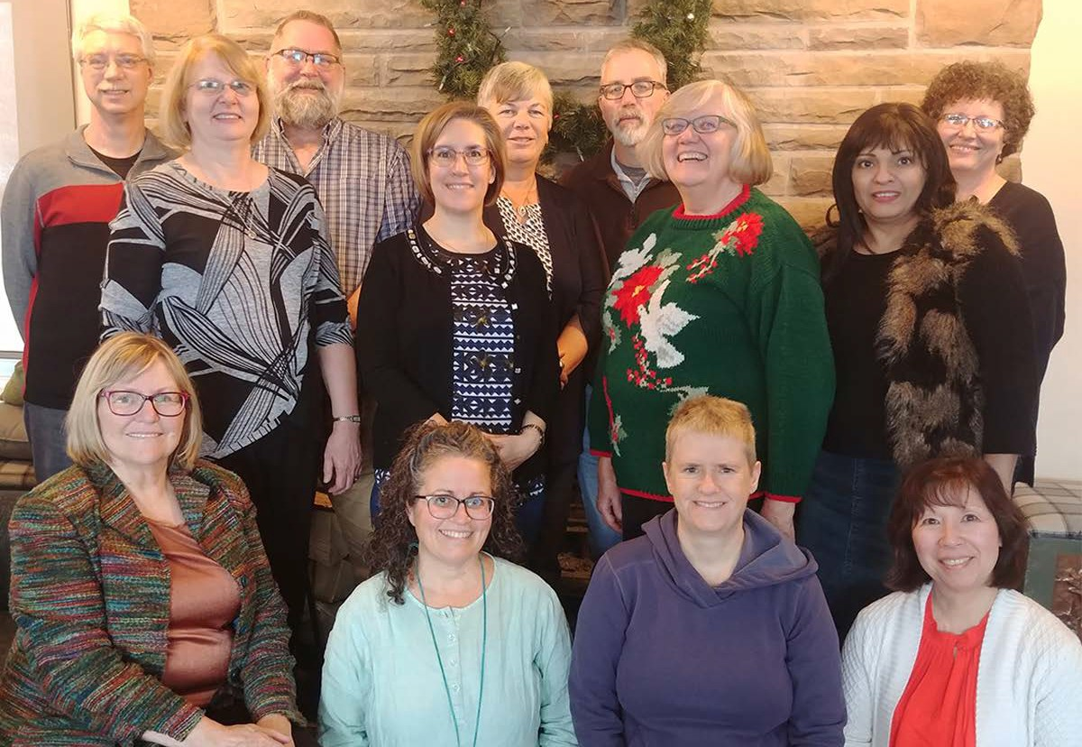
Subscribe |  | Past Issues |  | Translate |  | RSS
 | View this email in your browser
May the Spirit of Christmas Be Yours!

Standing left to right: Dave Jagger, Lynne Allin, John Neff, Tanya Cameron, Joan Tuchlinsky, Kevin

Steeper, Cheryl-Ann Stadelbauer-Sampa, Pretima Kukadia-Kinting, Sue Duliban. Seated: Diane Blanchard, Kathy Douglas, Ruthanna Mack, Kim Uyede-Kai.

This time of year brings the joy and hope of Christ that we at Western Ontario Waterways Regional Council wish to extend to all of you. May you be blessed with God’s love and peace throughout the coming year.

The Regional Council office will be closed Monday, December 23 through January 3 and will reopen

Monday, January 6, 2020.

During this time urgent messages can be left at 905 -659 -3343 ext. 2 or toll-free 1-833 -236 -0280 ext. 2. This voicemail will be checked periodically during the Christmas break.
Connecting, Supporting, Transforming

Western Ontario Waterways Regional Council
The United Church of Canada
Sign up for our newsletters.

Copyright © 2019 Western Ontario Waterways Regional Council, UCC, All rights reserved.

Want to change how you receive these emails?
You can update your preferences or unsubscribe from this list.

