How to Navigate ChurchHub
As I have walked with folks doing the initial posting, there have been some learnings that I think might be helpful to folks.

Role of Administrator
The person identified as the “administrator” for your community of faith is the person who would have received the information about ChurchHub and access to your page.
When there is a Search Committee using the ChurchHub for the purpose of searching, it is important that you have a conversation with your “administrator” about information and confidentiality of information.
If you are a community of faith entering the Search process, please note that the administrator has the same password and can enter the “Search for Minister” portal which allows s/he to see those ministry personnel who have said they are available for search. It would be a good idea to make sure the administrator is aware that this information is highly confidential and it cannot be shared.

Logging On
An email will come to the Administrator with the initial login information. It is likely the administrator will set the password for the community of faith’s page. You will need this information to enter the community of faith portal to post your information.

What the community of faith must post
If you are in the Search process, you must post the Community of Faith 5 Profiles (6 if you have a manse) that have been approved by the Regional Council Liaison and the community of faith at a community of faith called meeting.
Living Faith Story
Financial
Demographics
Real Property
Manse
Position Description

Additional things you may post
You can post on the “published documents” portal any additional information you would like to share. Annual Reports, visioning documents, videos, pictures. From the Community of Faith Homepage, click on Published Content and upload the documents or other material you wish to post there. This is public information!

Where are they posted?
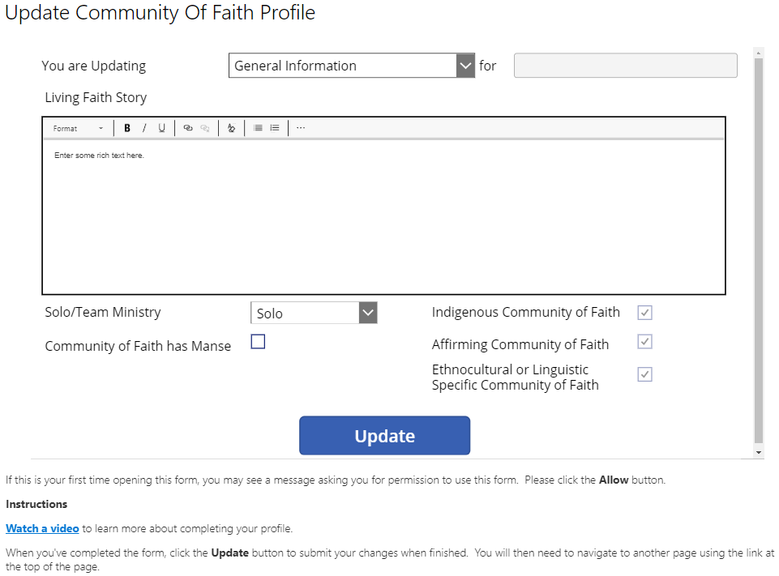
Living Faith Story is posted in Community of Faith first drop down “General Information”. A text box will appear with Living Faith Story at the top corner. You can cut and paste a narrative into the box. If your Living Faith Story is a video or graphic you can write a few sentences and then provide the link to the video or graphic. There are prompts – See our Youtube… Our story board is found… You can also provide links to any other information you have posted on “Published by the community of Faith”.
You also need to click on the boxes below the text window to indicate the things that apply to your community of faith. I check mark should appear in those boxes you have clicked.
When you enter the information you want to appear in this window, click the update button.

Other profiles available on this portal window
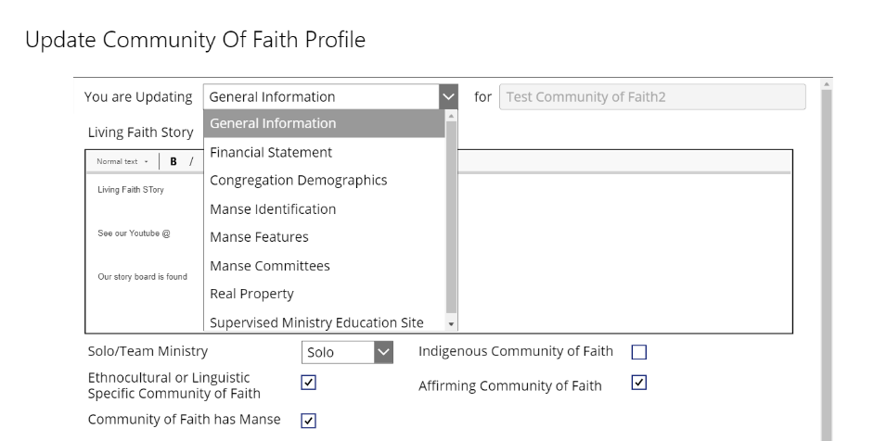
In the drop down box there links to the pages for the other profiles. Click the arrow on the drop down menu (General Information is the word that will appear first) and proceed to next profile page you wish to enter.

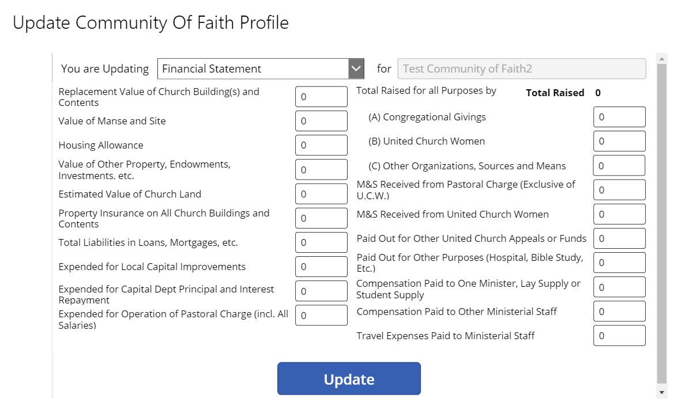
Financial Statement
You will have this information from the Financial Viability worksheets in the Resources for Communities of Faith. Enter the numbers into the profile by clicking on the box and typing in the information. When you have completed, click the update button. It will as you to go back to the homepage.

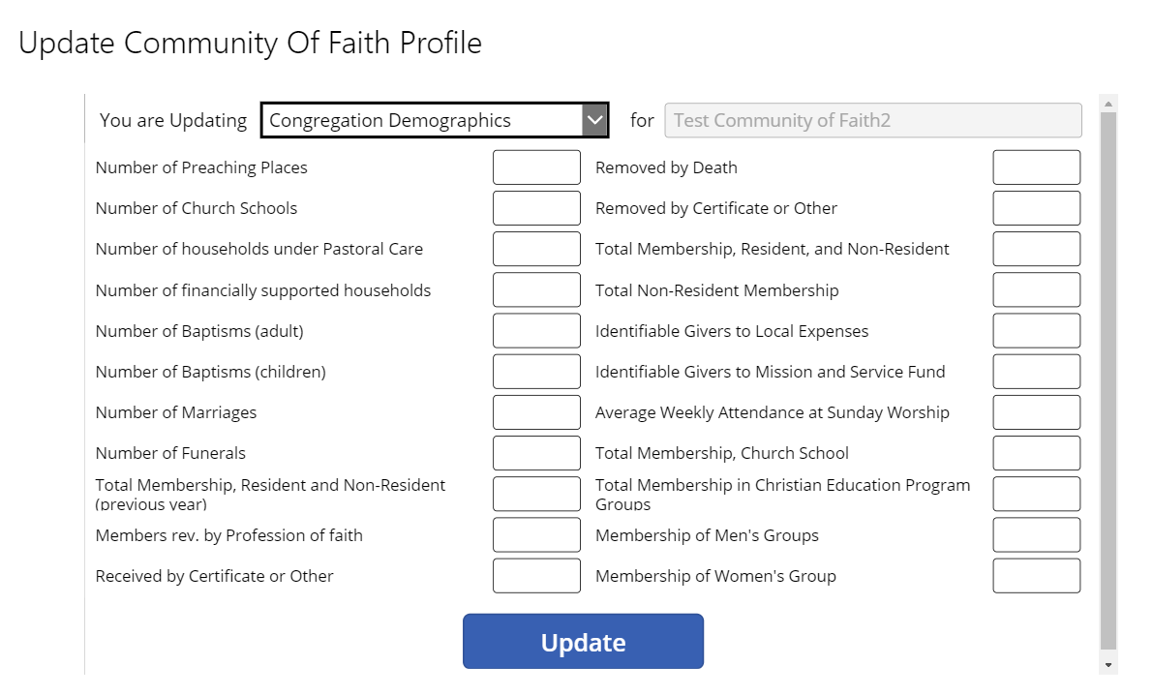

Demographics
This information is available from your statistical forms. In the future it may already be populated but for the moment you need to enter the information. Then click update. It will ask you to go back to the homepage.

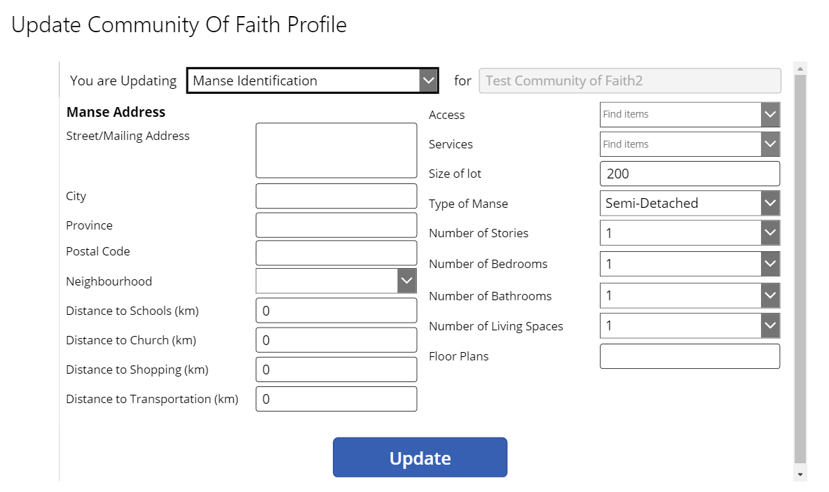
Manse Information – for Communities of Faith that have a manse
There are three pages related to manse information.
Page one – Manse Identification
Complete the boxes and click update. It will ask you to go back to the homepage.

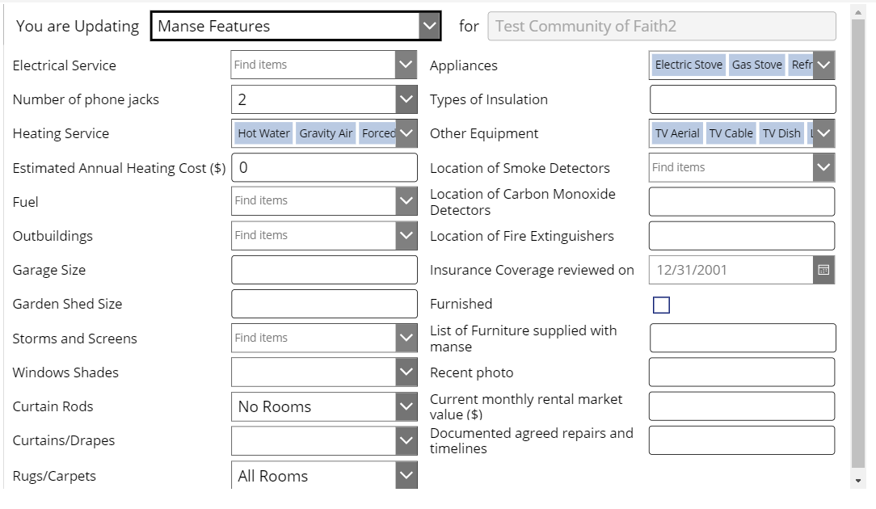
page two – Manse Features
note that at this time the update button is missing from this page. It should be there soon. In the meantime the work around is this – you can edit fields on this Manse Features page, then switch pages using the dropdown at the top of the form, and click the Update button on another page. That Update button will included updates to data you made on the Manse Features page.

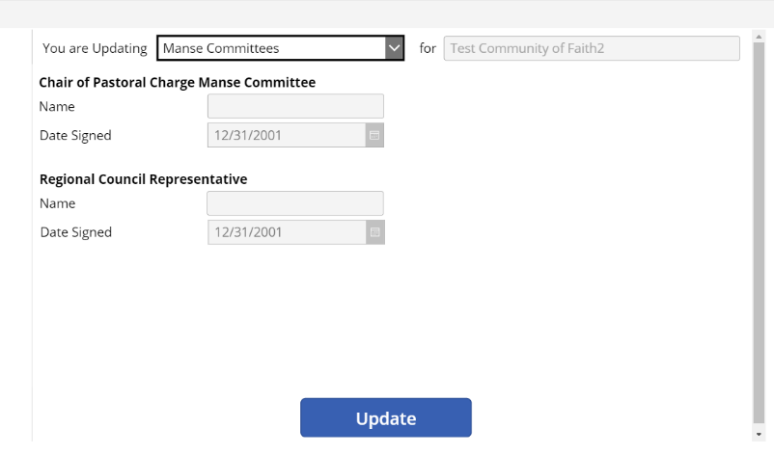
Page 3 – Manse Committee information and verification
Complete the contact information for the committee and the date they signed off on the information provided in the previous 2 profile windows. Click update. It will ask you to go back to the community of faith homepage

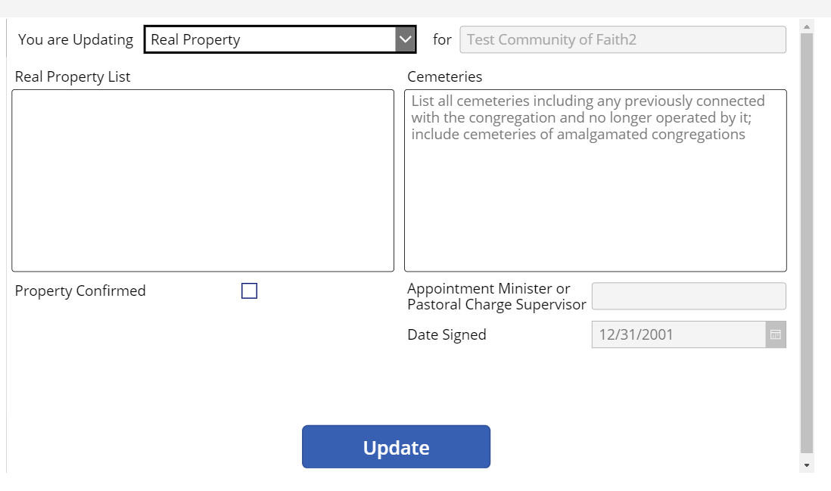
Real Property
This is information you gathered on the worksheet from the Resources for communities of faith. Complete and update. It will ask you to go back to the community of faith homepage.

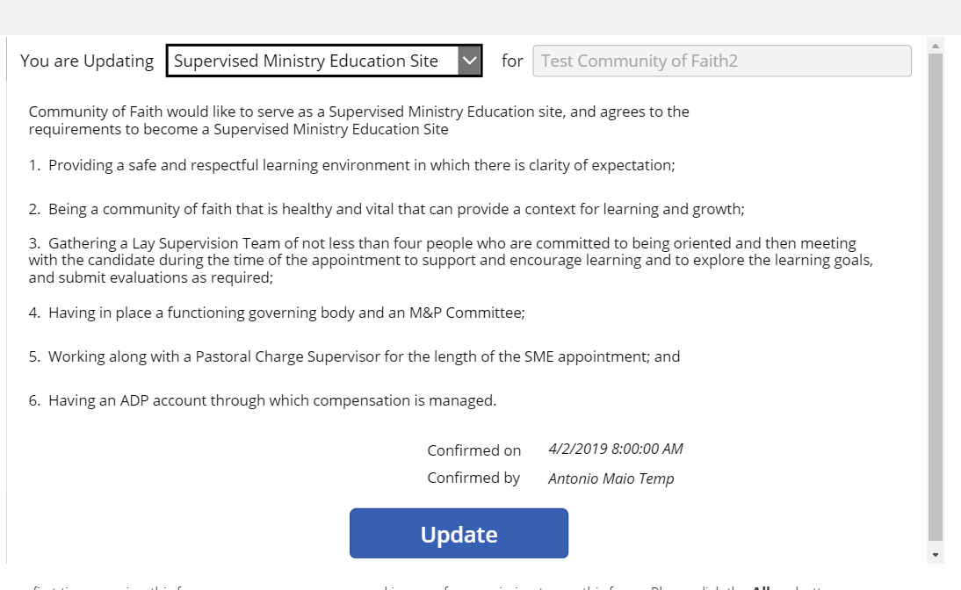
Supervised Ministry Education Site
This is to be completed if you have decided to be a SME site and if your Liaison has agreed that you are an appropriate context for a SME. By confirming with name and date, you are committing your community of faith to the covenant statements in the profile field. DO NOT COMPLETE THIS if your Liaison has not approved your community of faith as a SME site.
YOU HAVE NOW COMPLETED ALL THE PROFILES ON THE COMMUNITY OF FAITH PROFILE PORTAL!
YOU ARE NOW READY TO MOVE ON TO POSTING ON LOOKING FOR A NEW MINISTER.

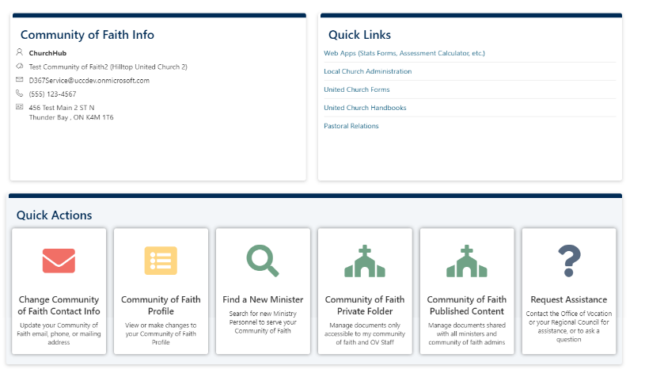
Entering a the next portal that needs information

Find a New Minister
Return to homepage and click on “Find a New Minister” portal

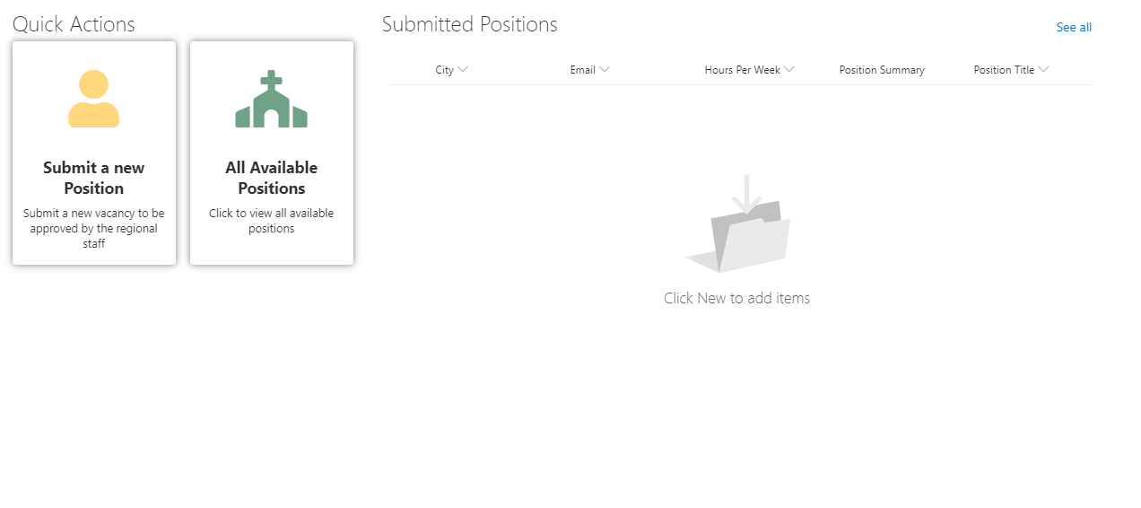
Submit a new Position
This is the portal where your position description information will be entered. Click on Submit a new Position

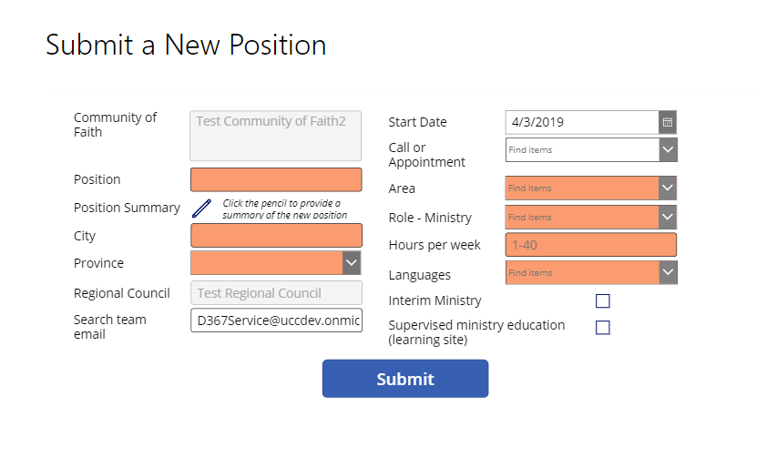
The next window will look like the graphic. Enter the information in the boxes. Those coloured boxes must be completed in order for the position to be submitted.
However do not “Submit” until you have updated the position summary described below.

Note this is to be a confidential email for the purpose of the search.
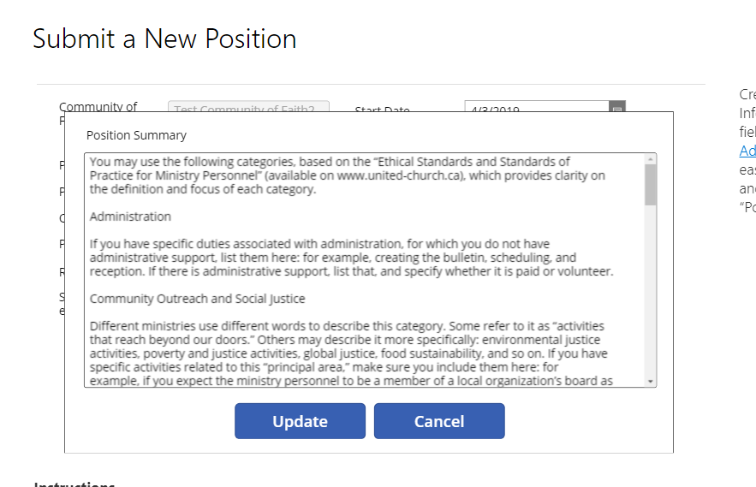
Your position description is to be pasted into the Position Summary. You click on the pencil. When the window opens it will have an example position description. You must first delete what is in the box, then you can paste or type the position description in the window. If you are pasting you must be pasting text not a pdf.
The position summary has its own update button. Update this first and then…

return to Submit a New Position first window and submit. This will trigger an email to the pastoral relations minister asking if
the Regional Council has approved this posting.
At this point the necessary pieces of the community of faith profiles are now posted to ChurchHub.
For assistance during this process you can use the video links on the ChurchHub; the help desk; call John or Lynne, your Congregational Support and Vision Minister; Diane, your Pastoral Relations Minister, or the Liaison working with your community of faith.
Thank you to Rev. Lillian Roberts, Canadian Shield Region, for preparing this resource.

